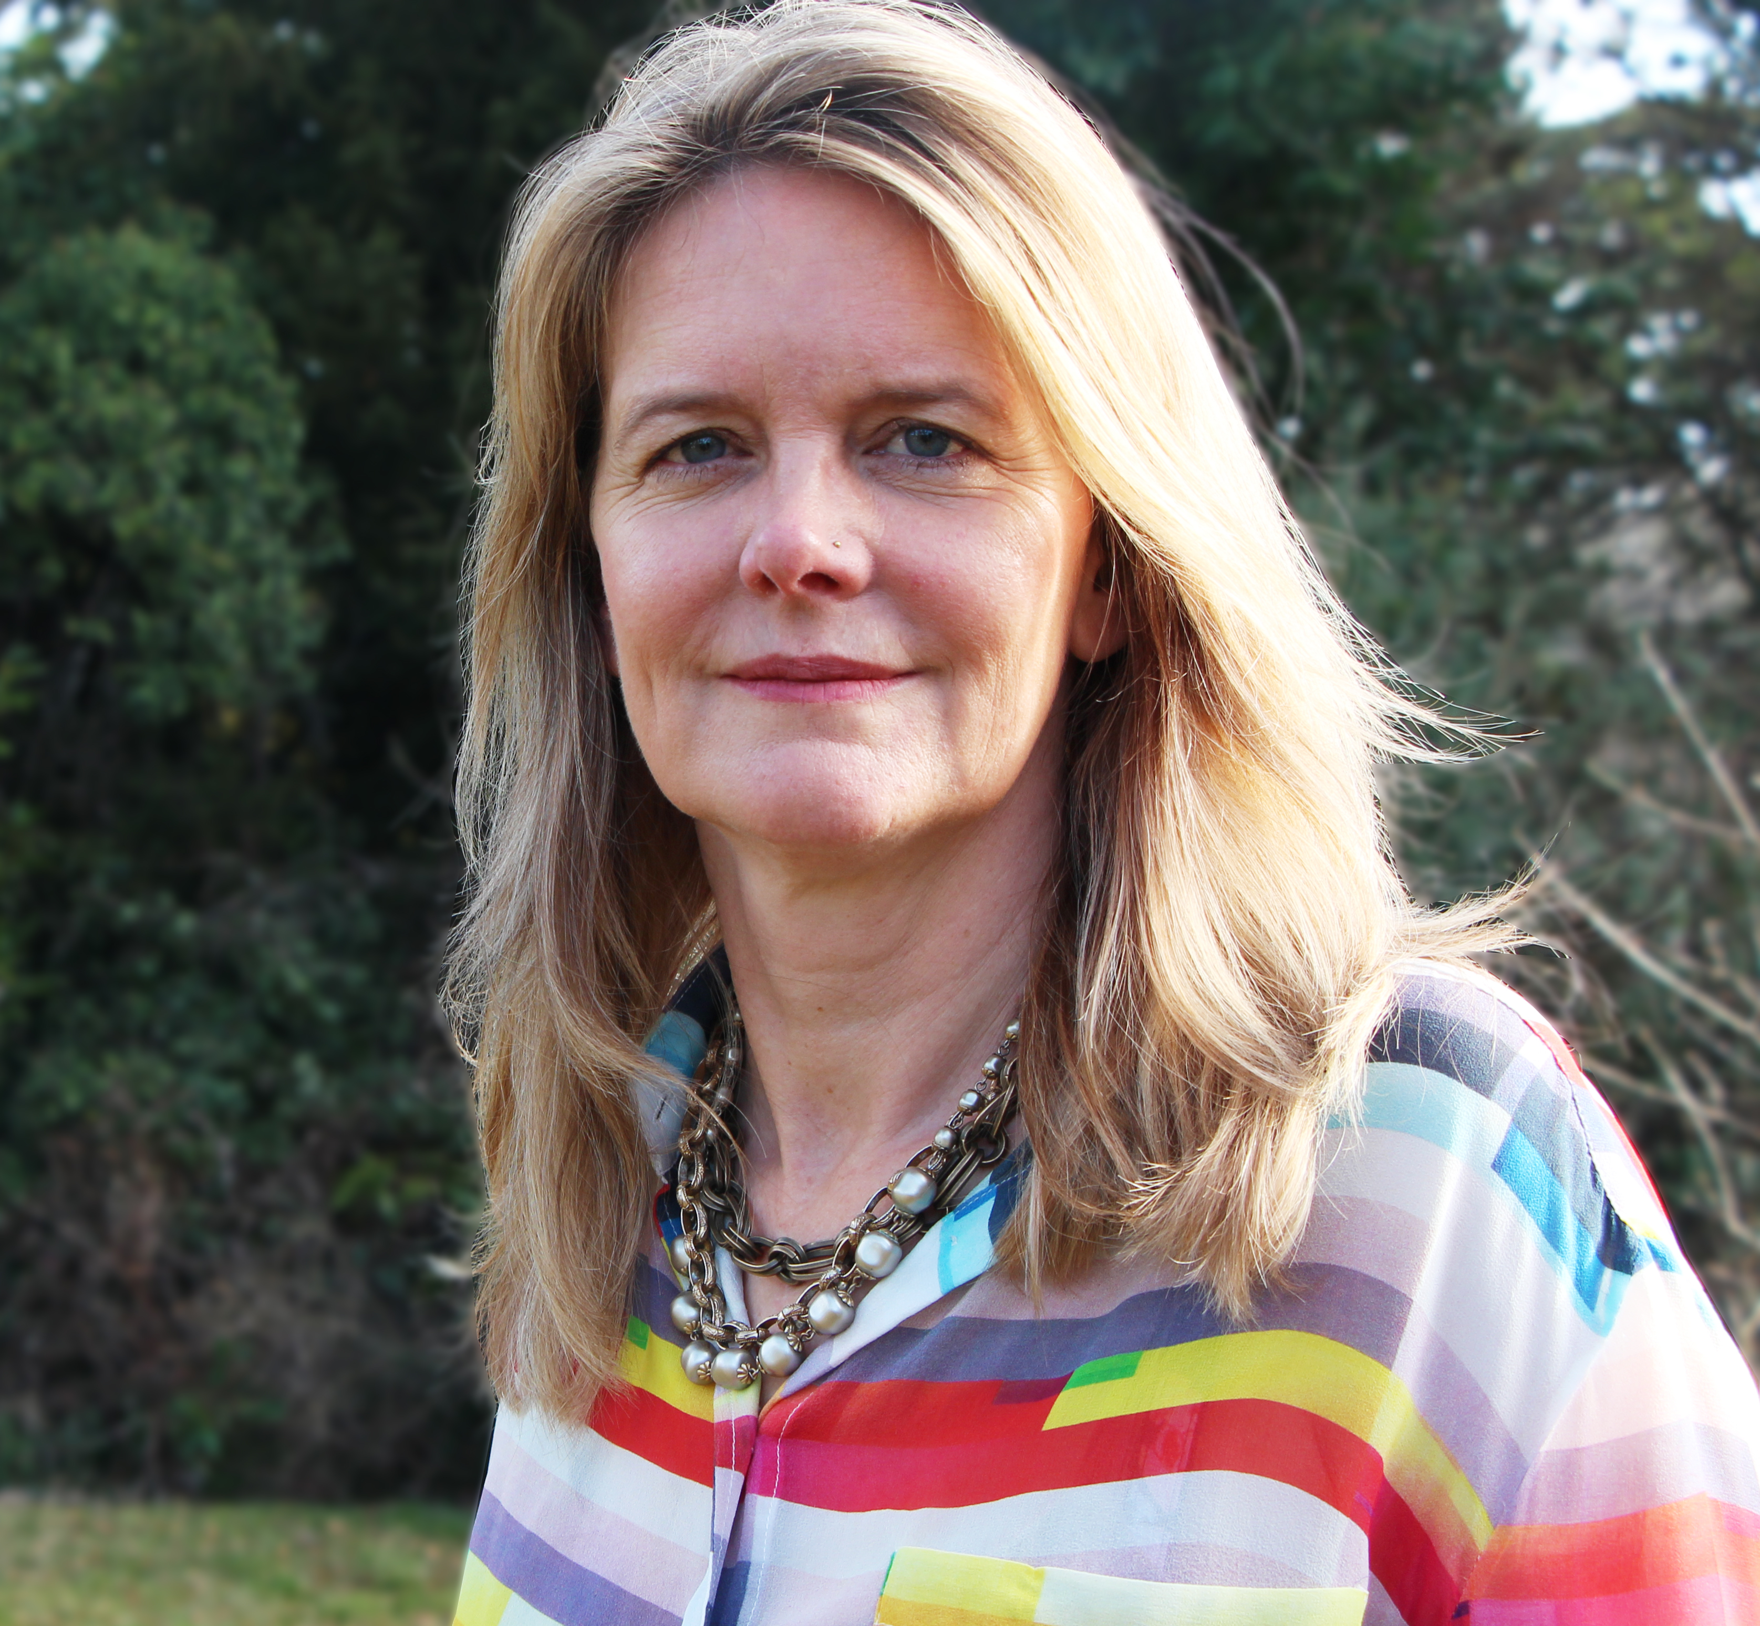
Malayah Harper
General Secretary, World YWCA

Malayah Harper is the General Secretary of the World YWCA, a global movement working for the empowerment, leadership and rights of women, young women and girls in 120 countries and 20,000 communities.

Malayah has worked for 20 years internationally in the area of social justice and equality. She has significant representational and diplomatic experience – a history in social movement building and a track record for establishing innovative partnerships. She has a deep commitment to ensure that no woman or girl is left behind as we make progress on gender equality and the empowerment of women.

Prior to joining the World YWCA, Malayah worked with the Joint UN Program on HIV and AIDS (UNAIDS) as Country Director for Uganda and Kenya and subsequently as the Global Chief for Gender Equality and Diversity Division.

She worked as a Senior Advisor in the UK Department of International Development (DFID) from 2000- 2005. In this capacity she was appointed to lead negotiations across UK government and with the pharmaceutical industry the UK government’s first Access to Essential Medicines Strategy in the Developing World (2003). She also held posts leading the team on service delivery, and maternal mortality and worked on the establishment of the Global Fund for AIDS, TB and Malaria (GFATM) and G8 commitments in the area of health and access to medicines.

Malayah worked with the World Bank from 1995-1999 and pioneered innovative approaches for financing malaria and supporting World Bank programs in Zambia and India. She was seconded to the World Health Organisation as the Chief of Partnership development to establish the new innovative Roll Back Malaria Partnership.

In the 1990s, Malayah worked as community development officer for a Thai NGO on the Thai-Burmese border and as a Team Leader for Canada World Youth, leading a cross cultural youth exchange program between rural Thailand and Canada.

Malayah is a Canadian and British national and holds a BA in International Development, with a major in Anthropology, from the University of Toronto in Canada and a Masters in Health Policy, Planning and Financing in the Developing World from the London School of Economics (LSE) and the London School of Hygiene and Tropical Medicine (LSTHM).

Malayah Harper joined the World YWCA in December 2016 and as General Secretary to lead the implementation of the organisation’s bold and transformative vision that by 2035, 100 million young women and girls transform power structures to create justice, gender equality and a world without violence and war leading to a sustainable YWCA movement, inclusive of all women.

