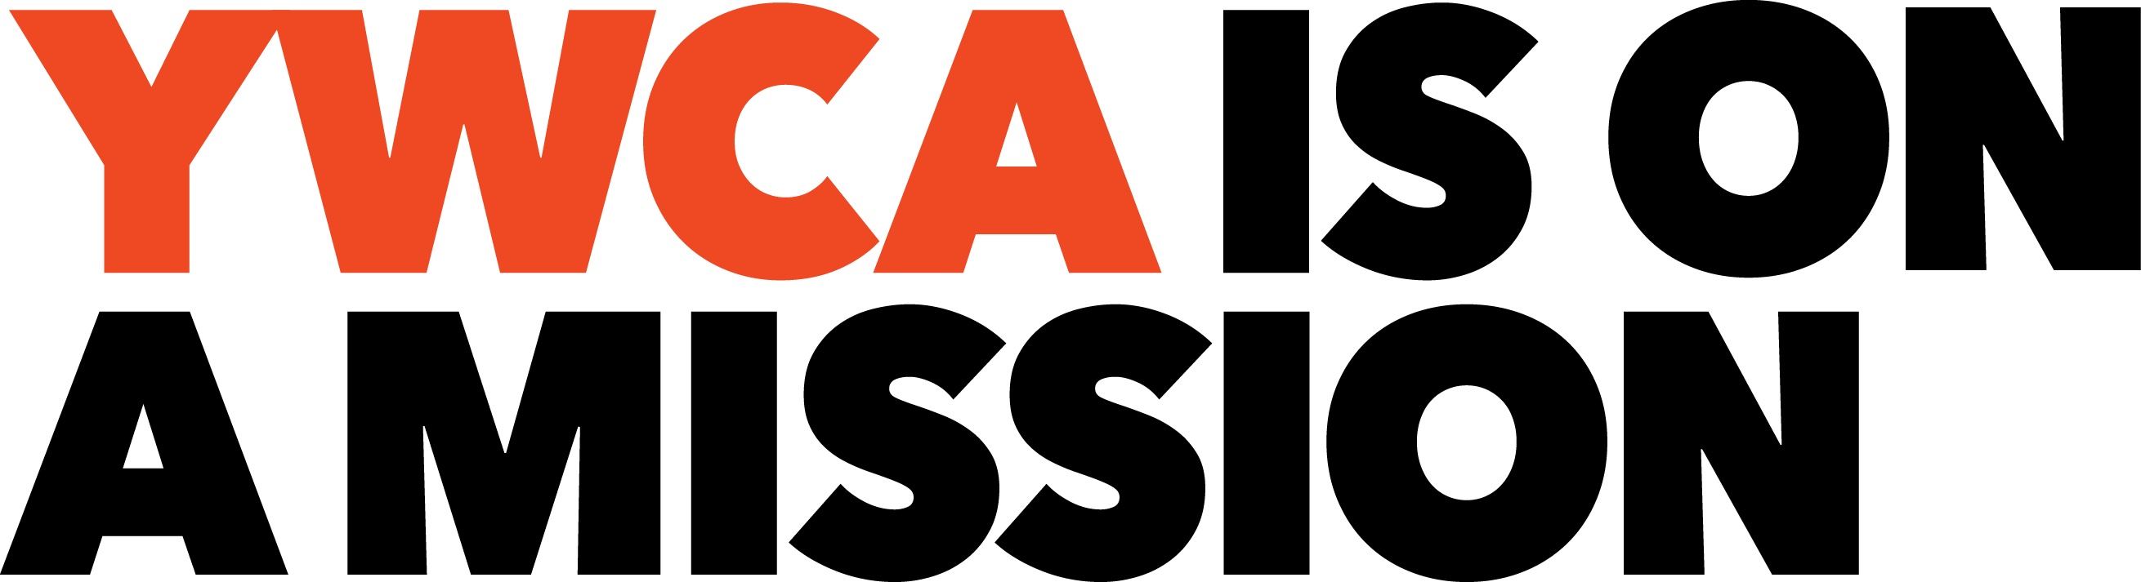

YWCA ONLINE RESOURCE LIBRARY: NEW POSTINGS
February-March 2020

Below please find the resource library’s newest postings - this index highlights and provides easy access to the latest additions. Anyone having any trouble accessing a resource, looking for a resource, or needing a different format is encouraged to contact Martha Breunig: mbreunig@ywca.org for assistance.

Visit YWCA USA's Online Resource Library Often!
15 YWCA-Tailored Categories 100+ Topics 700+ Postings

PLEASE NOTE: Some of the resources will be downloads and show at the bottom of your screen – others will open directly to the file. And, after choosing a folder on the 'Folders Page,' remember to look to the right and top of the screen for the list of postings in that category. When accessing a resource, viewers may need to double click on the resource title.

Resource Library Category | > Topic | Resource Title  and Live Link | Description
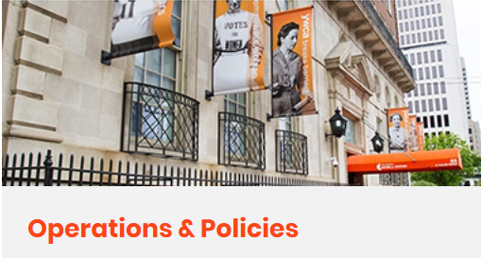 | > General Operations Policy Samples, Including Access and Accommodation | Sample YWCA Program, Access and Accommodation Policies | Sample policies covering access to YWCA buildings and programs, onsite behavior requirements; membership/ enrollment payments and refunds; accommodation re: gender identity; accommodation for those seeking higher levels of privacy; and accommodation for those with disabilities.
 |  | YWCA General Building Access Security Policy Samples | Tips for developing and examples for general access and security policies to achieve an appropriate balance between an open and a safe facility environment.
 | > Program Handbooks | Sample YWCA Residence/Shelter Code of Conduct | Sample YWCA policy covering a code of conduct for those living in a YWCA residence or shelter.
 |  | YWCA Child Development Program Parent Handbook; Sample Outline | An outline to guide the development of a parent handbook for YWCA child development programs
 | > Buildings and Grounds | YWCA Facilities Checklist and Budget Planning Worksheets | Charts for recording structural and systems attributes and ongoing maintenance, repairs, and capital plans.
 |  | YWCA Facilities Management Guide | Planning process for routine and preventative maintenance and capital planning to ensure smooth systems operations day-to-day as well as long-range.

Resource Library Category | > Topic | Resource Title  and Live Link | Description
Operations and Policies, continued | > Property Management and Risk Management | Sample Property Rental Agreement | Sample agreements for rental of YWCA rooms or facilities.
 | > Records Security and Retention | Records Locator Form | A form on which to note where current important documents are stored as well as contact information for the YWCA’s bank and insurance, employee benefits and legal firms.
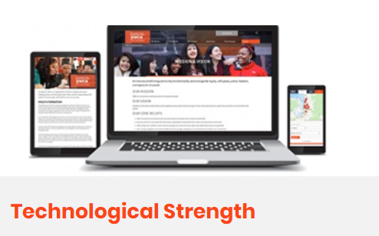 | > Technology Planning | Best Cloud Storage for Nonprofits 2020 | From Cloudwards for nonprofit consideration, reviews and a list of computer cloud service choices.
 |  | Core Elements of a Technology Plan | An article listing 4 essential components of technology planning
 |  | Digital Strategy - Planning for Today's YWCA | A guide covering steps to take to maximize the YWCA’s place in the digital economy, or electronic marketplace. A digital status assessment tool is included.
 |  | Technology Inventory and Planning Worksheets | A guide with worksheets for inventorying technological equipment and planning, internal and external connectivity, software, back-up processes, risk assessment, support and training and overall technology management.
 |  | YWCAs and Technology - A Crucial Link | An article outlining the role technology plays in YWCA operations and how technology’s newest applications in the areas of social media, outcome tracking, donor engagement, cloud technology, and mobile technology are being implemented. Also included, barriers to the uptake process, goals to develop and hardware and software resources for nonprofits.
 | > Technology Security | Technology Risk Management Checklist | A short description of the role of technology risk management and an assessment checklist.
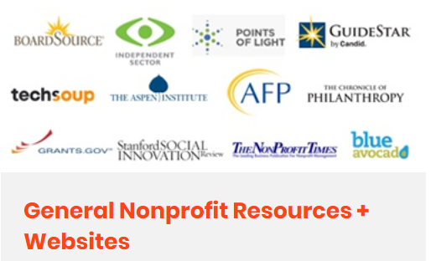 | > Program Evaluation and Impact Measurement | At-Risk Kids are Best Served by the Nonprofit Sector | An opinion describing the benefits of youth services being provided by non-profit organizations instead of government or for-profit agencies.

