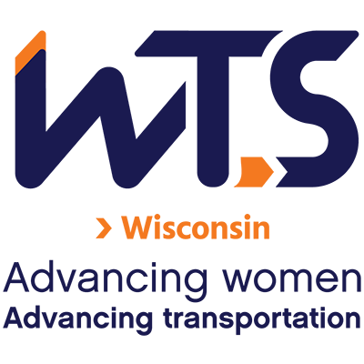

WTS Junior College/Trade School Scholarship

WTS fosters the development of women in the transportation field by encouraging bright new professionals to undertake careers in transportation. One way it does this is by awarding community, technical, or trade college scholarships to women pursuing transportation-related studies at community and trade colleges.

This scholarship is intended for students pursuing an associate or technical degree in transportation-related studies.

The WTS Wisconsin Junior College/Trade School Scholarship is in the amount of $500. The winner will also receive a one-year WTS International Student Membership and become eligible for the national scholarship of $2,500. The minimum criteria for selection are:

- GPA of 3.0 or higher
- Currently enrolled in a degree program in a transportation-related field.
- Plans to pursue a career in a transportation-related field.

Applications must be submitted through local WTS chapters as typed documents. Scholarships are competitive and based on the applicant's specific transportation goals, academic record, and transportation-related activities or job skills. WTS-Wisconsin award winners will be announced mid-December 2022 and will be celebrated at the WTS-Wisconsin awards event in Spring 2023. National awards will be presented during the WTS Annual Conference in May 2023, and attendance during the awards ceremony is strongly recommended. Conference registration for scholarship winners is complimentary. Local chapters will assist with arrangements upon selection and may have additional requirements, such as personal interviews or higher GPA.

Please send your questions and application to wts.wisconsin@gmail.com

Submissions will be accepted until 11:59 p.m. on Monday December 5, 2022

WTS Junior College/Trade School Scholarship Application

I. Personal Information

Last Name | First Name | Middle Name
Email |  | Phone Number
Current Street Address, City, State, Zip Code

Permanent Street Address, City, State, Zip Code

Educational Background

Current College/University

City, State

Expected Date of Graduation | Current Grade Point Average  (Minimum 3.0. Attach official copy of transcript to application.)
Degree to be Earned | Area of Concentration
Previous Colleges/Universities Attended | Degree Earned, Date and/or Dates of Attendance | GPA
Professional or School Affiliations (list any school, professional or community activities you have participated in. Include offices held and awards received)

III. Employment History

Work Experience (List full-time, part-time, co-op and summer employment. Briefly describe duties and responsibilities.

IV. Recommendation: Letter of recommendation by a professor or job supervisor must accompany your application.
Provided

V. Personal Statement:
A statement about your career goals after graduation and why you think that you should receive the scholarship award. Statement should not exceed 500 words.

VI. Proof of Enrollment: Attach a copy of your tuition receipt or current registration card.
Provided

Applicant Signature |  | Date

VII. Demographic Information: WTS is committed to recognizing the achievements of students pursuing transportation related degrees. To track our progress in reaching diverse applicants, we ask that you complete this confidential demographic information. This is not required for scholarship awards and will not be used in the selection process.

- Race/Ethnicity (select all that apply)
Asian
Black
East Indian
Hispanic/Latino
Indigenous
Middle Eastern
Multiracial
Pacific Islander
White
Other (Please write in)
Choose Not to Disclose

- Age
15-18
19-23
24-30
31-50
50 +

- Anticipated or Current Mode of Transportation Career Focus (select all that apply)
Aviation
Freight
Highway/Auto
Maritime/Port
Multi-Modal
Non-Motorized
Passenger
Transit
Other (Please write in)

- How did you hear about this scholarship?
Friend
School/Teacher
WTS Chapter
WTS International Website
Other (Please write in)
Social Media:
Facebook Instagram
LinkedIn Snapchat
TikTok Twitter
YouTube Other (Please write in)

