2019 | 

Change Notification

Admin Guide

11/15/2019

Table of Contents
Change Notification 5
Overview 5
Architecture 5
Installation and Initial Configuration 6
Integrate Change Notification Trigger 6
Registering the Change Notification Trigger 6
Updating an Existing Trigger for a Repository 7
Managing Multi-Language Attributes in Existing Trigger 8
Registering Change Notification as a PreSave Validation Rule 9
Activating Debug Logging 9
Operational Configuration 9
CN_Registry Repository 9
Summary Tab 10
Conditions Tab 11
Attributes Tab 12
Log Tab 15
Update Tab 16
Transformation Tab 18
Translation Tab 19
Email Tab 19
CN_Log Repository 22
Reporting Using Scheduled Exports 23
Transformation Extension 26
Overview 26
CN_Transformation_Repository 26
Summary Tab 26
Target Tab 27
Condition Tab 28
SQL Expressions 30
Example Transformations 31
Rollup Attribute 31
Language Translation Extension 37
Overview 37
Change Notification Translation Registry 38
Summary Tab 39
Attributes Tab 41
Change Notification Translation Queue 42
Change Notification Translation Log Repository 44
Translation Request File 46
Translation Request Scheduled Export 48
Translation Request Log Update Scheduled Import 50
Translation Queue Cleanup Scheduled Export 50
Translation Queue Update Scheduled Import 50
Translation Language Update Import Templates 53
Reports 54
Report Registry Repository 55
Scheduled Export Post-Processing Configuration 57
On-Demand Launch of Report 57
Change Report Processing 58

Change Notification

Overview
The Change Notification module provides the ability to track changes made to designated attributes in designated repositories and take one or more of the specified notification actions:
- Update designated attributes with the specified values in the changed record
- Log change details to the Change Notification Log
- Send e-mail to the designated addressee(s)
- Facilitate sending Language Translation Requests to an external language translating service.
- Update designated attributes with the specified values in target repository records associated to the changed record
- Facilitate transformations to designated attributes based on values and conditions defined in a Change Notification Transformations repository

Architecture
The following diagram illustrates the Change Notification architecture:
The Change Notification Registry identifies which repositories and attributes are to be monitored and what actions are to be taken when changes are detected. The Change Notification Processing is invoked any time a repository record is modified. It uses the details in the Change Notification Registry to determine if any action needs to be taken.
- Email - notifications are placed into the Email Queue (table). The Email Queue Process (EPX workflow) retrieves the queued messages and packages them in to e-mails based on common To address and Subject text.

- Log - The Change Notification Queue is used to log the details of the changes in order to minimize the performance impact of the original operation that invoked the Change Notification Processing. Since a single update to a repository record could result in multiple updates to the change log (one for each changed attribute), inserts into a SQL table are significantly faster than inserts into an Enable repository. A background (EPX) process monitors the Change Notification Queue for new records and moves them to the Change Notification Log repository(ies). In high-volume change scenarios (e.g., large file imports or mass edits), there may be a backlog of pending changes in the Change Notification Queue that takes a while to move to the Change Notification Log repository(ies).

- Update – the specified updates are made to the record that triggered the change notification

- Language Translation – identifies an entry in the language translation registry (CN_Translation_Registry) that defines the language translation configuration for a repository.

- Transform – identifies transformations that are to be conditionally made to attributes in the record that triggered the change notification or to attributes in a record that is linked to the record that triggered the change notification. The conditions would be based off values in the changed record or the record linked to the changed record.

Installation and Initial Configuration
The following sections detail the steps necessary to install and initially configure the Change Notification processing. The necessary files, database tables and stored procedures, and data model (profiles, repositories, and code sets) should all be pre-installed with the Services Framework installation. The only configuration step required is to register the Change Notification trigger with each repository in the sharedConfig.properties file.

Integrate Change Notification Trigger
The Change Notification processing requires the Change Notification Trigger be invoked (directly or indirectly) for each repository for which Change Notification processing is to be enabled. If a repository already has a trigger defined for it, that trigger must be updated to call the Change Notification trigger as a final step before saving any updates to the changed record.

Registering the Change Notification Trigger
If a repository to be monitored does not currently have a trigger defined for it, the Change Notification Trigger must be registered by performing the following steps:
- Edit each sharedConfig.properties file for each Enable Server Tomcat and JBoss services.
- Make sure the property allow.external.event.handler is set to “true”.
- Add an entry to the property external.event.handlers. Entries must be separated by commas with no spaces. The name chosen will be used in the subsequent properties (referenced in this document as “<repo>”). For example, if the PIM_Item_Staging repository is to be monitored, an appropriate name would be “itemStaging” and the property: external.event.<repo>.target.repository would be defined as: external.event.itemStaging.target.repository=PIM_Item_Staging
- Add the following properties below the external.event.handlers property:
external.event.<repo>.type=0
external.event.<repo>.sync=true
external.event.<repo>.passInDBSessionInd=true
external.event.<repo>.classname=com.enterworks.services.changenotification.ChangeNotificationTrigger
external.event.<repo>.target.repository=<actualRepositoryName>

Note: In general, all triggers should be defines as synchronous (external.event.<repo>.sync=true). If there is a need for a Tomcat trigger to be asynchronous, set this flag to false. The JBoss triggers MUST be defined as synchronous.

- Repeat the above steps for each repository to be monitored.

Updating an Existing Trigger for a Repository
If a repository to be monitored already has a trigger registered for it, that trigger should be updated to call the Change Notification trigger to keep the overhead processing to a minimum. A second trigger can be defined for the repository, but this will result possibly two new versions of the record being created for each change.
To integrate the Change Notification Trigger into an existing trigger, perform the following steps:
- Edit the sharedConfig.properties file for each Enable Server Tomcat and JBoss service.
- Make sure the existing trigger is configured to pass the DB session to the trigger by the external.event.<repo>.passInDBSessionInd property being set to true. If it is not defined or is set to false, change it to true. This will also require the trigger doWork() method to be updated.
- Edit the source file for the existing trigger.
- Make sure the doWork() method has the following signature:

public void doWork(String repositoryName, long itemId, int action, ItemObject currentItem, List diffList, org.hibernate.Session hibernateSession, Connection conn)
throws Exception

- Define a BsessionEpimHelper instance with the following code:

CustomRepositoryItem itemData = (CustomRepositoryItem)currentItem;

// Change the session to admin user
Bsession bSession = EpimCustomHelper.getAdminBsession();
itemData.setCurSession(bSession);
HashMap<String, String> itemChanges = new HashMap<String, String>();

// Create session helper using existing session and DB connection
BsessionEpimHelper bsessionEpimHelper = BsessionEpimHelper.getInstance(bSession, conn, hibernateSession);

// Retrieves all changes including to non-default languages in multi-language attributes:
HashMap diffMap = ChangeNotificationTrigger.getCurDiffMap( diffList, itemData );

Note: The current session should be changed to the admin user to ensure attribute security does not interfere with trigger operations.

- After the existing New/Modify processing, add the following statement:

// Honor any change notifications

itemChanges.putAll(ChangeNotificationTrigger.processChangeNotifications(repositoryName, itemId, itemData, action, bsessionEpimHelper, diffMap, itemChanges, null));

// Save any changes
if (itemChanges.size() > 0) {
if (debugEnabled) appLogger.severe( "AutoCalculateTrigger.doWork: saving changes: " + itemChanges);
itemData.updateItemDataByFormatAttrHash(itemChanges, false);
}

- Recompile the trigger source file
- Repeat the above steps for each existing trigger.

Managing Multi-Language Attributes in Existing Trigger
If the existing trigger deals with non-default multi-language values, the getCurDiffMap() includes them using the following naming convention: F_<formatAttrId>_<langExt> where <formatAttrId> is the internal ID for the attribute and <langExt> is the language extension. This is the form the attribute name must be in order to update a non-default multi-language attribute. The Change Notification class has a method that provides lookup maps to facilitate dealing with multi-language attributes:
ChaneNotificationTrigger.getMultiLanguageAttributesForRepository(DBQuery dbQuery, String repositoryName, ArrayList<String> multiLanguageSystemNames, HashMap<String,String> extensionForSystemName, HashMap<String,String> attributeForSystemName, HashSet<String>languageExtensions, HashMap<String,String> systemNameForAttributeWithExtension);

- dbQuery – the caller must pass in a valid DBQuery object

- repositoryName – name of the repository being processed by the trigger

- multiLanguageSystemNames – empty ArrayList to be populated with the list of the system names (e.g., F_100000_es) for all multi-language attributes.

- extensionForSystemName – empty HashMap to be populated with a lookup for the extension for each system name (e.g, es for F_100000_es)

- attributeForSystemName – empty HashMap to be populated with a lookup for the attribute name for each system name (e.g., Brand Name for F_100000_es)

- languageExtensions – empty HashSet to be populated with a list of only the active multi-languages (except the default)

- systemNameForAttributeWithExtension – empty HashMap to be populated with a lookup for the system name for each user-friendly attribute name with language extension (e.g., F_100000_es for Brand Name_es)

Registering Change Notification as a PreSave Validation Rule
The Change Notification functionality can be invoked using a PreSave Validation rule by performing the following steps:
- Edit the profile of the repository for which Change Notification processing is to be enabled.
- Add a validation rule to an attribute in the profile.
- Set the Type to Pre-Save Callout
- Set the Class Path to: com.enterworks.services.changenotification.ChangeNotificationPreSaveValidation
- Edit the Rule Properties for the repository.
- Assign the new validation rule.
- Clear the Data Cache

Activating Debug Logging
Debug logging for the Change Notification functions is controlled by the property debug.ChangeNotificationEnabled being set to true in the Enterworks.properties file. Services must be restarted for any property file changes to go into effect.
WARNING: Having the debug logging enabled may have a detrimental impact to performance. It is recommended to rely on the debug logging while developing a Change Notification-based solution, and then disabling the logging after development and sufficient testing has been completed.

Operational Configuration
Once the Change Notification module has been configured and enabled for a repository, the Change Notification Registry can be configured to activate the Change Notification processing can be enabled.

CN_Registry Repository
The CN_Registry repository defines the registered change notifications and their actions. Each record in the repository represents changes being monitored and what actions are to be taken. Typically, there will be only one registration for each monitored repository but there may be situations where having more than one registration is warranted. For example, if different actions are needed depending upon which attributes are changed, each different set of attributes and their actions would be specified in separate CN_Registry records.
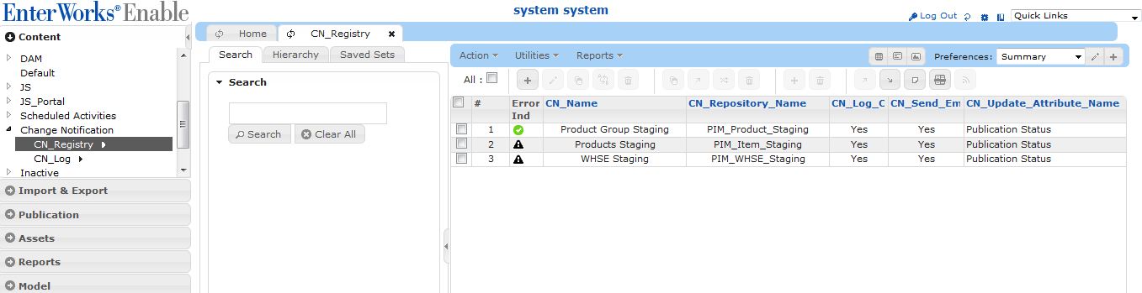
The following sections provides detailed information on each attribute in this repository, grouped by tabs:

Summary Tab
The Summary tab identifies the basic information for the registry entry, including registration name, repository being monitored, whether the registry entry is active and its processing order (when multiple registry entries are defined for the same repository):
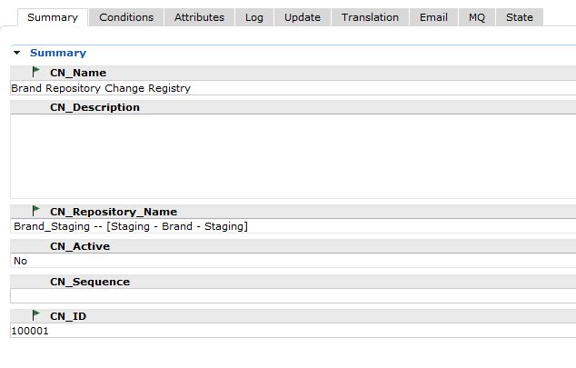
CN_Name - is a logical name for the registry entry. If there is only one change notification registered for a repository, the name will likely be set to match the name of the repository. If a repository has multiple registrations, the name should reflect the nature of the registered notification. For example, if the Item Staging repository has a set of attributes that require manager review and another set of attributes that only need to be logged, two CN_Registry records would be created with the first having a name of “Item Staging Review” and the second having the name “Item Staging Log Only”
CN_Description - Optional description for the registry record. It is strongly recommended that a description be specified and kept up-to-date when changes are made to the record.
CN_Repository_Name - Name of the repository to which the registered change applies. The Drop-down selection list shows all repositories defined in the system, but only those that have been configured for the Change Notification trigger or pre-save validation rule will be processed.
CN_Active - The CN_Registry record is active if Yes and ignored if No.
CN_ID - Internal ID for the registered change. This value will be specified in the CN_Registry_ID for any record in the CN_Log repository that originated from this registered change.
CN_Sequence - Determines the order registry records for the same repository are processed. The order may be significant. For example, if one registered change updates an attribute that needs to be logged by another registered change, the update change needs to have a lower sequence number than the log change.

Conditions Tab
The Conditions tab specifies any conditions that must be met before any action is taken for a repository record.
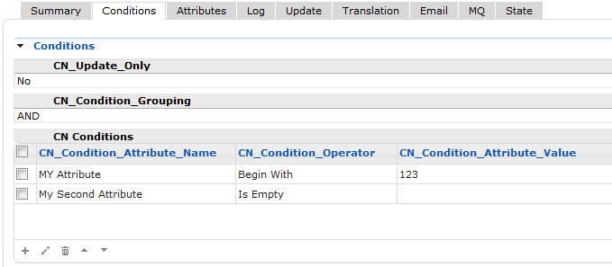
CN_Update_Only – Specifies that the change is only triggered on updates if Yes, otherwise it is triggered on updates and on new records.
CN_Condition_Grouping - Specifies whether the multiple conditions are grouped by AND, meaning all conditions must be met, or OR meaning any condition must be met.
CN_Condition_Attribute_Name - Name of the attribute for which a condition is defined. The condition must be evaluated as “true” in order for the actions in this registry record to be applied.
Conditions can only be defined on the default language – other languages cannot be specified. Generally, the conditions determine whether the particular record is subject to a registered change notification. This would typically be an attribute (or attributes) containing a value for the default language only.
CN_Condition_Operator - Specifies the condition operator for the CN_Condition_Attribute_Name. Must be one of the following:
- = - The value of an attribute exactly matches the specified value
- <> - The value of an attribute does not exactly match the specified value.
- Begin With – the beginning of the value of an attribute matches the designated value.
- End With – the ending of the value of an attribute matches the designated value
- IN – the value of an attribute matches one of the values in the designated delimited list
- Is Empty – the designated attribute has no value
- Is Not Empty – the designated attribute as any value
CN_Condition_Attribute_Value - Value to be compared to the actual value of the attribute identified by CN_Condition_Attribute_Name when the CN_Condition_Operator is =, <>, Begin With, End With or IN. Multiple values can be specified for the IN operator by separating them with commas (no spaces)

Attributes Tab
The Attributes tab identifies the attributes in the repository being monitored for changes or to be logged any time there is a change:
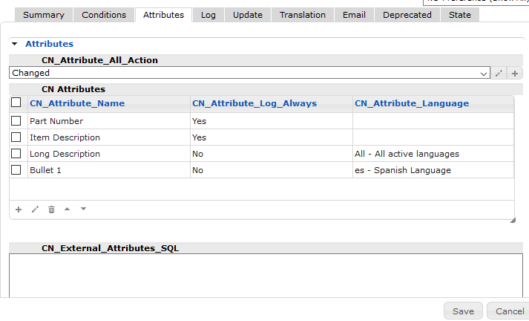
This list of attributes excludes the multi-language attributes to be processed for language translation – these attributes are defined in the named CN_Translation_Registry record.

CN_Attribute_All_Action - Specifies the action to be taken on all attributes in the repository. This eliminates the need to list every attribute in the CN_Attribute_Name attribute. If a new attribute is added to the repository, it will automatically be included:
- Changed – take action on a change being made to any attribute in the repository but only log attributes that have actually changed. If specific attributes should always be logged, they must be listed in the CN_Attribute_Name list with the corresponding CN_Attribute_Log_Always set to Yes.
- Changed with Multi-Language – take action on a changed being made to any attribute in the repository including the non-default Multi-Language extensions.
- Log Always – log the values of each attribute in the repository. If this option is set, at least one attribute must be specified in the CN_Attribute_Name list to trigger the notification processing.
- Log Always with Multi-Language – log the values of each attribute in the repository including all active language extensions for Multi-Language attributes. If this option is set, at least one attribute must be specified in the CN_Attribute_Name list to trigger the notification processing.
CN_Attribute_Name - The attribute CN_Attribute_Name identifies each attribute to be monitored or logged. Changes to attributes not in this list will be ignored unless CN_Attribute_All_Action is set.
CN_Attribute_Log_Always - Specifies whether the corresponding attribute in the CN_Attribute_Name list is always logged (if other attributes in the list have changed) or only when there is a change. If the log always attribute has not changed, the Old Value and New Value will be the same.
CN_Attribute_Language – Optionally defines the language extension for each attribute being monitored (if it is not the default language) for multi-language attributes. For example, to monitor changes to the Spanish version of Long Description, the CN_Attribute_Language would be set to “es”. The “All” option indicates that all active languages are to apply. Unless the CN_Attribute_All_Action attribute is set to “Changed with Multi-Language” or “Log Always with Multi-Language”, the only way to trigger or log non-default language values is by explicitly listing the attribute and language extension (with All indicating all active languages should be included):
CN_External_Attributes_SQL – Optional SQL Statement that returns a single row of additional data (from other repositories) that is connected to the changed record. Each column in the SELECT statement is captured and logged as additional attributes. This allows for contextual information to be recorded at the time of the original record was changed since retrieving the linked values at report time may be different from when the original change was logged.
The SQL statement may contain any valid SQL for a SELECT query. Data from the changed record can be included in the statement through named references (denoted by the attribute name surrounded by double pipe-characters). These references are resolved before the SQL statement is executed. If the value needs to be treated as a character value in the query, it must be surrounded by single quotes.
For example, if the Enable data model has a Product repository linked to an Item repository by an alphanumeric ID and changes to Item records need to record the Product Group Name (from the Product record), the following SQL can be used to retrieve that information:
SELECT Product_Group_Name FROM _PIM_Product_Staging WHERE Product_ID = '||Product ID||'

All external attributes will show the same value for the Old and New values in the log.
If the name of a column in the query matches the name of an attribute in the monitored repository, the external attribute should be aliased to something unique. For example, if the Product repository and the Item repository both have a “Publication Status” attribute and both need to be logged, the SQL statement must alias the attribute:
SELECT Publication_Status as [Product Publication Status], Product_Group_Name FROM PIM_Product_Staging WHERE Product_ID = '||Product ID||'

If the SELECT statement may return more than one row, only the first record retrieved will be used – the subsequent records will be ignored. If the values of the field(s) being retrieved may be different, the SQL must be structured such that the value from the desired record is returned first in the results.
In addition to referencing any attribute in the monitored repository, the SQL may also contain the date and time stamp of when the change was made by specifying the reserved reference ||CURRENT_DATETIME||. This is resolved to the current date and time in the format yyyyMMddHHmmssSS. Alternative formats can be specified by using the Java class SimpleDateFormat’s notation. For example, to only include the date in mm/dd/yyyy format, the reference must be ||CURRENT_DATETIMEMM/dd/yyyy||.

Log Tab
The Log tab controls whether changes are logged to the CN_Log repository:
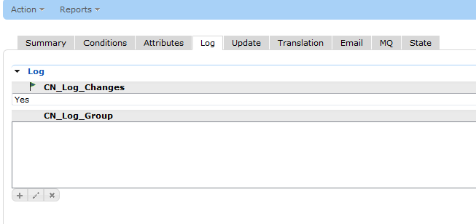
CN_Log_Changes - Specifies changes are to be logged to the CN_Log repository if Yes.
CN_Log_Group - Lists the applicable groups for which the changes are to be logged. If the user is not a member of any of the specified groups, the change is not logged. If left blank, then all changes are logged, regardless of who made the change.
CN_Log_In_Sync_Only – Change events are logged to the CN_Log repository only when the Staging record is in Sync with Production if Yes. This has the effect of only logging the set of changes when the Staging record is promoted to Production. Normally the log messages are placed in the queue when changes are made to the Staging repository records and are soon dequeued and added to the CN_Log repository. Since the Change Notification cannot operate on Production repositories (due to triggers not being invoked during the promotion operation), delaying the dequeue and logging of change events provides a method of logging and reporting changes made to a promoted record. When a Staging record is promoted to production, its Record State will be changed to In Sync. At that point, any queued change events will be logged to the CN_Log repository. The next time a report export runs, it will pick up all of the changes made to the Production record since the last promotion. This assumes that the reporting is run after each promotion.
If a scheduled export is set up as a delta export on the CN_Log repository for events associated with the delayed sync option, all of the changes made to the record (with the final ones in the batch of records reflecting the final values) in the Production repository. The following table visually illustrates the events over a period of time:
Event | Sync State | Change Notification Queue Dequeue Action | Attr A Old Value | Attr A New Value | Attr B Old Value | Attr B New Value | Production Report Attr A Old Value | Production Report Attr A New Value | Production Report Attr B Old Value | Production Report Attr B New Value
Record in Sync with Production | In Sync | Dequeue | one | one | a | a | one | one | a | a
Update Staging | Not In Sync | Hold | one | two | a | a
Update Staging | Not In Sync | Hold | two | three | a | b
Update Staging | Not In Sync | Hold | three | four | b | b
Promote to Production | In Sync | Dequeue |  |  |  |  | one | four | a | b
Update Staging | Not In Sync | Hold | four | five | b | c
Update Staging | Not In Sync | Hold | five | six | c | c
Promote to Production | In Sync | Dequeue |  |  |  |  | four | six | b | c

As the table shows, once a record in Staging has been modified, it’s sync status indicates not in-sync with Production. Any changes made to the staging record that are queued to the Change Notification log would remain in the queue until the record is promoted. Once the record is promoted, all the queued change events would be dequeued and inserted into the CN_Log repository.
The Change Notification dequeue operation (which is launched every 5 minutes by default) is expected to run frequently enough that there would not be time for a staging record to have subsequent changes after it has been promoted, which would prevent the pending records from being dequeued.
Once the records have been stored in the CN_Log repository, a SQL-based delta export can extract the old value from the oldest new record and the new value from the newest new record for a given attribute to obtain an accurate picture of the changes of the records in Production since the last report was generated.
In order for all changes for a promoted record to be logged, it is essential that the Staging record not be modified before the dequeue operation has been able to retrieve all of the queued events for the record. This is best accomplished by either having the promotion operation run after normal business hours.
If a Staging record is promoted to Production multiple times during a single reporting period, the report will not identify the specific changes that were made for each promotion, only the changes made for all promotions since the last report was generated. If there is a requirement to report the changes for each promotion, the report must be run after each promotion (allowing sufficient time for all queued changes to be dequeued and logged).

Update Tab
The Update tab specifies any attributes in the changed record that are to be updated to specified values:
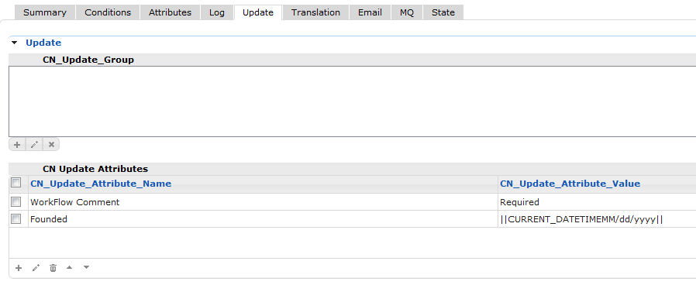
CN_Update_Group – List of Groups to which an update would be applicable if the user who triggered the change is a member of one or more the specified groups. If the user is not a member of any group, the update does not occur. If no groups are specified, then the update occurs for all users.
CN_Update_Attribute_Name - List of attributes in the changed record to be updated on change. This must exactly match the name (including case) in the repository.
CN_Update_Attribute_Value - The value to change the corresponding attribute. The value can be a literal (e.g., setting the attribute “Review Record” to “Yes”) a field reference (surrounded by double pipe-characters) or a combination of the two. The following field references can be specified:
Reference | Description
||<attributeName>|| | Replaced by the value of the specified attribute
||<attributeName>_NEW_VALUE|| | Replaced by the new value for the specified attribute.
||<attributeName>_<langExt>_NEW_VALUE|| | Replaced by the new value for the specified non-default multi-language attribute for the specified language extension.
||<attributeName>_OLD_VALUE|| | Replaced by the old value for the specified attribute
||<attributeName>_<langExt>_OLD_VALUE|| | Replaced by the old value for the specified non-default multi-language attribute for the specified language extension.
||CURRENT_DATETIME[<format>]|| | Replaced by the current date and/or time. The default format is MM/DD/YYYY HH:MM:SS. Any valid SimpleDtetimeFormat can be specified between “CURRENT_DATETIME” and the ending double-pipe characters. For example, to return just the date with no punctuation: ||CURRENT_DATETIMEyyyyMMdd||
||CHANGED_BY|| | Replaced by the login ID of the user who made the change.
||CHANGE_LIST_<delimiter>|| | Builds a delimited list using the specified delimiter character of the names of the attributes that have changed. This reference can only be used in an Update list. It is assumed the target attribute will contain a delimited list of attribute names that were previously changed since the last reset-event.  A pipe delimiter must be specified as “PIPE” and the comma delimiter must be specified as “COMMA”.  If the target attribute already has a value, the new attributes are added to the list if not already present. The attribute should be cleared when the appropriate event occurs, such as a Delta Export of changed records.  For example, to build a tilde-delimited list, specify: ||CHANGE_LIST_~||. To build a comma-delimited list, specify: ||CHANGE_LIST_COMMA||. To build a pipe-delimited list, specify: ||CHANGE_LIST_PIPE||.
||CHANGE_LIST_RESTRICTED_<delimiter>|| | Same as CHANGE_LIST_<delimiter> except the list contains the restricted names for the attributes.

Transformation Tab
The Transformation tab identifies the transformations that are to be performed in association with the registered change event.
CN_Transformation_Name - Identifies the CN_Transformation_Registry entry to be processed. The drop-down selection list will show all defined CN_Transformation_Registry record names, which means the transformation registry records need to be created first. Multiple transformations may be identified on this tab – each named transformation will be processed independent of any other in the same Change_Notification_Registry record. For example, if three transformations are named and the first has no conditions met for performing any transformation, the other two will still be processed. Each named transformation may have a different target repository record that differs from the record that triggered the change event, which merely identifies when the set of transformations are to be performed. If a transformation target is a different repository record, it must be associated to the triggered record (i.e., it must be linked).

Translation Tab
The Translation tab identifies whether language translation is to be performed for changes to the record and identifies the translation registry entry to be used:
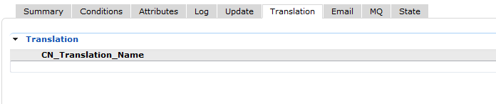
CN_Translation_Name - Identifies the CN_Translation_Registry entry to be processed. The drop-down selection list will show all defined CN_Translation_Registry record names, which means the translation registry record needs to be created first.

Email Tab
The Email tab specifies whether a notification e-mail should be generated and to whom it should be sent and what it should contain:
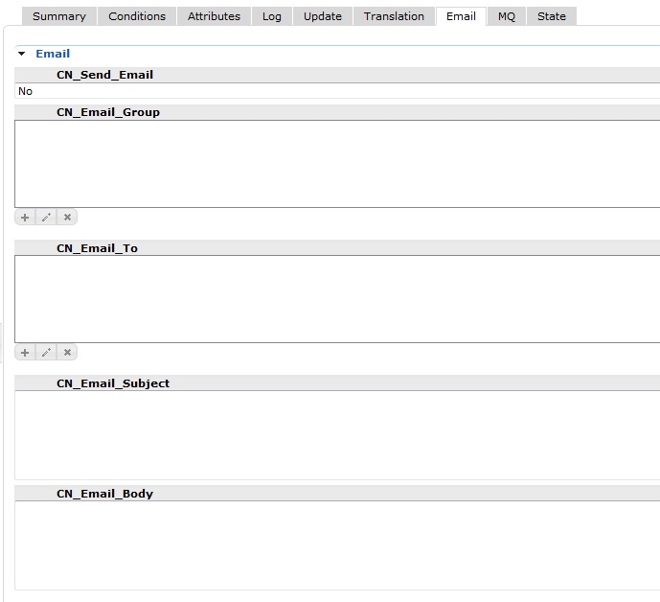
CN_Send_Email - Specifies e-mail notification should be sent if Yes
CN_Email_Group - Lists the groups to which the user making the change must be a member in order for an e-mail to be sent. If the list is empty then the e-mail will be sent regardless of who made the change.
CN_Email_To - List of e-mail addresses to which the e-mail is to be sent.
CN_Email_Subject - Subject line for the e-mail.
CN_Email_Body - Message body in the e-mail.
The To, Subject and Body fields can have literal text, references to attributes surrounded by double-pipe characters. They can also include special fields including the ones defined under the Update Tab as well as the ones below.
- CHANGE_DETAIL_PLAIN – replaces the reference with the list of changes in the format:
<attribute1Name>: old=<oldValue>, new=<newValue>;<attribute2Name>: old=<oldValue>, new=<newValue>

- CHANGE_DETAIL_CSV – replaces the reference with a CSV-formatted list:
<attribute1Name>,<oldValue>,<neValue>
<attribute2Name>,<oldValue>,<newValue>

- CHANGE_DETAIL_HTML – replaces the reference with a block of HTML table rows:
<tr><td><attribute1Name></td><td><oldValue></td><td><newValue></td></tr>
<tr><td><attribute2Name></td><td><oldValue></td><td><newValue></td></tr>

The HTML reference should be surrounded by <table></table> tags as well as <html></html> tags. By default the generated e-mail is in plain text unless the body contains the literal value “<html>” then HTML formatting will be processed.

For example, the following CN_Email_Body value:
<html>
<pre>
The Product Group with ID=||Product Group ID|| has the following changes: ||CHANGE_DETAIL_PLAIN||

In CSV Form:

Attribute Name,Old Value,New Value
||CHANGE_DETAIL_CSV||
</pre>

In HTML Form:
<table border="1">
<tr><th>Attribute Name</th><th>Old Value</th><th>New Value</th></tr>
||CHANGE_DETAIL_HTML||
</table>
</html>
Produces the following e-mail message:
The Product Group with ID=9916 has the following changes: Prod Grp Hdr: old=Oil Burner Combustion Test Kit, new=Oil Burner Combustion Test Kits; Prod Grp Subhdr: old=headers here, new=headers here with more text; Applications: old=apps here, new=applications list here; Specifications: old=specs here, new=specifications; Features: old=features here, new=list of features

In CSV Form:

Attribute Name,Old Value,New Value
Prod Grp Hdr,Oil Burner Combustion Test Kit,Oil Burner Combustion Test Kits
Prod Grp Subhdr,headers here,headers here with more text
Applications,apps here,applications list here
Specifications,specs here,specifications
Features,features here,list of features

In HTML Form:
Attribute Name | Old Value | New Value
Prod Grp Hdr | Oil Burner Combustion Test Kit | Oil Burner Combustion Test Kits
Prod Grp Subhdr | headers here | headers here with more text
Applications | apps here | applications list here
Specifications | specs here | specifications
Features | features here | list of features

Email messages generated in rapid succession with the same recipient list and subject line may be combined into a single e-mail message with the contents of the message bodies concatenated into a single body.
In general, it is recommended to only use e-mail notification when the frequency of change is relatively low.

CN_Log Repository
If logging is enabled for one or more registered change notification, records will be produced in the CN_Log repository for each attribute that has changed (or is designated to be displayed alongside a change):
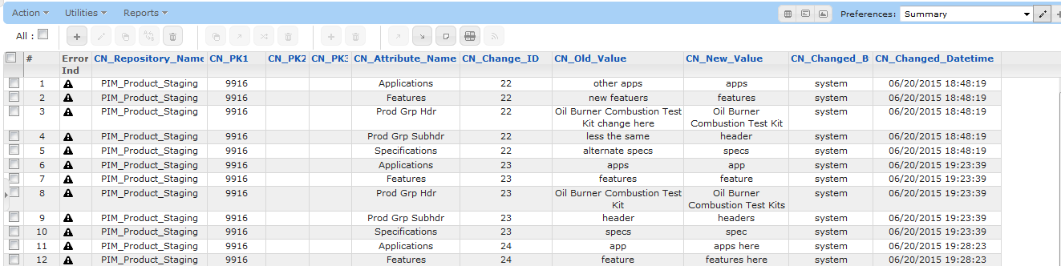
The following table provides detailed information on each attribute in this repository:
Attribute Name | Description
CN_Attribute_Language | Identifies the language for which the change was made if the attribute is multi-language, otherwise blank.
CN_Attribute_Name | Name of the attribute that was modified, or specified to be logged always or derived from an external repository.
CN_Change_ID | Sequential ID of a specific change. If more than one monitored/logged attribute was changed, all will share the same change ID.
CN_Changed_By | Login name of the user who initiated the change.
CN_Changed_Datetime | Date and time of when the change was made.
CN_Internal_Record_ID | Internal ID of the record that was changed. This value can be used when performing SQL queries to retrieve current data from the record.
CN_Log_ID | Unique ID for each CN_Log record.
CN_New_Value | The current or new value for the attribute (at the time of the change).
CN_Old_Value | The previous value for the attribute. For “allways log”attributes that have not changed as well as external attributes, the old and new values will be the same.
CN_PK1, CN_PK2, CN_PK3, CN_PK4, CN_PK5 | Primary key for the modified record. The number of key fields defined depends on the repository. Many repositories will only have a value in the first key field.
CN_Registry_ID | ID of the CN_Registry record that was used to log the change.
CN_Repository_ID | Internal ID of the repository in which the record was changed.
CN_Repository_Name | Name of the repository in which the record was changed.

Reporting Using Scheduled Exports
Detailed reports can be generated from the CN_Log repository contents using the View (SQL) type of Scheduled Export. The SQL for the export can pull information from the Change Notification Registry and Log repositories as well as from any other repository to include contextual information:
The complexity of the reporting is limited to the complexity of the SQL SELECT statement or Stored Procedure that is defined to generate that report.
For example, to generate a report that includes key business fields for each change row: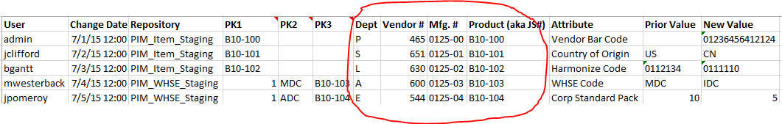
Those attributes are first defined in the Change Notification Registry as Log Always:
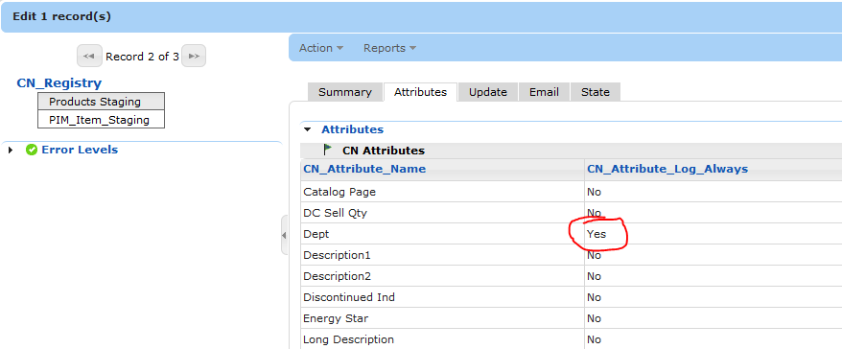
The Change Notification log will include those attributes and their values for each logged change:
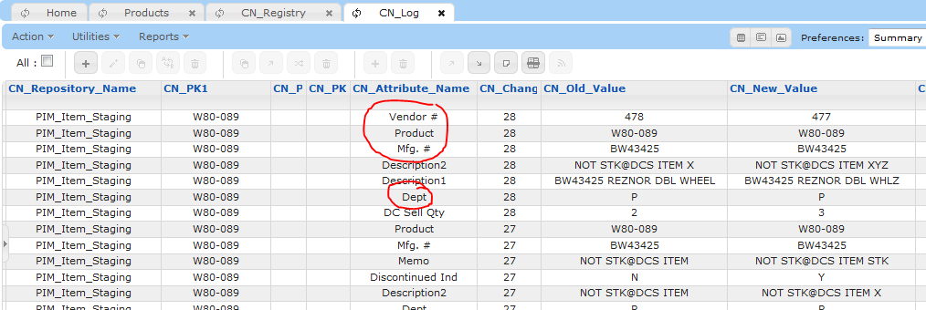
Then using the PIVOT function in SQL Server, these entries can be converted to columns in the report:
select l.CN_Changed_By as [User], CN_Changed_Datetime as [Change Date], CN_Repository_Name as Repository,
CN_PK1 as PK1, isnull(CN_PK2, '') as PK2, isnull(CN_PK3, '') as PK3,
isnull(c.Dept, '') as Dept, isnull(c.[Vendor #], '') as [Vendor #],
isnull(c.[Mfg. #], '') as [Mfg. #], isnull(c.Product, '') as [Product (aka JS#)],
CN_Attribute_Name as Attribute, isnull(CN_Old_Value, '') as [Prior Value], isnull(CN_New_Value, '') as [New Value]
from CN_Log l
left outer join (Select CN_Change_ID, Dept, [Vendor #], [Mfg. #], Product from
(SELECT CN_Change_ID, CN_Attribute_Name, CN_New_Value
FROM (select CN_Change_ID, CN_Attribute_Name, CN_New_Value
from CN_Log where CN_Attribute_Name in ('Dept','Vendor #','Mfg. #','Product')) e
) AS X
PIVOT
(
MAX (CN_New_Value)
FOR CN_Attribute_Name IN (Dept, [Vendor #], [Mfg. #], Product)
) AS PivotTable) c
on c.CN_Change_ID = l.CN_Change_ID
where not (l.CN_Attribute_Name in ('Dept','Vendor #','Mfg. #', 'Product') AND l.CN_Old_Value = l.CN_New_Value)
order by l.CN_Change_ID, CN_Attribute_Name

The above SQL query creates a pivoted table containing the data from only the change records for the attributes: Dept, Vendor #, Mfg. #, and Product. This data is joined to the main log by the Change ID. The same entries are excluded from the main entry unless they have been changed. This results in each row of the report representing a changed value:
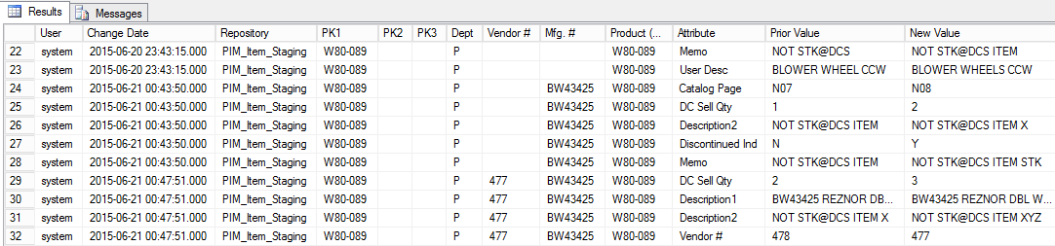
To produce a delta report, showing only the changes since the previous report, the SQL must include the condition comparing the Created column to the [DELTA_DATETIME] field:
where not (l.CN_Attribute_Name in ('Dept','Vendor #','Mfg. #', 'Product') AND l.CN_Old_Value = l.CN_New_Value)
and l.Created > '[DELTA_DATETIME]'

Transformation Extension

Overview
The Transformation Extension functionality leverages the Change Notification functionality to facilitate conditionally updating attributes in the changed record or other record(s) that are linked to the changed record, using values from the changed record or from another record that is linked to the changed record. The Transformation definitions are intended to be managed by business users and not require programming skills. Basic knowledge of SQL queries is a key requirement for accessing or updating records linked to the changed record.
Each named Transformation is referenced by a CN_Registry entry that activates it. One or more records are defined in the CN_Transformation_Registry

CN_Transformation_Repository
The CN_Transformation repository contains the transformation rules for one or more CN_Registry record. Each record in this repository represents a single condition on a rule for a transformation. Multiple conditions may be defined for a single rule and multiple rules may be defined for a single Transformation.

Summary Tab
CN_Transformation_Name – name of the transformation. This must match the CN_Transformation_Name value in a CN_Registry entry. All records in the CN_Transformation_Registry repository having the same CN_Transformation_Name will be processed together whenever a repository record is changed for which a CN_Registry record applies AND that record references the Transformation by this name.
CN_Transformation_Description – optional description for the transformation. Likely to be defined only the first record for the Transformation but may have different values for each record to clarify the transformation rule or condition
CN_Transformation_Rule_Name – name of the transformation rule. Multiple CN_Transformation records may identify the same rule for the same Transformation. Multiple rules may be defined for the same Transformation.
CN_Transformation_Rule_Sequence – specifies the order in which the transformation rules are processed. This is only important if the Transformation_Rule_Exclusive is Yes.
CN_Transformation_Rule_Exclusive – indicates the transformation rule is exclusive if Yes. Each exclusive rule will only be processed if no previous transformation rule for the same transformation has its conditions met. Each rule that is not exclusive will always be applied, regardless of whether any previous rule has its conditions met. Only one exclusive transformation rule will be processed for a given Transformation and given change event. The Transformation_Rule_Sequence can be used to force the processing of exclusive rules before any non-exclusive rules in case there is a dependency. The sequence can also be used in cases where some conditions may be common to multiple rules, but some rules have additional conditions being sequenced first.
For each rule for which the conditions are met, log the details of the rule that was applied to the log file and perform the update(s) identified by the corresponding Target settings.

Target Tab
CN_Target_Repository – identifies the target repository to be updated if the Transformation rules determine any changes should be made. This will typically be the same repository identified in the CN_Registry entry that invokes this transformation. If the target repository is not the same, there must the specific record(s) to be updated must be identified by either the CN_Target_Link Rrelationship or CN_Target_SQL attribubtes.
CN_Target_Link_Relationship – (FUTURE – NOT YET IMPLEMENTED) optional name of the link relationship that is to be used to identify the target record. Can be blank if the Target_Repository is the same as the repository specified in the CN_Registry record invoking this transformation. If the target repository is not the same, the Target_Link_Relationship must be specified
CN_Target_SQL - SQL expression linking the Target record to the change event repository record (as an alternative to referencing the link relationship). The SQL must return the InternalRecordID of the record. If the query returns references to multiple records (i.e., multiple result rows), each referenced record is to be updated according to the Target_Attribute_Name and Target value.
CN_Target_Attribute_Name – name of the target attribute to be updated by the transformation. This attribute will only be updated if the new value does not match the current value
CN_Target_Value_Literal – specifies the value for the target attribute if the transformation rule conditions are met. Must be blank if the target value is to come from an attribute in a linked record
CN_Target_Value_Source_Repository – name of the repository containing the target value to be used. This repository must either be the same as the change even repository or a repository that is linked to the change event repository. Ignored if the Target_Literal_Value is not empty
CN_Target_Value_Source_Link_Relationship – (FUTURE – NOT YET IMPLEMENTED) name of the link relationship to be used to identify the record containing the target value as defined by the Target_Value_Repository and Target_Value_Attribute fields. Must be defined if the Target_Value_Repository is not the change event repository
CN_Target_Value_Source_SQL – SQL expression returning a row of data to be used as the source for the target value. A column name must match the Target_Value_Source_Restricted_Attribute (defined below). The same SQL may be defined in multiple conditions but each referencing a different column. This allows the data for multiple conditions to be returned and used for multiple conditions and rules with a single execution of the query. This SQL can return calculated values as well as columns from linked records. For example, if the target value is revising an End Date to be one day before a new record’s start date.
CN_Target_Value_Source_Restricted_Attribute– restricted name of the attribute containing the target value to be used. Ignored if the Target_Literal_Value is not empty.

Condition Tab
CN_Condition_Sequence – determines the order in which the conditions are processed when more than one condition is defined for the same rule.
CN_Condition_Group – optional name of the group of conditions in cases where combinations of AND and OR are needed. The conditions within a group are combined based on the Condition_AND_OR setting on all but the first condition in that group. The condition groups are combined by the setting of the Condition_AND_OR of the first condition of each group. Any condition that does not have a condition group assigned will be automatically part of a DEFAULT group and will be treated as though a group name was specified.
CN_Condition_AND_OR – specifies whether the condition must be met with the other conditions defined or
The conditions for a rule are handled in a consistent manner on a group by group basis, followed by the results of each group. The evaluation of the conditions in the group will have the following behavior:
- The first condition is evaluated to produce an outcome of true or false.
- If there are no other conditions in the group, this value is used as the outcome of the group.
- If there are additional conditions then the first condition outcome is assigned to the current condition outcome
- Loop for each condition
  - If the current condition outcome is true and the next condition is set to OR, it is skipped and the value defined for the first condition is returned.
  - If the current condition outcome is true and the next condition is set to AND, it is evaluated.
    - If the next condition is false, the false outcome is returned for the group
    - If the next condition is true, the current condition outcome is set to true and return to the Loop for the next condition. All conditions for the same rule must evaluate to true in order for the rule to be applied. If this is the case, the target value associated with the last condition will be used.
  - If the current condition outcome is false and the next condition is set to OR, return to the Loop for the next condition
  - If the current condition outcome is false and the next condition is set to AND, the false outcome is returned for the group.
- If all conditions have been processed, return the current condition outcome. In summary, if the conditions within a group are combined with OR, the first condition to evaluate to true will be used to identify the value for the target. If the conditions within a group are combined with AND, the last condition to be evaluated will be used to identify the value for the target (providing all conditions to evaluate to true). If multiple condition groups are defined for a rule, the same logic is applied to the outcome of each condition group.
CN_Condition_Repository – name of the repository containing the attribute containing the value to be tested for the condition
CN_Condition_Link_Relationship – (FUTURE – NOT YET IMPLEMENTED) name of the link relationship if the Condition_Repository is different than the change event repository
CN_Condition_SQL - SQL expression returning the value to be applied to the left-side of the condition. The SQL should identify a record that is linked to the change event repository record (as an alternative to referencing the link relationship). The query must return one or more columns, of which only one will be referenced by this condition (in the CN_Condition_Attribute_Restricted_Name attribute). Multiple columns should be specified if different conditions need different values from the same record as the data will be cached after the first time the SQL is executed. If multiple rows are returned, the rows after the first are ignored.
CN_Condition_Attribute – name of the attribute containing the value to be tested for the condition. Only used if the attribute is in the Trigger record
CN_Condition_Attribute_Restricted_Name – restricted name of the attribute containing the value to be tested for the condition. Only used if the Condition_Repository and Condition_Link_Relationship, or Condition_Link_SQL are defined.
CN_Condition_Operator – operator to be used to compare the specified attribute value against the condition value. Supported operators are:
- = - the attribute has the same value as the Condition_Value
- <> - the attribute does not have the same value as the Condition_Value
- > - the attribute is greater (or alphabetically higher) than the Condition_Value
- >= - the attribute is greater or equal (or alphabetically higher or equal) than the Condition_Value
- < - the attribute is smaller (or alphabetically lower) than the Condition_Value
- <= the attribute is smaller or equal (or alphabetically lower or equal) than the Condition_Value
- Is One Of – the attribute matchs one of the delimited values in the Condition_Value
- Is Not One Of – the attribute doesn’t match any of the delimited values in the Condition_Value
- Is Empty – the attribute doesn’t have a value
- Is Not Empty – the attribute has a value
- Like – the attribute matches the pattern where ‘%’ and ‘_’ are wildcards
- True – always returns true. This can be used to act as a default rule for a sequence of exclusive rules. If no other rule is met, the rule with this condition will always be
CN_Condition_Data_Type – Data type for the condition. Both sides of the condition must be of the same type. The supported types are:
- Text – the values are to be compared as text strings
- Number – the values are to be compared as numbers
- Date – the values are to be compared as date (and optional time)
CN_Condition_Value_Literal – value used in the comparison with the Condition_Attribute. If the Condition_Operator is Is One of or Is Not One Of, the value will be a delimited list.
CN_Condition_Value_Repository – name of the repository containing the record and attribute to be compared to the Condition_Attribute. Ignored if Condition_Value_Literal is set. The repository must be the same as the change event repository or be linked to the change event repository
CN_Condition_Value_Link_Relationship – (FUTURE – NOT YET IMPLEMENTED) name of the link relationship to be used to identify the record in the designated repository. Ignored if Condition_Value_Literal is set
CN_Condition_Value_SQL – SQL expression returning a row of data to be used as the source for the condition value. A column name must match the Condition_Value_Restricted_Attribute (defined below). The same SQL may be defined in multiple conditions but each referencing a different column. This allows the data for multiple conditions to be returned and used for multiple conditions and rules with a single execution of the query. This SQL can return calculated values as well as columns from linked records. For example, if the target value is revising an End Date to be one day before a new record’s start date, the SQL will include an expression that subtracts one day from the snapshot view column that contains the record’s start datae. This field is ignored if Condition_Value_Literal is set.
CN_Condition_Value_Attribute – name of the attribute to be compared to the Condition_Attribute. Only used if Condition_Value_Literal, Condition_Value_Repository and Condition_Value_Link_Relationship, or Condition_Value_SQL are not set.
CN_Condition_Value_Restricted_Attribute – restricted name of the attribute to be compared to the Condition_Attribute. Ignored if Condition_Value_Literal or Condition_Value_Attribute is set

SQL Expressions
For each of the SQL fields listed above, the SQL expression can either be one of the following:
- Full select statement, starting with “SELECT”. If the SQL is to include dynamic information from the triggered event record, values can be referenced by surrounding the attribute name with double-pipe characters. This will accommodate use cases where other Change Notification events or a trigger event on the triggered repository have modified one or more attributes that are referenced in the SQL. The SQL statement should retrieve a superset of columns such that the same SQL can be used for each target, source, or condition that access the same record. If the SQL is for a link, it must return the InternalRecordId for the record. If the SQL is for a value, it must return one more more columns which are referenced by the restricted name field.
- Stored procedure invocation, starting with “EXEC”. Dynamic information can be included as parameters to the stored procedure in the same manner as the full select statement.
- JOIN/WHERE clauses, starting with “JOIN” relies on the SELECT and FROM clauses will be generated automatically. The FROM clause will reference the snapshot view associated to the repository to which the triggered event is assigned. This view will use the alias ‘v”. To join with additional tables, the SQL should start with: “JOIN <tableOrView) v2 ON v2.<column> = v.<column>….”. If the SQL expression is to include a WHERE clause, dynamic values from the triggered record can be referenced by surrounding each attribute name with double-pipe characters.
- WHERE clause, starting with “WHERE”. The trigger repository can be referenced with the “v” alias. Dynamic values from the triggered record can be referenced by surrounding each attribute name with double-pipe characters.
Data from the changed record can be included in the statement through named references (denoted by the attribute name surrounded by double pipe-characters). These references are resolved before the SQL statement is executed. If the value needs to be treated as a character value in the query, it must be surrounded by single quotes.
For example, if the Enable data model has a Product repository linked to an Item repository by an alphanumeric ID and changes to Item records need to record the Product Group Name (from the Product record), the following SQL can be used to retrieve that information:
SELECT Product_Group_Name FROM _PIM_Product_Staging WHERE Product_ID = '||Product ID||'

In addition to referencing any attribute in the monitored repository, the SQL may also contain the date and time stamp of when the change was made by specifying the reserved reference ||CURRENT_DATETIME||. This is resolved to the current date and time in the format yyyyMMddHHmmssSS. Alternative formats can be specified by using the Java class SimpleDateFormat’s notation. For example, to only include the date in mm/dd/yyyy format, the reference must be ||CURRENT_DATETIMEMM/dd/yyyy||.

Example Transformations
The following sections provide examples of common transformations.

Rollup Attribute
When a search is performed on a repository, Enable can only search on attributes in that repository or in linked repositories one “jump” away from the repository of interest. This means it is sometimes necessary to replicate data that is in a related repository of interest that is two or more jumps away into an adjacent repository, or even into the repository being searched. If the nature of the data is one-to-many where the repository of interest is the “one” and the related repository of interest is the “many”, the different values in the “many” records need to be rolled-up into a single value and stored in a reachable repository. The rollup-attribute needs to be updated any time the data in the “many” records is changed. For thoroughness, the rollup-attribute can also be updated any time the record storing the value is changed (and the computed rollup value differs from the actual rollup value).
For this example, the data model has two repositories: PRODUCT_Staging and PRODUCT_Variant_Staging. There is a one-to-many relationship between PRODUCT_Staging (one) and PRODUCT_Variant_Staging (many). The PRODUCT_Variant_Staging has the attribute “Product Delivery”, which is tied to a code set. The PRODUCT_Staging repository has the attribute “Product Delivery Rollup” which must contain a delimited list of all unique Product Delivery values from the linked PRODUCT_Staging records. In order to ensure the rollup attribute is always up to date, two change notification transformations need to be defined: one on PRODUCT_Staging and the other on PRODUCT_VARIANT_Staing.
The CN_Transformation_Registry repository needs an entry for each repository to perform the transformation whenever they are invoked by their respective CN_Registry entries which are invoked any time records in the respective repositories have been created or changed:
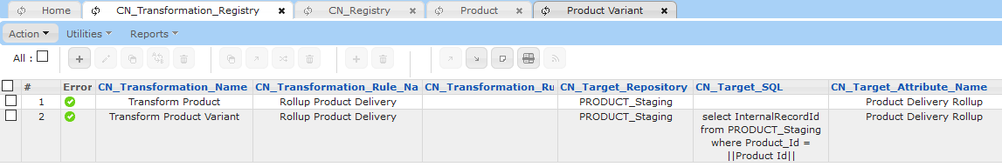
The Transform Product transformation needs to collect the unique Product Delivery values from the linked PRODUCT_VARIANT_Staging records, and then compare them to the Product Delivery Rollup value currently stored in the PRODUCT_Staging record. If the values differ, the Product Delivery Rollup attribute must be updated with the new computed value.
The target for PRODUCT_Staging is defined as follows:
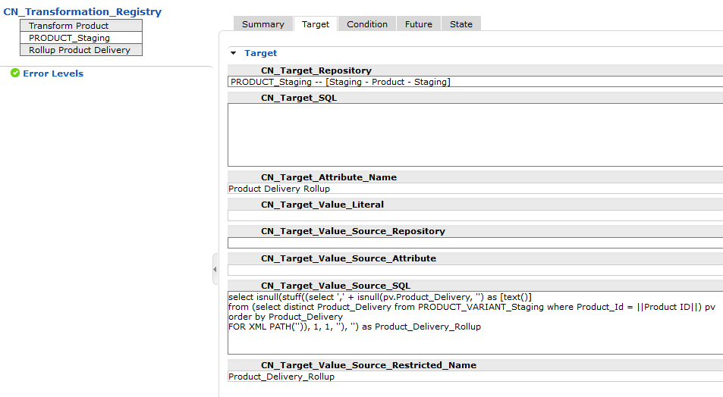
PRODUCT_Staging is identified as the CN_Target_Repository. This is the same repository that is the trigger repository. This means the target record does not have to be identified by CN_Target_SQL or CN_Target_Link_Relationship. The source value for the target is defined by a SQL query that produces a delimited list of the unique Product Delivery attributes in the linked PRODUCT_VARIANT_Staging records using the following SQL Query:
select isnull(stuff((select ',' + isnull(pv.Product_Delivery, '') as [text()]
from (select distinct Product_Delivery from PRODUCT_VARIANT_Staging where Product_Id = ||Product ID||) pv
order by Product_Delivery
FOR XML PATH('')), 1, 1, ''), '') as Product_Delivery_Rollup

The SQL query ensures only the unique values are included (distinct) and they are sorted alphabetically.
Since the update is only necessary if the calculated list of values differs from the actual list of values, the condition for the transformation rule compares the two and requires that they are not equal:
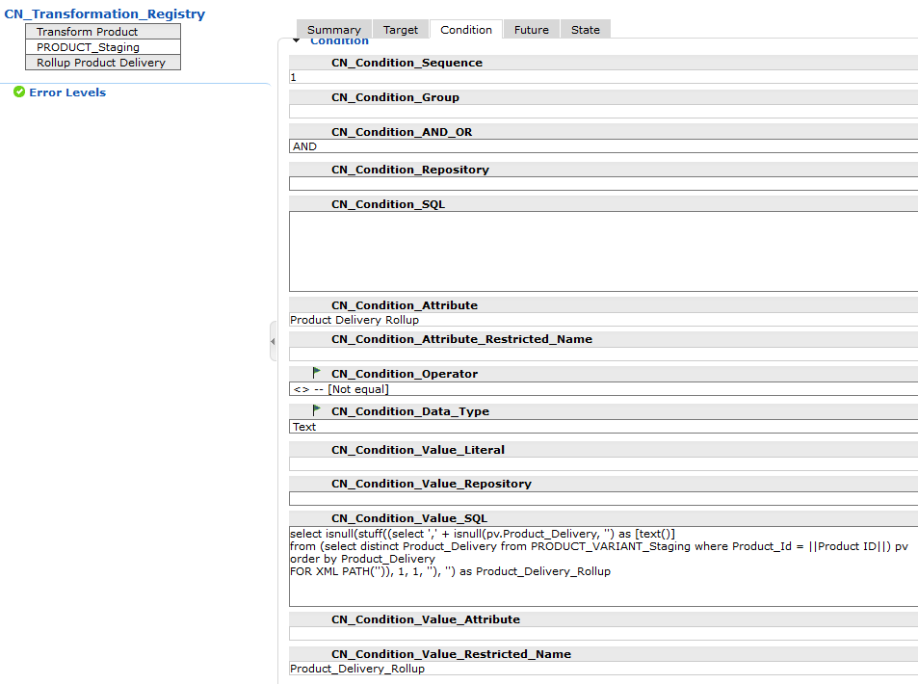
The attribute to be compared on the trigger record is Product Delivery Rollup. The value to be compared is the calculated rollup value defined by the same SQL that is used to populate the target attribute. Since the SQL for the target and condition are identical it is only executed once per event and the cached results used for the condition compare and the target value population.
The PRODUCT_VARIANT_Staging needs a similar Transformation to support the use-cases where new records are defined, existing records are linked to a different PRODUCT_Staging record, or Product Delivery is changed in an existing variant to a different value.
The target for PRODUCT_VARIANT_Staging is defined as follows:
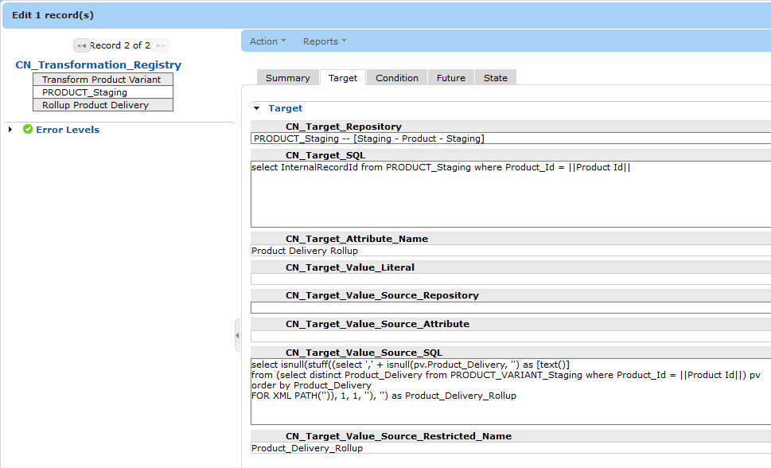
PRODUCT_Staging is identified as the CN_Target_Repository. This is the not the same repository that is the trigger repository. This means the target record has to be identified by CN_Target_SQL or CN_Target_Link_Relationship. The target PRODUCT_Staging record for the triggered PRODUCT_VARIANT_Staging record is identified by the following SQL:
select InternalRecordId from PRODUCT_Staging where Product_Id = ||Product Id||

The source value for the target is defined by a SQL query that produces a delimited list of the unique Product Delivery attributes in the linked PRODUCT_VARIANT_Staging records using the following SQL Query:
select isnull(stuff((select ',' + isnull(pv.Product_Delivery, '') as [text()]
from (select distinct Product_Delivery from PRODUCT_VARIANT_Staging where Product_Id = ||Product Id||) pv
order by Product_Delivery
FOR XML PATH('')), 1, 1, ''), '') as Product_Delivery_Rollup

The SQL query ensures only the unique values are included (distinct) and they are sorted alphabetically.
Since the update is only necessary if the calculated list of values differs from the actual list of values, the condition for the transformation rule compares the two and requires that they are not equal:
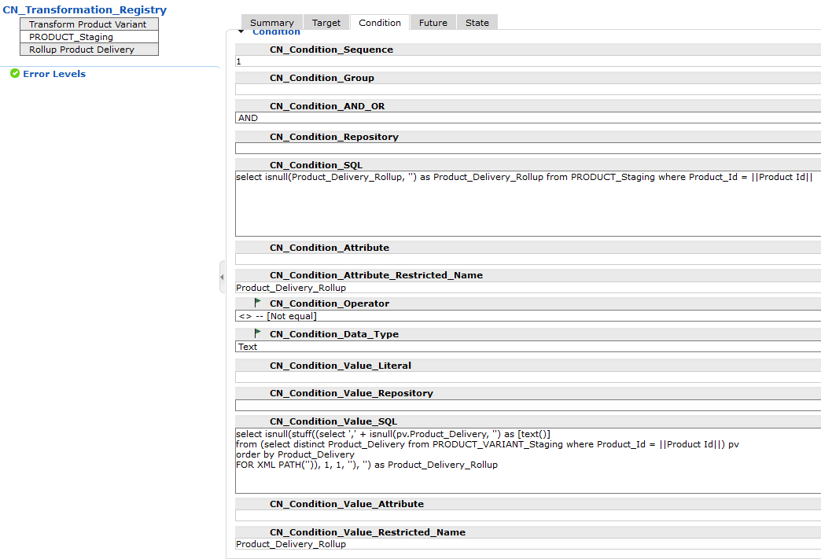
The attribute to be compared on the trigger record is Product Delivery Rollup. Since the condition attribute is not in the triggered record, it must be retrieved from the PRODUCT_Staging record using the restricted name and the following SQL:
select isnull(Product_Delivery_Rollup, '') as Product_Delivery_Rollup from PRODUCT_Staging where Product_Id = ||Product Id||

The value to be compared is the calculated rollup value defined by the same SQL that is used to populate the target attribute. Since the SQL for the target and condition are identical it is only executed once per event and the cached results used for the condition compare and the target value population.
The CN_Registry repository needs an entry for each repository to associate a triggered repository record to the appropriate Transformation:
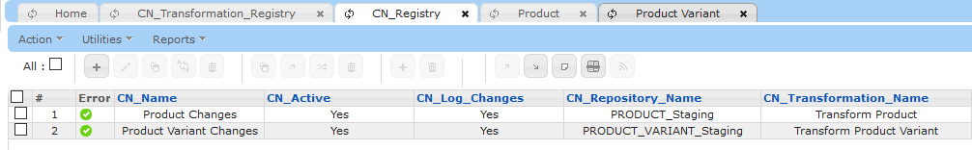
If in the future additional transformations were needed for the PRODUCT_Staging and/or PRODUCT_VARIANT_Staging repositories, more entries would be added to CN_Transformation_Registry using the appropriate value for the CN_Transformation_Name attribute.

Language Translation Extension

Overview
The Language Translation Extension functionality leverages the Change Notification functionality to facilitate having a third-party generate language translations for changes to data within Enable.
The following diagram shows the basic flow of data for the Language Translation process:
The Change Notification/Translation registry repositories identify which repositories and the attributes within the are to be translated. When a change is made to data in the Company Data Model (data repositories), a change event is generated. If this event is associated with a registered translation, a Translation Request is submitted to an internal Change Notification Translation queue.
On a periodic basis, such as nightly, a Scheduled Export is launched that retrieves the most-recent translation requests from the Change Notification Translation Queue along with optional descriptive data from the Company data and generates two files. The first file is submitted to the Translation Company via FTP (this can also be Email or Network file directory). The second file updates the Change Notification Translation Log to identify which repositories, records, and attributes have been submitted for translation.
The translation company retrieves and processes each translation file, returning a translated file to the FTP server (or network file location or configured Email address). A scheduled import retrieves each update file and pre-processes it into two import files. The first file updates the designated language attributes in the Company data repository. The second file updates the Change Notification Translation Log repository to indicate translations have been received for the requests.

Change Notification Translation Registry
The Change Notification Translation Registry repository defines the details for all language translations. A separate record must be defined for each repository requiring translation but more than one record may be defined for the same repository. The following sections provide the details for the repository attributes by tab:

Summary Tab
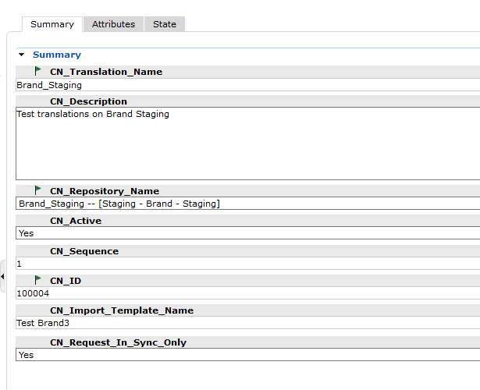
CN_Translation_Name - Name of the translation. Used to identify the translation request files sent to the translation company. Will usually match the repository name but may identify part number if multiple translations are needed due to a large number of multi-language attributes. This name must be selected on the Translation tab in a Change Notification Registry record.
CN_Description – Optional description of translation (user information only). It is strongly recommended that a detailed description be specified for better maintainability.
CN_Repository_Name - Name of repository containing the multi-language attributes to be translated. While the drop-down selection list shows all repositories defined in Enable, only the ones that have been registered with the Change Notification trigger will be processed.
CN_Active - Indicates the registry entry is active if Yes.
CN_Sequence - Sequence number to be used to control the order the registry entries are processed.
CN_ID - Sequential ID for each record.
CN_Import_Template_Name - Name of Import Template to be used to update the multi-language attributes in the designated repository. The drop-down selection list will show all import templates defined for the repository selected for CN_Repository_Name.
CN_Request_In_Sync_Only – Include only language translation request for records that have not been changed since the last time they were promoted if Yes. This ensures language translation requests are only transmitted on approved, promoted data.

Attributes Tab
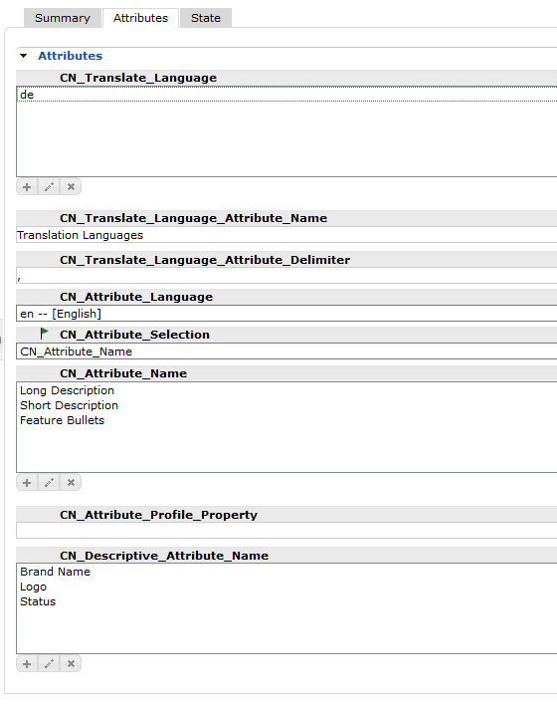
CN_Translate_Language - Delimited list of language extensions for the target languages for this translation. For example, to have the attributes translated to Spanish and French, the es and fr language extensions must be selected:
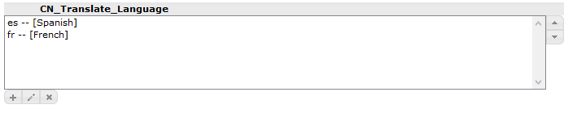
At least one language must be selected if CN_Translate_Attribute_Name is empty.
CN_Translate_Language_Attribute_Name - Name of attribute in repository containing multi-language attributes that contains a delimited list of target language extensions. This allows each record in the repository to self-identify which language translations are needed. Required if CN_Translate_Language is empty.
CN_Translate_Language_Attribute_Delimiter - Delimiter for the language values in the attribute specified by CN_Translate_Language_Attribute_Name. The default delimiter is the comma.
CN_Attribute_Language - Language extension for the source language for this translation. If blank, the default language will be used. For example, if changes to the French version of an attribute are to be translated, this attribute must be set to French.
CN_Attribute_Selection – Specifies the source selection for the list of attributes to be translated:
- All Multi-Language – translate all multi-language attributes in the designated repository
- CN_Attribute_Name – translate only the attributes listed in the CN_Attribute_Name attribute
- CN_Attribute_Profile_Property – translate only the attributes with the BOOLEAN profile property identified in the CN_Attribute_Profile_Property attribute set to a value of 1 (true).
CN_Attribute_Name – Names of the multi-language attributes to be translated. The names must exactly match (including case) the names of the attributes defined in the target repository.
CN_Attribute_Profile_Property – Name of the profile property assigned to the designated repository to be used to identify the attributes to be translated, each with a property value of 1 (TRUE)
CN_Descriptive_Attribute_Name - List of descriptive attributes to be included in translation request files.

Change Notification Translation Queue
The Change Notification Translation Queue is an Enable database table with the following columns:
Column Name | Description
seqNumber | Sequential number for each record. Primary key for table.
batchId | Set to the export job number for the queued records for a repository and language. Used to process the set of records as a batch in case additional requests are queued during the update process, which avoids overlaps (sending the same request twice) and gaps.
translationName | Name of the Change Notification Translation Registry definition used to populate this queue entry. In most cases, the translationName will likely match the repositoryName. But if the repository has multiple parts or there are different Change Notification Translation Registry definitions for the same repository (perhaps different languages are translated by different companies), the translation name would uniquely identify each translation. For example, if Brand had more than 1000 multi-language attributes, they may be split between two parts having translationName of “Brand1” and “Brand2”.
repositoryName | Name of repository for the request
internalRecordId | Internal record ID for the repository record
attributeName | Name of the attribute to be translated
oldTranslatedValue | (FUTURE) Previous translated value
newValue | New value that needs to be translated
changedby | Login of the user who changed the record containing the attribute.
changedDatetime | Date and time of when the change was made.
languageExt | Language extension for the value being translated. Implies the default languate (e.g., English) if null.
translateLanguageExt | Target language extension

When a repository record (containing multi-language attributes registered for translation) is modified, each registered multi-language attribute that was changed generates a record in this queue table. If the same attribute is changed multiple times, the queue will contain multiple records – one for each change. When these records are retrieved from the queue, only the entry with the newest date and time will be sent to the translation company. For example, if the Long Description in the Brand repository is registered for translation, and the Enterworks brand description is changed to “Enterworks”, then “Enterworks Incorporated”, and finally “Enterworks Acquisition, Inc.” all in the same day, the export for Brand will only include the “Enterworks Acquisition, Inc.” value. The same changes were made over successive days (and the export is scheduled to run once per day), each change will have been sent to the translation company. If the translation company has more than a one-day turnaround, it would be responsible for either translating each value received or only translating the last value received for the same record and attribute.
The final step in the export process removes the records from the Change Notification Translation Queue table.

Change Notification Translation Log Repository
The Change Notification Translation Log repository contains the details of each language translation request and translated response. Each record in the repository represents a single language for a single attribute in a repository record. The Scheduled Exports update this repository with the details about the record, attribute, and target language, including a request status of Requested along with the date the request was sent to the translation company. The Scheduled Imports also update this repository, setting the request status to Updated along with the date the update was received. The translated value is also stored in the same record. If a specific attribute value for a specific record is changed and translated frequently, the same entry in the Translation Log repository will be updated with alternating Request Status values of “Requested” and “Updated.
Attribute Name | Description
CN_Attribute_Language | Specifies the language extension for the source attribute. Part of the primary key.
CN_Attribute_Name | Name of the multi-language attribute. Part of the primary key.
CN_Attribute_Translated_Value | Translated value from the translation company
CN_Attribute_Value | Source value for the attribute to be translated
CN_ID | Unique ID for the record. While not part of the primary key, this can be used to access specific records without having to specify all four primary key attributes.
CN_Internal_Record_ID | Identifies a record in a staging repository. Part of the primary key.
CN_PK1 | Repository primary key1 value.
CN_PK2 | Repository primary key2 value.
CN_PK3 | Repository primary key3 value.
CN_PK4 | Repository primary key4 value.
CN_PK5 | Repository primary key5 value.
CN_Repository_Name | Name of the repository. This attribute is not part of the primary key since the internal record ID uniquely identifies each record, regardless of repository.
CN_Requested_Date | Date at which a translation request was sent or a translation update was received.
CN_Request_Status | Indicates the request status for this record:  - Requested - request has been sent to the translation company  - Updated – a translation update has been received from the translation company.
CN_Translate_Language | Language extension for the target language. Part of the primary key.

When attributes have been submitted to the language translation company, they will have a request status of “Requested”:
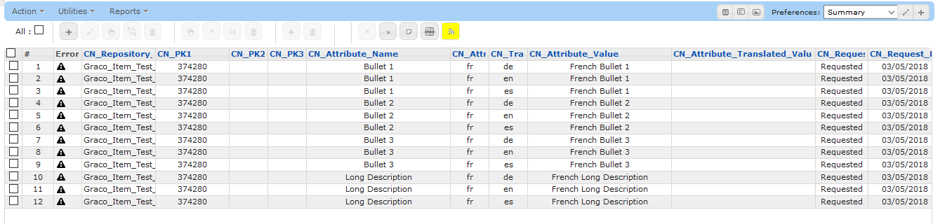
When the translation response is processed, the records are updated to show a status of “Updated” and also shows the translated values:
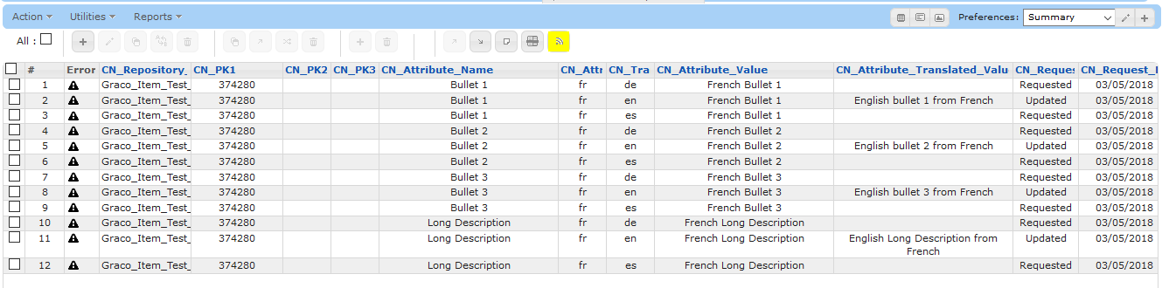

Translation Request File
The Translation Request File contains the translation requests for one or more attributes for one or more records for a specific repository. The file name does not need to follow any specific naming convention since its contents are self-identifying but it’s recommended as a best practice. Each file name should include the following information:
- Repository Name (e.g., Brand, SKU, Item, etc.). There’s no need to distinguish between Staging and Production since all translations should be performed on Staging only.

- Source Language Extension – if it’s possible for anything but the default language (e.g., English) to be translated, the source language for the file should be included in the file name (e.g., fr, sp, de, etc.)

- Target Language Extension – the extension of the target language (e.g., fr, sp, de, etc.)

- Unique Identifier – A unique identifier to make the resulting file unique (e.g., Export Job attribute value).
An example file format would be: Brand_en_fr_12345.xlsx – which would indicate the file is for the Brand repository and contain values in English to be translated to French.
The request file must have the following columns:
Column Name | Description
CN_Translation_Name | Name of the translation. This name is defined in the CN_Translation_Name column in the Change Notification Translation Registry. By using this name instead of the actual repository name, multiple translations can be defined for the same repository. For example, this may be necessary if there are multiple parts due to a large number of multi-language attributes (e.g., Brand1, Brand2, etc.)
CN_Attribute_Language | Extension of the source language (e.g., en, sp, de, etc.)
CN_Translate_Language | Extension of the target language (e.g., en, sp, de, etc.)
<primaryKeyAttribute> | One column for each primary key attribute, the the column names containing the attribute name (vs. the generic PK1, PK2, etc.). One column per attribute.
<descriptiveAttribute> | Optional descriptive attributes. Determined by the settings in the Translation Registry. One column per attribute.
CN_Attribute_Name | Name of the attribute to be translated
CN_Attribute_Value | Value that needs to be translated
Old Translated Value | [FUTURE] Current translated value for attribute (would be blank for new records).
CN_Attribute_Translated_Value | Translated value (populated by translation company)

The following sample file shows translation requests from French to English:
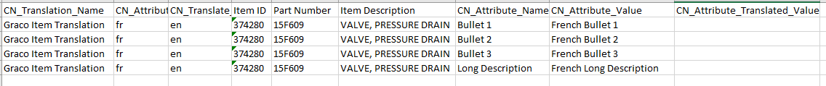
The same file format is used for the request files sent to and the translated files returned from the Translation company. The only difference between the two files is the request file will have an empty Translated Value column and the translated files will have it populated:
If a request file contains more than one multi-language attribute for the same repository record, the attributes must be in consecutive rows in the file. Otherwise the pivot pre-processing done for the translated files will contain more than one record for the same repository record, resulting in multiple updates, which includes multiple history records.
The Services Language Translation supports the translation of up to the number of multi-language attributes in a single repository determined by the following formula:
1,000 – (number_of_primary_key_attributes)
For example, if the primary key for a repository being translated contains 3 primary key attributes, then up to 997 multi-language attributes can be translated in a single group. If there are more multi-language attributes in a repository, additional imports and exports can be defined to accommodate them. Each part must be defined as a separate translation (e.g., Brand1, Brand2) having its own Translation Registry entry, Scheduled Export, and Import Template. If the multi-language attributes are category specific, the number of attributes that can be included in a single import may be further limited.

Translation Request Scheduled Export
A separate Scheduled Export must be defined for each repository and language to be translated. For example, if the Brand repository has multi-language attributes and the active languages are English (default), Spanish, French, German, and Chinese, there needs to be four Translation Request scheduled exports defined to translate from English to Spanish, French, German and Chinese. If the Item repository also contains multi-language attributes that need to be translated to the same languages, four additional Translation Request scheduled exports must be defined.
Each scheduled export invokes the SQL stored procedure CN_Generate_Translation_Request_File, passing in the following arguments:
Argument | Description
repositoryName | Name of the repository
languageExt | Extension of the source language (default if null)
translateLanguageExt | Extension of the target language
translationName | Name of the applicable translation definition in the Change Notification Translation Registry repository
batchId | A unique number (e.g., Export Job attribute value)

The following example shows the SQL for translating French to the language defined in the Export Language attribute for the language translation named: Graco Item Translation :
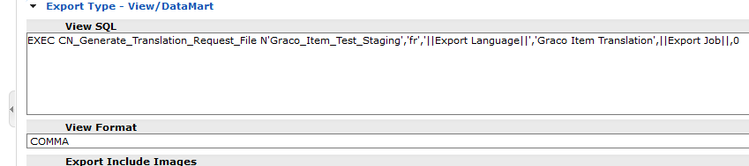
The following example shows the SQL for translating English to Spanish in a Linux/Postgres-configured Enable:

When called, the stored procedure performs the following steps:
- Tags each record in the Change Notification Transformation Queue table with matching repository, source and destination language with the batchId.
- Returns a result set of the newest translation for each attribute in each record being translated including the following data:
  - repositoryName
  - internalRecordId
  - attributeName
  - oldTranslatedValue (FUTURE)
  - newValue
  - changedby
  - changedDatetime
  - languageExt
  - translateLanguageExt
  - primary key columns as defined in the B_MASTER_REPOSITORY_ITEM repository (pk1 through pk5)
  - descriptive attributes and their values from the referenced repository record
The com.enterworks.services.changenotificaion.ProcessLanguageTranslationRequest post-processing block must be configured for each Scheduled Export. This post-processing block converts the exported file into a second file to be loaded into the Change Notification Translation Log repository. This second file contains all of the columns in the original file (described above) except for the descriptive attributes plus the request status of “Requested” and the current date for the Request Date. The post-processing block has the following configurable arguments:
Argument | Description
fileEncoding | Specifies the encoding for files. The default is UTF-8
requestFileFormat | Format for the translation request file: XLSX or CSV
logFileImportTemplate | Name of the import template used to update the CN_Translation_Log repository
logFileDirectoryName | Location of where the Translation Log import files are to be placed for processing
logFileName | Name of the Translation Log import file.

The following screen shot shows an example configuration for the ProcessLanguageTranslationRequest post-processing arguments:
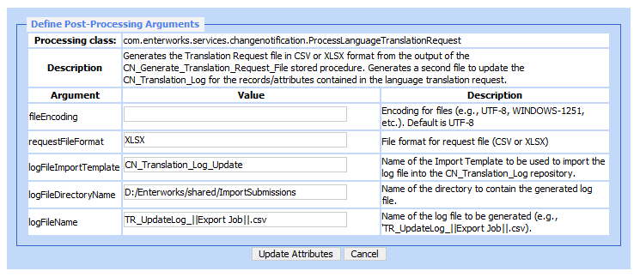
Once post-processing is complete, the original file is transmitted to the Translation Company in the manner defined in the Scheduled Export (e.g., by FTP, network file location, or e-mail). A scheduled import named “CN_Update_Translation_Log” to load the second file is launched to load the second file into the Change Notification Translation Log repository.

Translation Request Log Update Scheduled Import
The scheduled import named “CN_Request_Translation_Log” imports an update file into the Change Notification Translation Log repository. It is launched by each Translation Request Scheduled Export that completes successfully. When the referenced update file is imported, it will either create new or updating existing records in the Change Notification Translation Log repository. Once the import has completed, the Scheduled Export named “CN_Cleanup_Translation_Queue” is launched.

Translation Queue Cleanup Scheduled Export
The scheduled export named “CN_Cleanup_Translation_Queue” deletes the records in the Change Notification Translation Queue that are assigned to the batch ID passed to the export. The cleanup is handled as a separate job to facilitate troubleshooting as well as provide an opportunity to reprocess language requests if there is a failure to transmit the translation request file to the Translation Company or the update

Translation Queue Update Scheduled Import
A master Scheduled Import must be defined to pre-process all inbound translation update files. The Scheduled Import will retrieve a single file from the source (e.g., from the designated FTP server directory) then invoke the PrepareTranslationUpdate pre-processing block, which has the following arguments:
Argument | Description
fileEncoding | Specifies the encoding for files. The default is UTF-8
requestFileFormat | Format for the request file: XLSX or CSV
pivotFileDirectoryName | Fully qualified path to the directory where the pivot files are to be placed for import processing.
logFileImportTemplate | Name of the Import Template used to update the CN_Translation_Log records.
logFileName | Name of the file to update the CN_Translation_Log repository
templateScheduledImport | Name of the template Scheduled Import to be used when creating each language translation import. The contents of this Scheduled Import are copied to the Scheduled Import Jobs and the particulars (e.g., file name, language, repository name, etc.) are updated in the record before the import job is processed.

The following example shows the configuration of the ProcessLanguageTranslationResponse pre-processing:
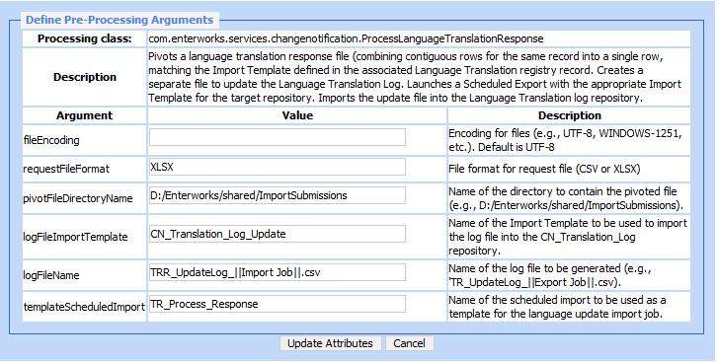
The preprocessing reads the contents of the file, identifying the associated Translation Registry entry, which identifies the repository name and multi-language attributes. The contents of the file are pivoted so that each row contains all multi-language columns for the same record. This file will be imported into the target repository for the target language identified in the file. A second file is created containing the updates for the Change Notification Translation Log repository.
The first file has the following format:
Column Name | Description
<primaryKeyAttributes> | Up to 5 primary key columns (depending upon the repository), with the column name being the actual primary key attribute names.
<multiLanguageAttributes> | One column for every attribute listed in the referenced Translation Registry record.

This second file contains:
Column Name | Description
CN_Repository_Name | Name of the repository
CN_PK1 | First primary key
CN_PK2 | Second primary key (empty if repository has only one primary key)
CN_PK3 | Third primary key (empty if repository has fewer than three primary keys)
CN_PK4 | Fourth primary key (empty if repository has fewer than four primary keys)
CN_PK5 | Fifth primary key (empty if repository has fewer than five primary keys)
CN_Attribute_Name | Name of the multi-language attribute
CN_Attribute_Language | Language extension of the source value for the attribute (empty if the default language)
CN_Translate_Language | Language extension of the target language
CN_Request_Status | Set to “Updated”
CN_Request_Date | Set to the current date.
CN_Translated_Value | Translation for the value.

Once pre-processing is complete, a Scheduled Import Job record is created and a job launched to process the target repository update file. This scheduled import job is used as the basis for the new job, but all of the appropriate attributes are updated to reflect the generated file name, target repository name, target language, and import template name. If the job is successfully launched, this import job proceeds to import the second file to update the Request Status in the corresponding records in the Change Notification Translation Log repository.
If the Import Directory Name points to a dedicated directory (i.e., not shared with other imports) and the Import File Name is set to find files matching a wildcard, the Scheduled Import will pick up the next file found in the designated directory:
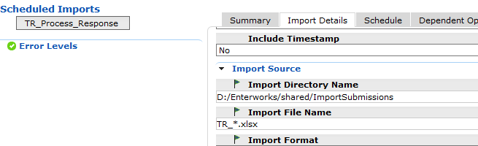
If a Dependent Operation that invokes the same Scheduled Import, then the process will be run repeatedly until all files in the source directory have been processed:
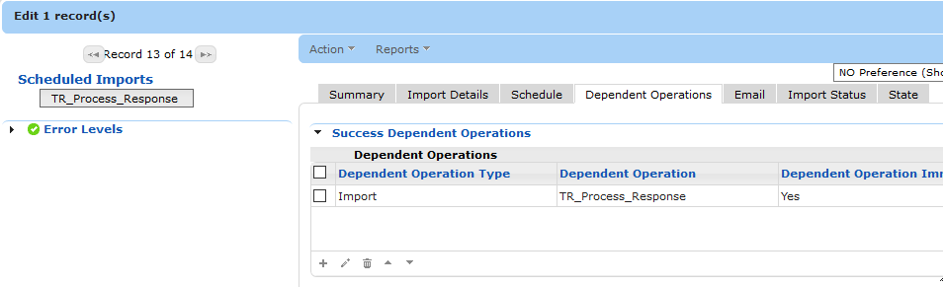

Translation Language Update Import Templates
An Import Template must be defined to update the multi-language attributes in each repository. Only one import template must be defined regardless of the number of target languages. Each scheduled import for the different target languages will reference the same Import Template for the same repository. Each import template must contain only the primary key columns (mapping PK1 through PK5 to the corresponding attributes) and the multi-language attributes. Multiple import templates must be defined for the same target repository if there is more than one Translation Registry entry for that repository, such as in cases where large numbers of multi-language attributes are broken up into multiple parts.

Reports
When the Change Notification functionality is used to log changes to the CN_Log repository, the data can be exported based on search criteria (e.g., repository, date range, etc.) without needing to use SQL. However, the resulting report will show referential attributes (i.e., attributes and their values that provide context such as key business fields, but aren’t necessarily part of the change) as separate rows in the export since they are stored that way in the CN_Log repository:
A more useful format for the report is one that includes the referential fields for each change row:
To produce the above report requires creating a View (SQL) scheduled export with a PIVOT like the following:
select l.CN_Changed_By as [User], CN_Changed_Datetime as [Change Date], CN_Repository_Name as Repository,
CN_PK1 as PK1, isnull(CN_PK2, '') as PK2, isnull(CN_PK3, '') as PK3,
isnull(c.Dept, '') as Dept, isnull(c.[Vendor #], '') as [Vendor #],
isnull(c.[Mfg. #], '') as [Mfg. #], isnull(c.Product, '') as [Product (aka JS#)],
CN_Attribute_Name as Attribute, isnull(CN_Old_Value, '') as [Prior Value], isnull(CN_New_Value, '') as [New Value]
from CN_Log l
left outer join (Select CN_Change_ID, Dept, [Vendor #], [Mfg. #], Product from
(SELECT CN_Change_ID, CN_Attribute_Name, CN_New_Value
FROM (select CN_Change_ID, CN_Attribute_Name, CN_New_Value
from CN_Log where CN_Attribute_Name in ('Dept','Vendor #','Mfg. #','Product')) e
) AS X
PIVOT
(
MAX (CN_New_Value)
FOR CN_Attribute_Name IN (Dept, [Vendor #], [Mfg. #], Product)
) AS PivotTable) c
on c.CN_Change_ID = l.CN_Change_ID
where not (l.CN_Attribute_Name in ('Dept','Vendor #','Mfg. #', 'Product') AND l.CN_Old_Value = l.CN_New_Value)
order by l.CN_Change_ID, CN_Attribute_Name

To produce a delta report, showing only the changes since the previous report, the SQL must include the condition comparing the Created column to the [DELTA_DATETIME] field:
where not (l.CN_Attribute_Name in ('Dept','Vendor #','Mfg. #', 'Product') AND l.CN_Old_Value = l.CN_New_Value)
and l.Created > '[DELTA_DATETIME]'

There may also be use cases (such as the one described in the first section) where a report needs to extract the first old value and the last new value for each attribute from the CN_Log entries that have been created since the last time the report ran. Generating such a report increases the complexity of the required SQL query.
The proposed solution provides a user-configurable Change Notification report capability where only the contents and characteristics of the report need to be specified and no SQL is required.

This report capability would be accomplished using a new repository (CN_Report_Registry) in which reports would be defined and a Scheduled Export of Custom with a new Post-Processing module selected and configured.

Report Registry Repository

The Cn_Report_Registry repository will have the following attributes:

Attribute | Description | Example For Above Report
CN_Name | Name of the report | Product Changes
CN_Description | Optional description for the report | Generates a detailed delta report of the product changes by Department, Vendor Number, Manufacturer Number and Product
CN_Registry_Name | Name of the CN_Registry to which this report is assigned. Only changes logged by this CN_Registry record will be included.  . | Log Product Changes
CN_Recipients | Comma-delimited list of groups identifying the users who will receive the reports via e-mail | Business Manager
CN_Owner_Attribute | Name of the attribute that is associated with a code set that contains ownership by group. Each value in this attribute determines how many different report files are generated and who sees them. | <not defined>
CN_Current_Attributes | Comma-delimited list of attributes to be retrieved from the current records to be included in the report as separate columns. If it’s necessary to report the values at the time the change was made, the attributes must be assigned to CN_Descriptive_Attributes. Any attributes listed here will be ignored in the CN_Descriptive_Attributes and CN_Change_Attributes lists.
CN_Descriptive_Attributes | Commad-delimited list of the attributes that were logged at the same time as the attributes of interest were changed but to be shown as separate columns in the report. Attributes included in this list will be ignored in the CN_Change_Attributes list | Dept, Vendor #, Mfg #, Product
CN_Change_Attributes | Comma-delimited list of the attributes to be reported when there’s a change (or ALL for all logged attributes).

Scheduled Export Post-Processing Configuration
For each registered reporting period (e.g., daily vs. weekly), a Scheduled Export must be defined. The Scheduled Export is configured as type Custom and invokes the ChangeNotificationReport Post-Processing Module. This post-processing module uses its configuration and the data in the referenced CN_Report_Registry entries to generate the necessary Scheduled Export jobs, each of which will generate on file for one of the named reports for a specific owner group (if specified or just one report if not specified). This post-processing module will have the following settings:

Argument | Description | Example
reportType | Specifies the type of report (CSV, XLSX) | CSV
reportDelimiter | For CSV reportType, specifies the delimiter. COMMA for comma (default) | COMMA
fileEncoding | Encoding for the file (default is UTF-8) | UTF-8
reportNames | Comma-delimited list of the CN_Report_Registry records to be processed. This | Item_Staging_Report, WHSE_Staging_Report
deltaExport | Generate a delta export if Yes | Yes
reportStartDatetime | Starting time for report if deltaExport is No. Blank if delta or older records to NOT be excluded | <blank>
reportEndDatetime | Ending time for report if deltaExport is No. Blank if delta or newest records to NOT be excluded | <blank>

The individual jobs launched by the ChangeNotificationReportManager post-processing module will invoke a

On-Demand Launch of Report
For On-Demand reports, a launch page will be provided that allows the user to select the report, date range (required), and target (file location, or e-mail address). If the e-mail address is specified as the target and the address is set to “ALL”, then all intended recipients (per the logic provided above) will receive the e-mails for each report.
The Report Launch Page would appear like the following:
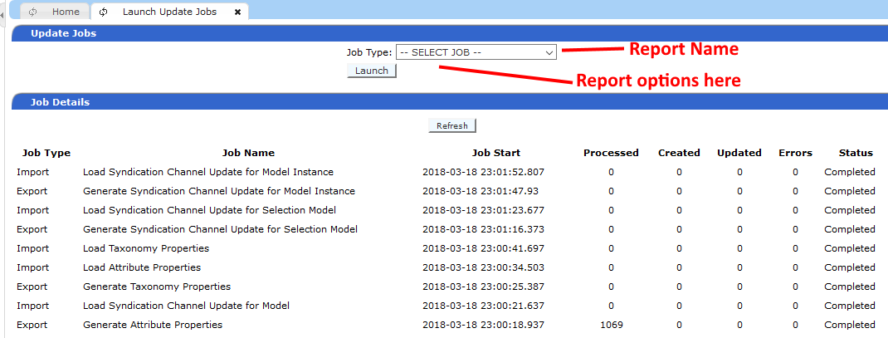

Change Report Processing
Whenever a change report scheduled export is launched, the following steps will be performed:

- Retrieve the details for each named report.
- For each report, determine whether there is an owner attribute specified. If there is, perform the following sub-steps:
  - Retrieve the list of unique owner groups from the code set associated with the owner attribute. This determines how many separate report jobs are going to be run.
  - For each owner group, cross-references the users assigned to the group with the users assigned to each recipient group defined for the report and generate a list of e-mail recipients.
  - One report will be generated for each unique owner group
- If there isn’t an owner attribute specified, perform the following sub-steps:
  - Retrieve the list of e-mail addresses solely from the users assigned to the designated recipient groups.
  - Only one report will be generated
- At this point, the process knows how many reports need to be generated and who the e-mail recipients would be.
- Retrieve the details from the scheduled export to be used as the basis for each report job to be launched.
- For each report identified in the previous steps, update the base export properties with the specifics, such as the identified e-mail targets and the specific report (including name and owner if specified) and create a new Scheduled Export Jobs record to launch each report.
Each new Scheduled Export Job’s post-processing generates the report according to the settings in the report definition and the specified owner group (if defined). The Scheduled Export process will then send the file as defined in the original job (Directory, Email, or FTP). If the targ

