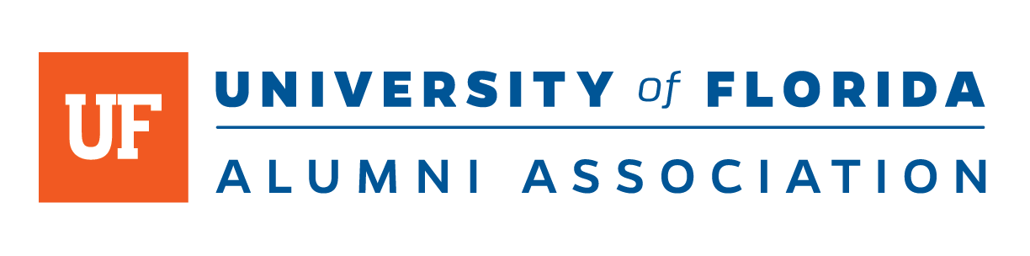

University of Florida Alumni Association FOR IMMEDIATE RELEASE
Heather Ashley Month Day, Year
352-392-9252
hashley@ufalumni.ufl.edu
ufalumni.ufl.edu

[Insert Honoree Name] Named a University of Florida 40 Gators Under 40 Awardee

GAINESVILLE, FLA. – [Insert Title and Honoree Name] is one of a select group of University of Florida alumni named to this year’s prestigious “40 Gators Under 40.” The annual awards program was established in 2006 to recognize alumni under the age of 40 whose achievements positively reflect The Gator Nation. Criteria for the competitive award include making a significant impact on the candidate’s industry and having civic or professional accomplishments at the state, national or international level.
“The word outstanding barely describes the alumni in this year’s ’40 Gators Under 40’ class. These young men and women are absolutely remarkable and have already made a significant impact in their professions and communities,” said Brian Danforth, executive director of the UF Alumni Association. “Collectively, they’re a wonderful reflection on The Gator Nation® and its potential to change the world.”
The Outstanding Young Alumni Award recognizes graduates from all UF’s 16 colleges. This year’s honorees range from doctors and pharmacists to entrepreneurs and artists. Past award winners include meteorologist Stephanie Abrams, politician Adam Putnam and sportscaster and television personality Laura Rutledge.
[Insert Honoree Bio Information]
The 167-year-old University of Florida has nearly than 450,000 alumni residing in every U.S. state and in more than 150 countries. The university has a long history of established programs in international education, research and service, and is one of only 17 public, land-grant universities in the prestigious Association of American Universities. It is ranked No. 6 in the most recent U.S. News and World Report’s list of public universities. The UF Alumni Association is responsible for a network of nearly 100 Gator Clubs, is actively involved with the recruitment of superior students, and hosts outreach and on-campus programs to connect alumni with their alma mater. To learn more, visit ufalumni.ufl.edu.

-30-

