Compliance Alliance Credential Letter

Bank Letterhead

Date
From: Name, Title
Subject: Financial Services Sector Essential Critical Infrastructure Workers

As the Nation comes together to slow the spread of COVID-19, on March 16th, the President issued updated Coronavirus Guidance for America. This guidance states that:

“If you work in a critical infrastructure industry, as defined by the Department of Homeland Security, such as healthcare services and pharmaceutical and food supply, you have a special responsibility to maintain your normal work schedule.”

The Financial Services sector is identified as a Critical Infrastructure Sector by the Department of Homeland Security (DHS). The attached DHS guidance, issued March 19, 2020, identifies the essential critical infrastructure workers during the COVID-19 response emergency.

Within the Financial Services sector, employees deemed Essential Critical Infrastructure Workers include the following:
- Workers who are needed to process and maintain systems for processing financial transactions and services (e.g., payment, clearing, and settlement; wholesale funding; insurance services; and capital markets activities);
- Workers who are needed to provide consumer access to banking and lending services, including ATMs, and to move currency and payments (e.g., armored cash carriers); and
- Workers who support financial operations, such as those staffing data and security operations centers.

The Department of Treasury has issued guidance dated March 22, 2020 and March 24, 2020 (attached), indicating that companies aligned to the essential critical infrastructure worker definition are expected to maintain their operations and work schedules.

“…The guidance provides information to State and local officials, as they work to protect their communities, to ensure the continuity of functions that are critical to public health and safety, as well as economic and national security. …The American people need access to financial sector services, and State and local governments must ensure the continuity of critical financial sector functions. …”

Pursuant to the guidance above, Name is considered an Essential Critical Infrastructure Worker as her/his job duties are needed to [include bulleted information above, as applicable].

Should you have questions or concerns about this determination, contact Name, Title at 888-888-8888.
Should you have questions about the list of Essential Critical Infrastructure Workers, please contact CISA at CISA.CAT@cisa.dhs.gov.

Sincerely,

Bank CEO

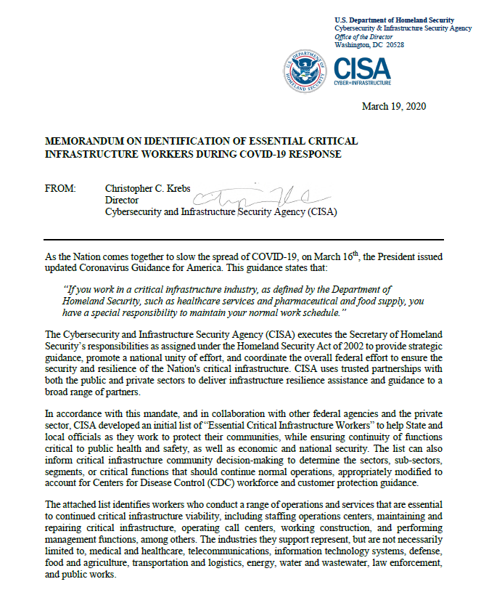
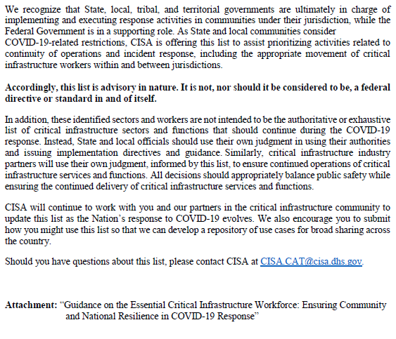
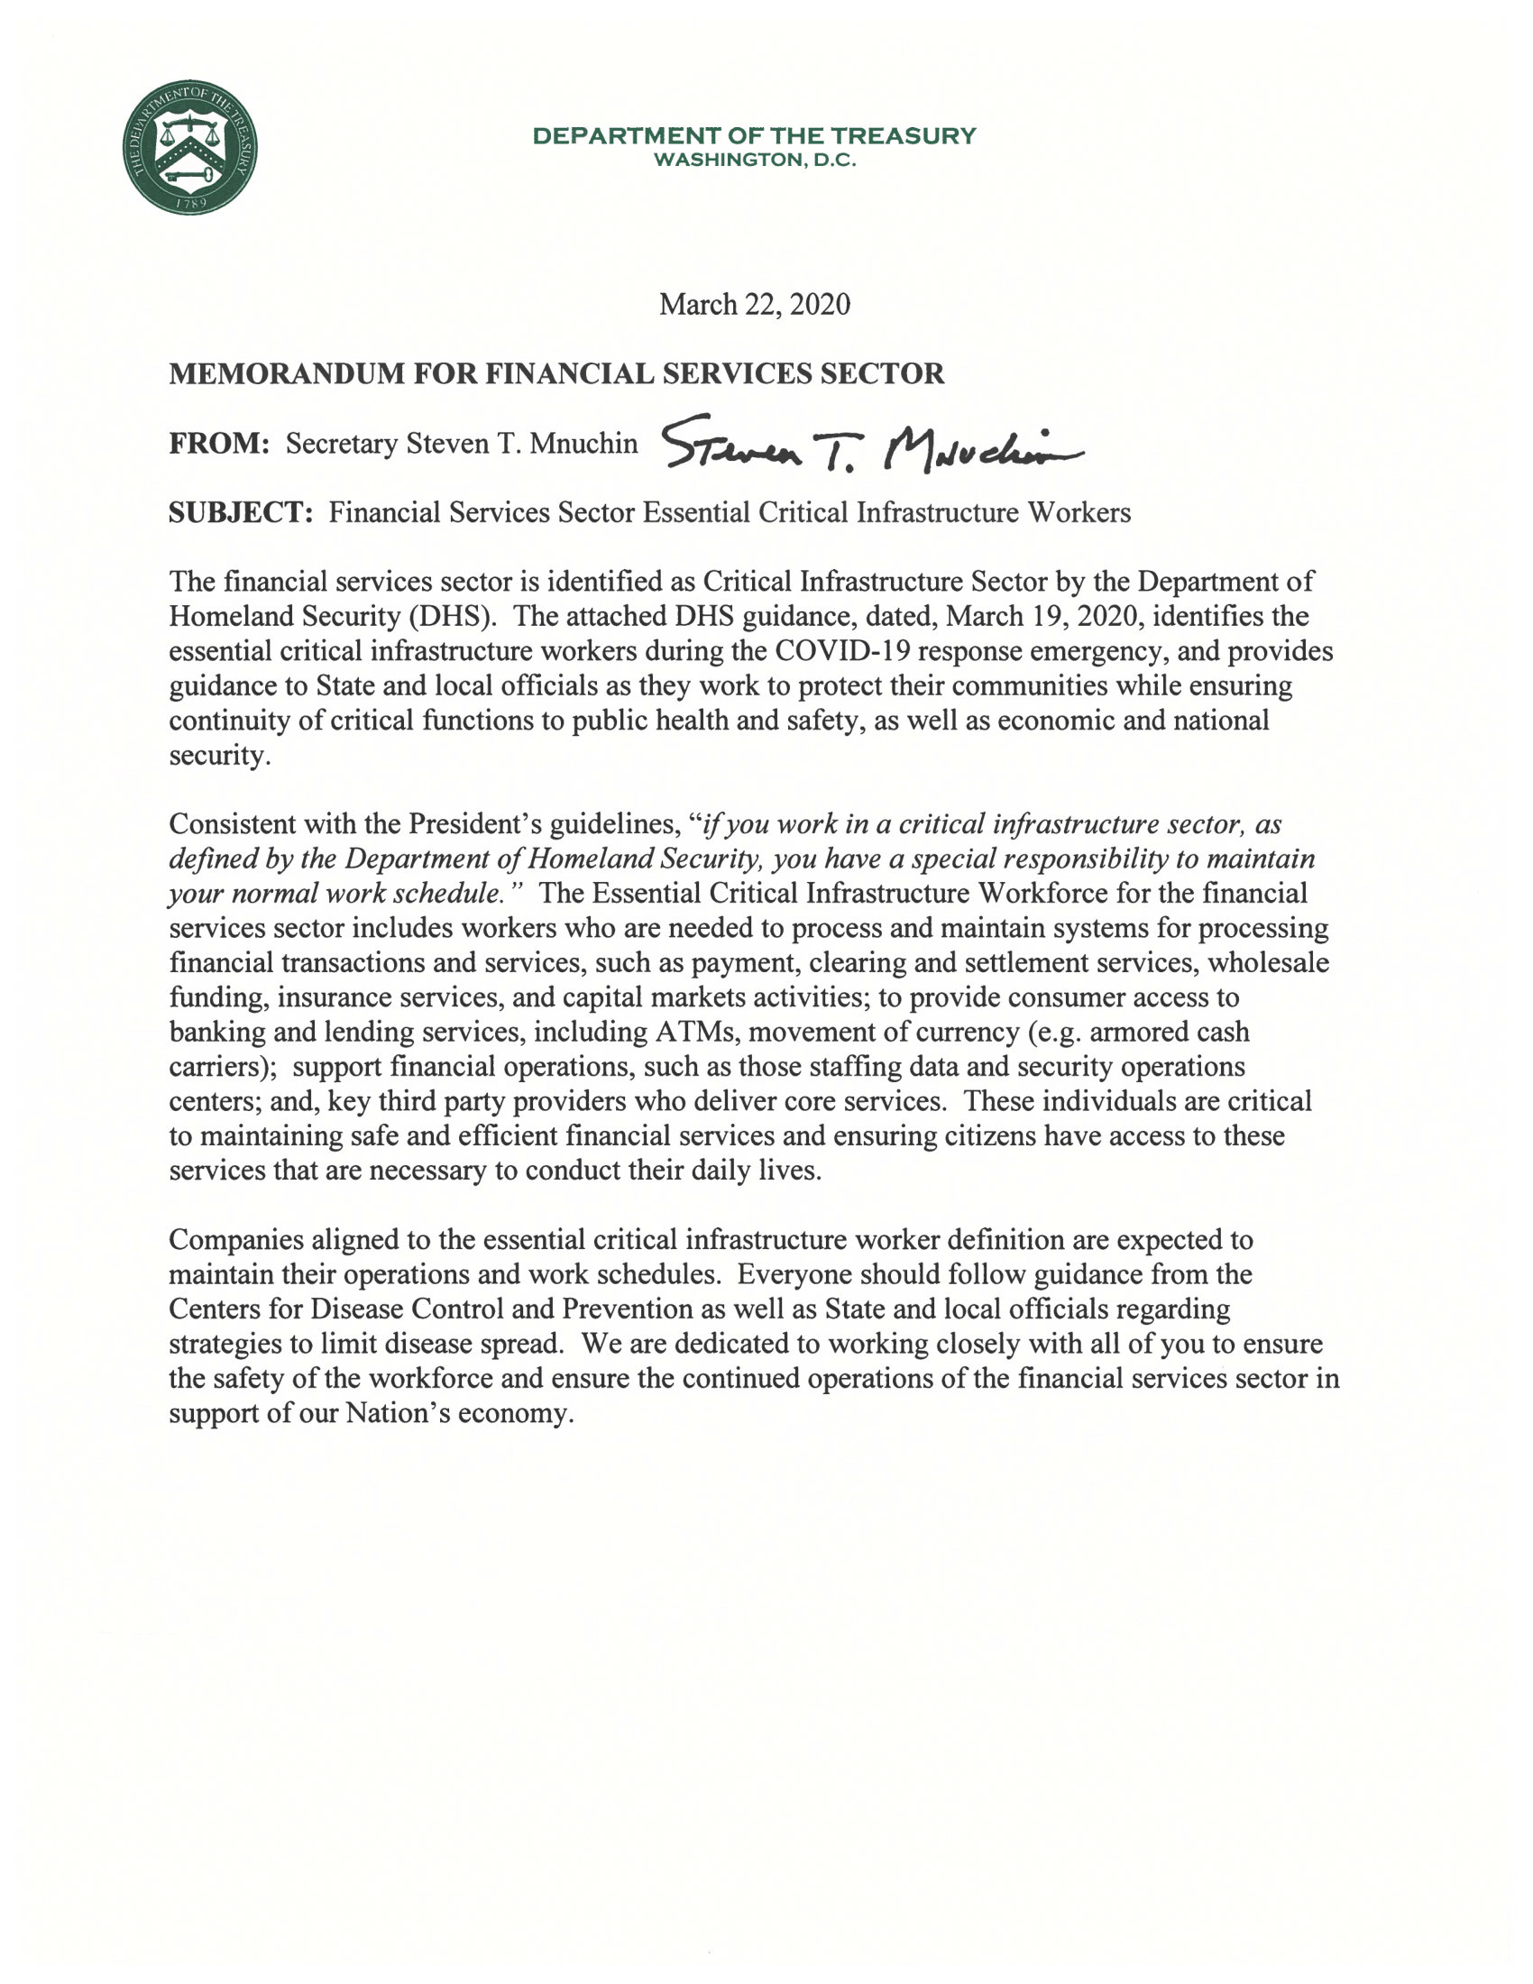
Statement by Secretary Steven T. Mnuchin on Essential
