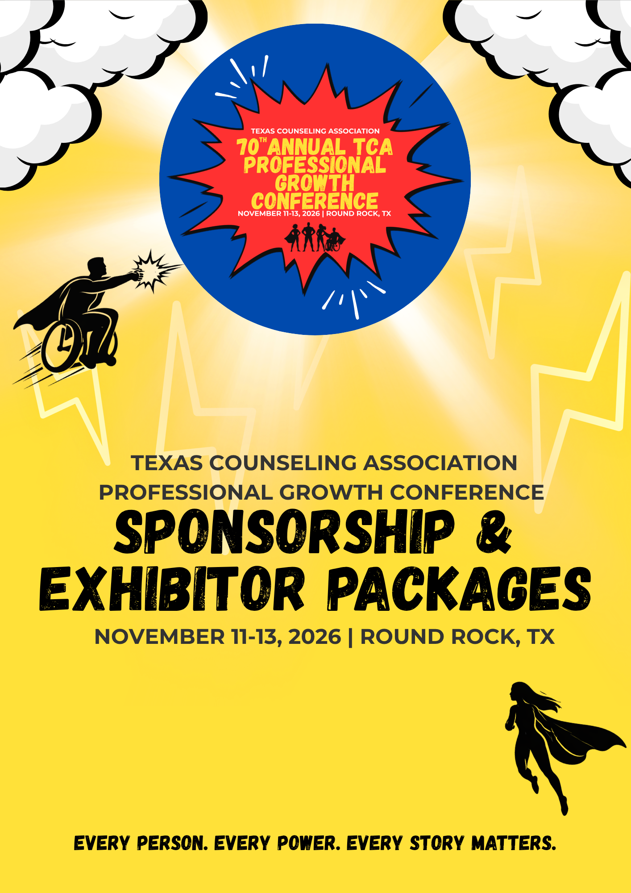
Sponsorship Packages
Platinum Sponsor*
$15,000 | One available spot
- Double exhibitor booth in a prime location
- Logo recognition on conference website with clickable link
- Logo displayed as app banner sponsor
- Logo displayed as app home page sponsor
- Logo displayed on conference app on rotating carousel
- Ad placement in 2 of TCA’s eUpdates, distributed to 6000 members
- Attendee list delivered post-conference
- Logo displayed on onsite signage
- Logo displayed in PGC communications to membership
- Introduction of one of the keynote speakers
- Push notification through conference app (sponsor must provide language)
- Two conference admission tickets
Gold Sponsor*
$10,000 | One available spot
- Single exhibitor booth space with prime location
- Logo recognition on conference website with clickable link
- Logo displayed on conference app on rotating carousel
- Logo displayed as app page sponsor
- Logo on select onsite signs
- Attendee List delivered post-conference
- Logo displayed in PGC communications to membership
- Introduction of one of the keynote speakers
- Exclusive logo placement on attendee badge lanyards
- Two conference admission tickets
Silver Sponsor*
$6,000 | Four available spots
- Single exhibitor booth space
- Logo recognition on conference website with clickable link
- Logo depicted in conference app on rotating carousel
- Logo displayed as app page sponsor
- Logo depicted in conference app for the specific session
- Logo displayed in PGC communications to membership
- Attendee List delivered post-conference
- One conference admission ticket
Bronze Sponsor*
$4,500 | Four available spots
- Single exhibitor booth space
- Logo recognition on conference website with clickable link
- Logo depicted in conference app on rotating carousel
- Logo displayed in PGC communications to membership
- Attendee List delivered post-conference
- One conference admission ticket
*If the logo is not received by 9/1/26, onsite signage is not guaranteed
**Attendee Lists: Only attendees who did not opt-out during registration will be available to anyone who purchases an attendee list.
***Bundle Incentive: Sponsors who purchase a Platinum, Gold, Silver, or Bronze package will receive 20% off one additional Sponsorship Highlight opportunity. Contact info@txca.org to receive your incentive.
Sponsorship Highlights
Awards Ceremony Sponsor*
$3,500 | One available spot
- Logo recognition on conference websites, with clickable link
- Logo on awards power point
- Recognized by the MC at the awards dinner
- Logo on the photobooth videos/images
- Logo depicted in conference app
- Logo depicted in the printed Award Booklet
- Logo depicted on all Award Ceremony Signage
Tote Bag Sponsor*
$3,000 | One available spot
- Exclusive logo placement on the official conference tote bag distributed to all attendees
- Logo recognition on conference website, with clickable link
- Opportunity to include one promotional item or flyer inside attendee tote bags (provided by sponsor)
- Logo depicted in conference app
Coffee Break Sponsor*
$2,500 | Four available spots
- Signage displayed during sponsored coffee break
- Logo recognition on conference website
- Recognition during break announcement push notification
- Logo displayed in conference app

Program Sponsor*
$1,500
- Logo recognition on conference website, with clickable link
- Logo on session presentation front page for attendees to see as they enter the session
- Logo depicted in conference app for the specific program
*If the logo is not received by 9/1/26 onsite logo promotion is not guaranteed
Exhibitor Booths
Included items: post conference attendee list, booth space, company name sign, 6'ft skirted table, 2 chairs, wastebasket
- Single Booth (10x10)
  - Early Bird: $1000 before August 15, 2026
  - Standard: $1300 after August 15, 2026
Attendee Lists
Boost your leads with access to the attendee list, which includes attendee names, mailing addresses, and email addresses.
- Post-conference List: $600
Platinum, Gold, Silver, and Bronze sponsorships already include the post-conference list. Sponsor Highlight opportunities do not.
On-site sponsorship is not required to purchase the post-conference attendee list.
*Attendees who select to opt-in during registration will be available to anyone who purchases an attendee list.

