How to Edit a Draft Program Submission

To Save a Draft
- When you are in the process of completing a submission click on Save and Return Later in the bottom corner.
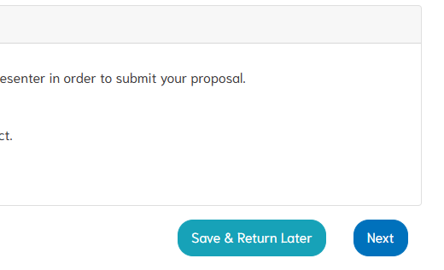

To Return to a Draft Submission
- Click on the 70th Annual Professional Growth Conference from the Event page in your member portal.
- Click on “Submit a Program Abstract” under Program Abstracts.
- 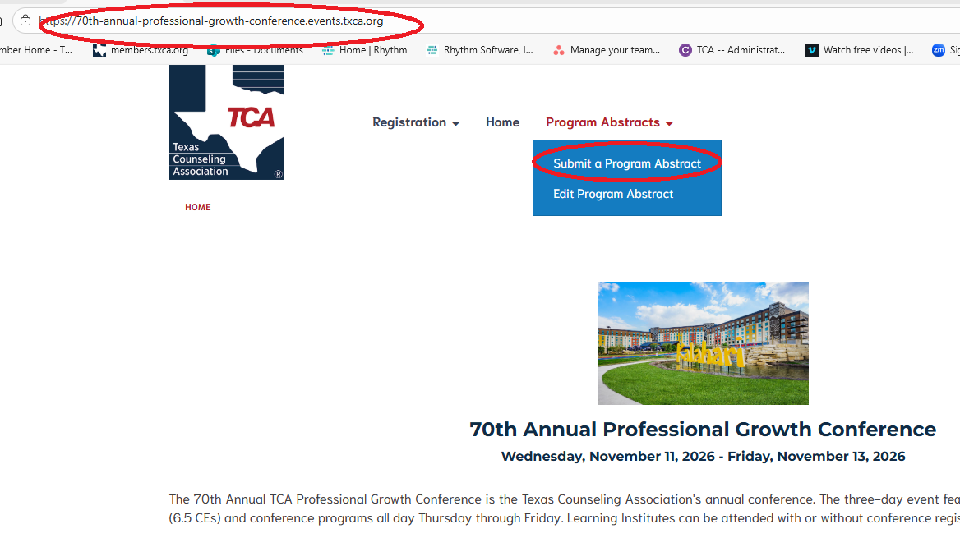
- Select the Abstract Type you saved as a Draft (LI, 90-Minute, 3-Hour, or Poster) and click Next.
- 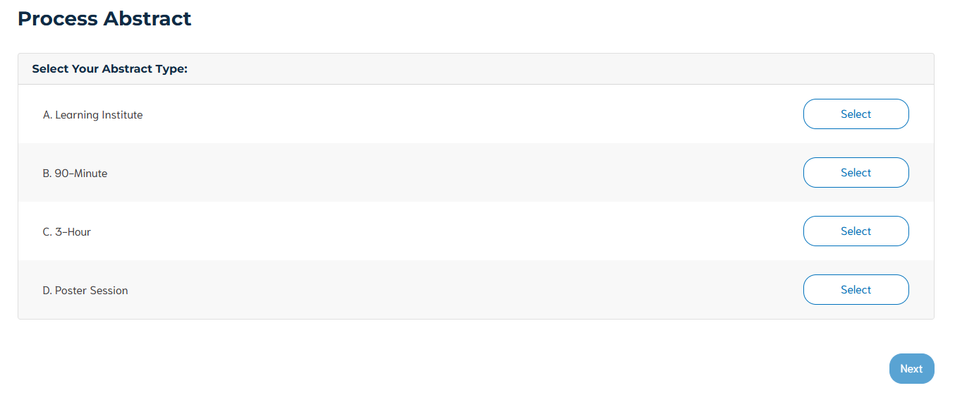
- Click on “Continue Working on a Draft
- 