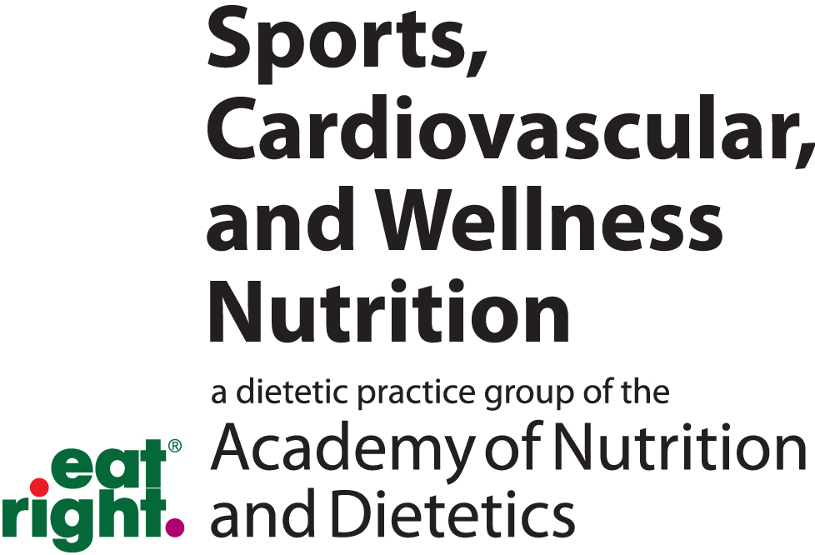
2017-2018 SCAN Awards Nomination Application
After reviewing the SCAN Awards Criteria document the award nominator will:
- Complete the following application
- Collect and submit the three letters of support
- Include the nominees up-to-date CV or Resume
- For Student award nominations, list the GPA below and attach most recent transcripts
- Submit all documents to: Michele Macedonio, MS, RD, CSSD, LD, Nominating Committee Chair (m.macedonio@myns1.com)
- Due Date: Monday, December 11, 2017, 5:00 PM CST

Submission Date:

I am submitting an application for the following SCAN Award:

SCAN Excellence in Practice Award SCAN Achievement Award SCAN Student Award
SCAN Distinguished Scholar Award (Current GPA )
Nominees Information
Name and credentials:
Contact phone number:
Contact Email address:

Nominated By
Name and credentials:
Contact phone number:
Contact Email address:

This is a self-nomination (use nominees contact information)

Membership History
Number of years as member
The Academy of Nutrition and Dietetics
SCAN: Sports, Cardiovascular and Wellness Nutrition DPG

Provide the names and contact information for three people willing to write letters of support
(Can include the individual nominating the candidate unless it’s a self-nomination).
 | Name and Credentials | Email | Phone
1
2
3

Letters of support should be no longer than 2 pages and address the following questions:
- How long have you know the candidate and in what capacity?
- What is the nature and length of their association with the nominee?
- Why is this nominee a strong candidate for this specific award?
- How has the nominee contributed to the profession and SCAN?

SCAN Awards Criteria for Nomination and Review
Student Award Qualifying Criteria:
- A current member of the Academy of Nutrition and Dietetics for at least 1 year
- A student member of SCAN for at least 1 year
- A current student (Bachelor, Master, or Doctoral candidate, or Dietetic Intern)

Excellence in Practice Award Qualifying Criteria:
- Member of SCAN for 3 plus years
- Visibility of practice in at least one of SCAN’s practice areas.
- Professional accomplishments demonstrated to advance and impact the profession
- Outstanding leadership/service to the profession

Achievement Award Qualifying Criteria:
- Member of SCAN for 10 or more years.
- Significant history of outstanding service to SCAN in various leadership roles, such as SCANs Executive Committee, Symposium Director/Assistant Director, Subunit leadership and involvement, major publications (Pulse, CV/Well newsletter, SCORE, The Beat), etc.
- Professional accomplishments in the field of sports or cardiovascular nutrition, wellness and/or disordered eating/eating disorders as exemplified through teaching or professional training, clinical experience, public speaking, research, publications, nutrition education for the public, etc.

Other forms of service and professional accomplishment that may be considered for the Achievement Award
- Participation in Academy and/or other professional organizations at the national, state, and/or local levels.
- Community Service/Volunteerism at the national, state, and local levels
- Formal and/or informal mentoring of peers and young leaders
- Collegiality

Distinguished Scholar Award Qualifying Criteria:
- Holds a leadership position in sports, cardiovascular, wellness or disordered eating in a professional, academic, industry, or government organization
- Has authored peer-reviewed publications that advance the body of knowledge in sports, cardiovascular, wellness or disordered eating
- Has advanced the field of dietetics practice through or by research publications; development of programs, competencies, or standards of practice; authorship of manuals, texts, or position papers; or other professional accomplishments.
- Candidates must be distinguished by leadership and scholarly endeavors. Candidates may be RDs or non-RDs, SCAN members or non-SCAN members.

Disqualifying criteria for SCAN Awards
- Currently serving on the SCAN Executive Committee
- Having already received the award
- Incomplete award application

