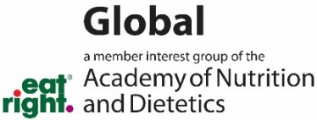
Global MIG Photography/Videography Release

By my signature below, I authorize and permit the Academy of Nutrition and Dietetics and its group, the Global Member Interest Group, to take, obtain and use photos and videos of myself or my child/guardianship with the following understanding:
- The photos or videos will be used to promote global nutrition education to the public and may be shared with organizations who work in global health.
- There will be no compensation to the person being photographed or videoed.
- The photos or videos may be used in print, online on the internet, or in educational presentations.
- The images will not be sold or offered for sale.

By signing below I warrant that I am of legal age to sign a contract in my own name or that I am the authorized parent or guardian of the minor under age 18 and that I have read or had read to me this release form and understand and agree to it.
Date | Printed Name | Signature if Over 18 | Parent/Guardian  Printed Name if Under 18 | Parent/Guardian Signature if Under 18

If person being photographed/videoed is unable to sign a full signature due to illiteracy or disability, then an X-mark signature may be written above and witnessed here:
Date | Witness Printed Name | Signature

If translation assistance was required, translator attests to the best of their ability translating the release wording in the native language of the person being photographed/videoed.
Date | Translator Printed Name | Signature

Thank you for your permission. Please email this release to GMIG@eatright.org.

