Yam Rice Porridge 地瓜粥 (dìguā zhōu)

By:
Cindy Chou, RDN
website: https://healthyfeels.com IG: @thesoundofcooking

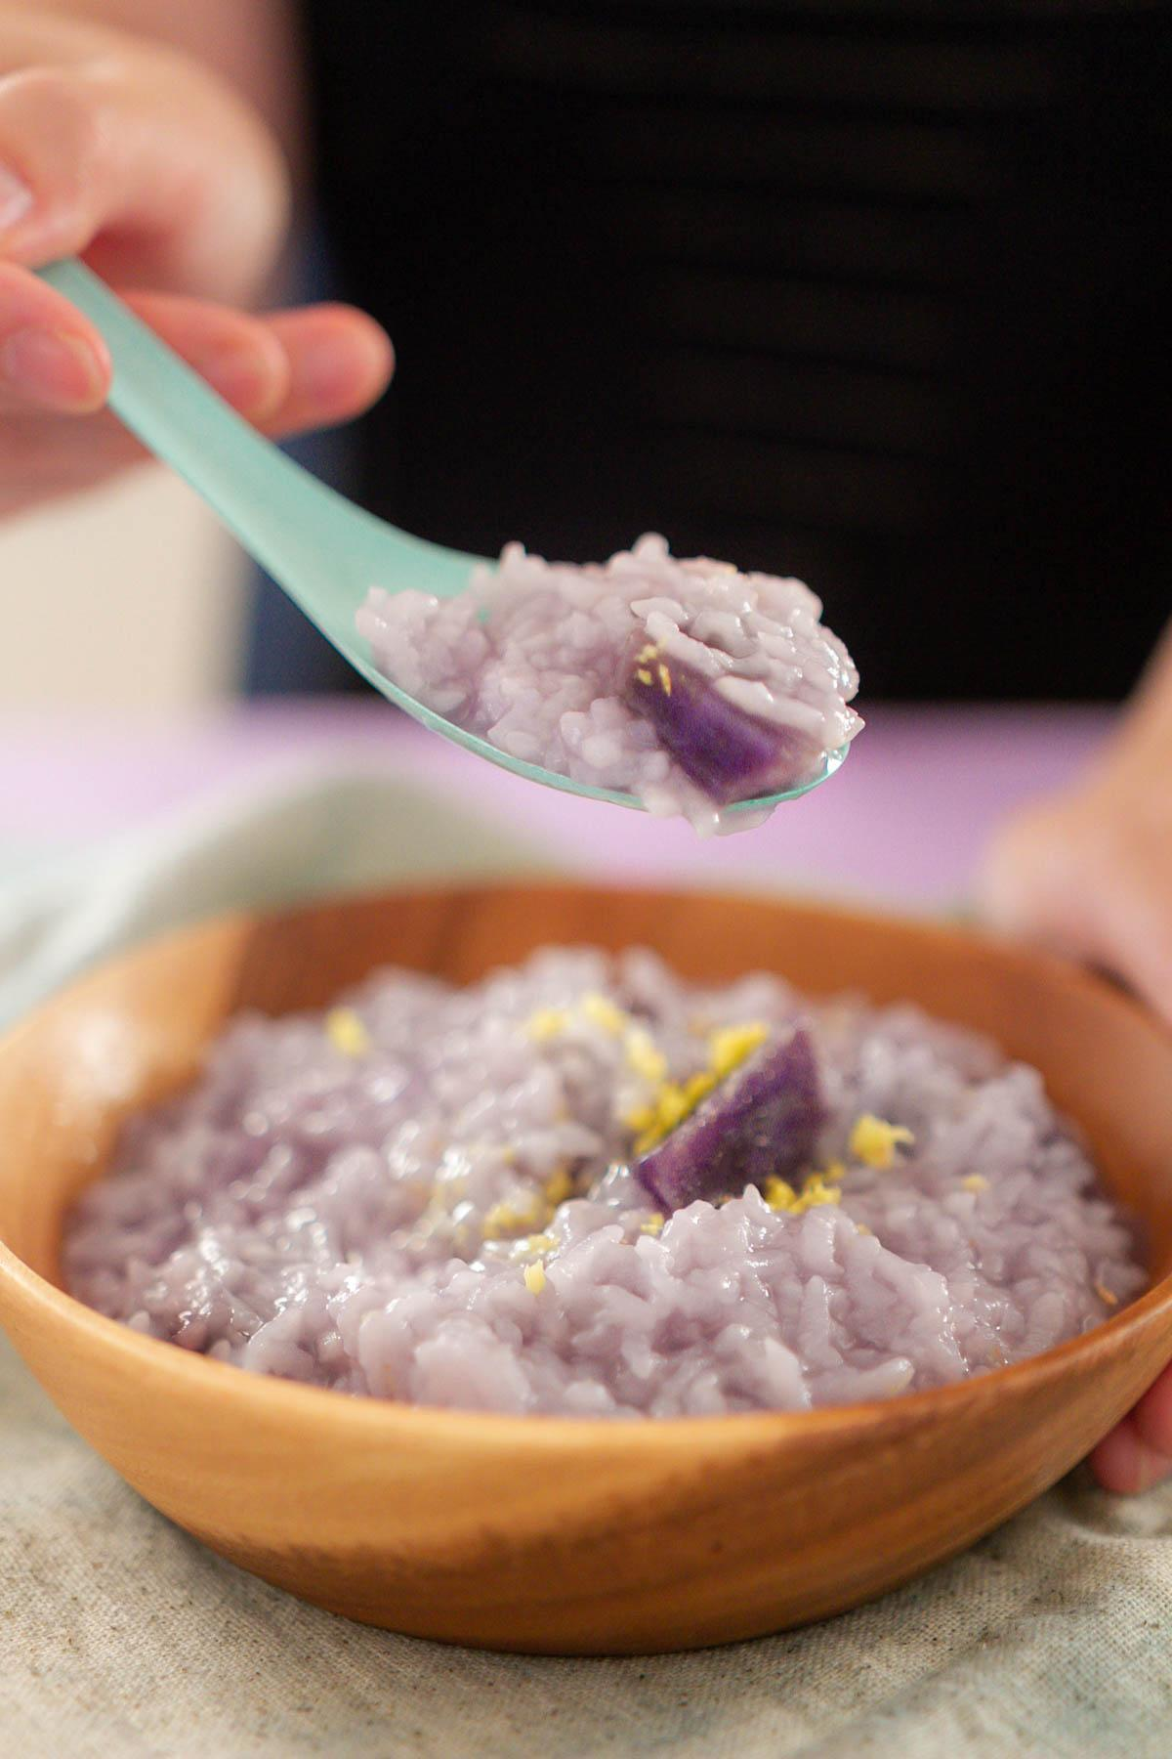

Recipe Ethnicity/Cultural Inspiration: Taiwanese and Chinese

About this recipe:
Yam or sweet potato rice porridge is a go-to dish in Taiwanese and Chinese households, especially if someone is feeling under the weather, has an upset stomach, or has a low appetite. Historically, this dish was made by poor families to stretch out rice rations, but it’s now enjoyed as a comfort food or easy breakfast.

It’s a simple and nourishing dish that goes well with most foods. To add protein, you can eat it with shredded chicken or a poached or boiled egg.

Here, I add grated fresh ginger to help with nausea. In Chinese medicine, ginger is also thought to help with circulation and is used to expel “cold.”

What side effects can this recipe help with:
The ginger helps with nausea and the simplicity of the flavors make this perfect for someone who has a low appetite. This dish is also eaten when someone has diarrhea since the rice doesn’t agitate the digestive system and the water content helps to prevent dehydration.

Rice porridge is also easy to eat for anyone that may have a sore mouth or throat and can be watered down further for individuals that have trouble swallowing.

The subtle sweetness from the yams may help with certain taste changes as well (please see notes below).

If you need to adjust for taste changes try doing these: Make small adjustments at a time in your bowl rather than the entire batch of porridge. Once you find something that works, you can make the same changes to the rest of the porridge.

- If you are experiencing metallic taste changes or if things taste bitter: Try mixing in a little maple syrup or cane sugar (1/2 teaspoon).
- If food tastes like cardboard: Try adding a little salt in increments to your bowl while tasting throughout until you can taste the rice porridge more. You can also try eating the rice porridge with some pickled vegetables unless you have a sore mouth or throat.
- If everything tastes too sweet: Try adding a little salt in increments to your bowl while tasting throughout until your liking. You can also try eating the rice porridge with some pickled vegetables unless you have a sore mouth or throat.

In table format:
Taste Changes | Try These Seasoning Techniques
Metallic taste to food or food tastes bitter | - Try mixing in a little maple syrup or cane sugar (1/2 teaspoon).
Food tastes like cardboard | - Try adding a little salt in increments to your bowl while tasting throughout until you can taste the rice porridge more.  - You can also try eating the rice porridge with some pickled vegetables unless you have a sore mouth or throat.
Everything tastes too sweet | - Try adding a little salt in increments to your bowl while tasting throughout until your liking.  - You can also try eating the rice porridge with some pickled vegetables unless you have a sore mouth or throat.

Yam Rice Porridge 地瓜粥 (dìguā zhōu)

prep time: 5 minutes
cook time: 20 minutes
total time: 25 minutes

Servings: 4

Serving Size: 2 cups

Ingredients:
- 1 cup rice, medium grain, rinsed and drained (300 grams)
- 6.5 cups water (2.4 Liters)
- 1 small yam or sweet potato (about 8 ounces or 230 grams), peeled and cut into 1-inch cubes or oblique pieces
- 1 teaspoon grated fresh ginger

Optional additions:
- 1 medium egg, hard or soft boiled
- 3 ounces shredded cooked chicken
- ¼ cup pickled vegetables of your choice

Instructions:
- In a medium pot (about 4-quarts), add in washed and drained rice, 6.5 cups of cold/lukewarm water, prepared yam, and 1 teaspoon of grated fresh ginger.
- Bring to a boil, turn the heat down to medium-low, and stir before covering with the lid partially closed (to avoid the liquid overflowing). Cook for 20 minutes.
- Serve hot or warm.
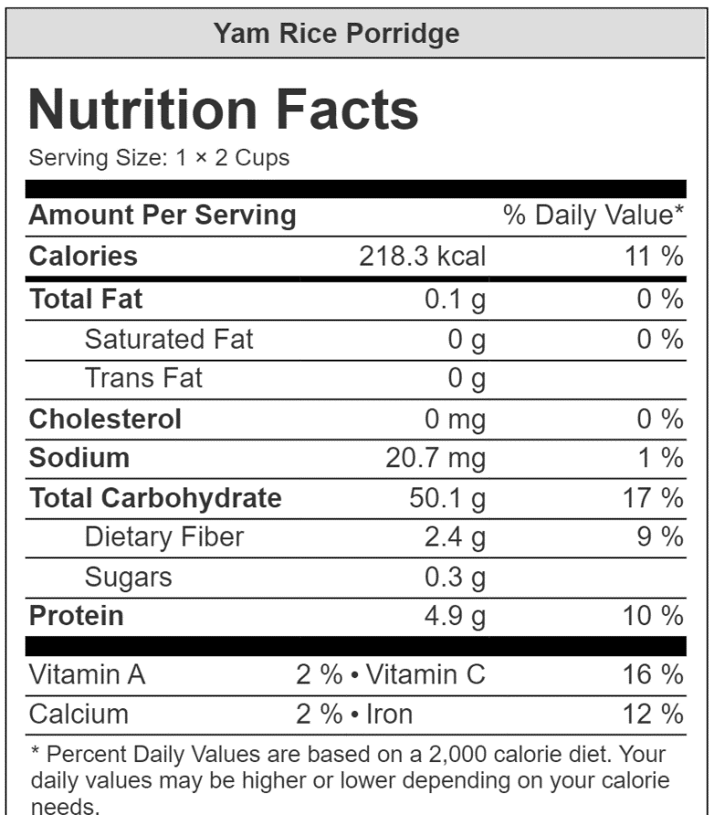

Nutrient Info:

