Tempeh Sweet Plantain “Lasagna”

By:
Madeline Butler-Sanchez, RDN

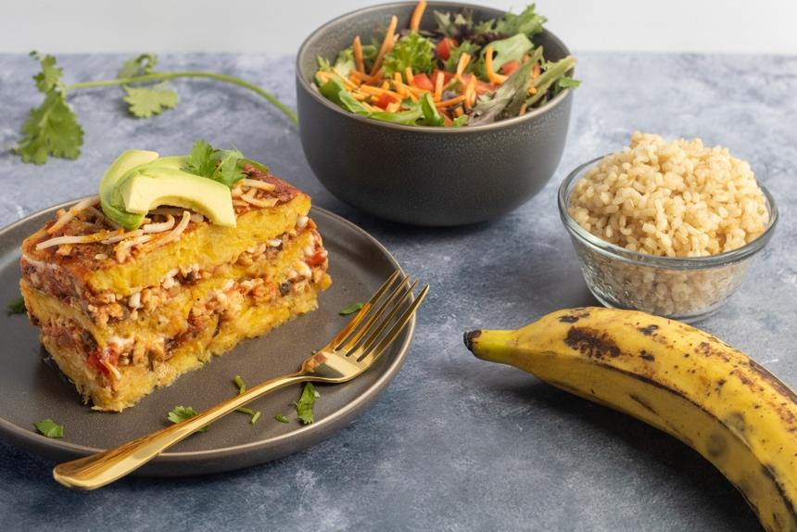

Recipe Ethnicity/Cultural Inspiration: Latin / Caribbean

About this recipe:
"Pastelón!" ... Have you ever heard this word before? It is a traditional dish from Puerto Rico layered like lasagna but made enterally with sweet plantains, typically stuffed with ground meat, cheese, and vegetables. Plantain or sweet plantains (ripe plantains) are a dietary staple with roots in Africa, Central America, and the Caribbean islands. Plantains are a source of fiber, vitamins, minerals, and antioxidants. To make a plant-based version of this dish, I substituted the typical ground meat layer with a mix of tempeh, mushrooms, and vegetables, increasing the nutrient profile. Tempeh is a soy-derived food product primarily consumed in Asia. It contains isoflavones, also known as phytoestrogens, linked to favorable outcomes in breast cancer survivors. Including at least 3 mg/day of isoflavones from soy foods has shown benefits in decreasing breast cancer recurrence and mortality. Tempeh and other soy products are rich nutrient-packed foods considered an excellent plant-based protein source. The nutrient profile of soy products also includes fiber, B vitamins, potassium, magnesium, copper, manganese, and essential fatty acids.

Tempeh Sweet Plantain “Lasagna”
Plant-Based

Prep Time: 1 hr
Servings: 6 servings

Serving Size: 1 square

Ingredients:
- 6 Ripe Plantains
- ¼ cup low-sodium vegetable broth or water
- ½ cup Red onion, diced
- ½ cup bell pepper mix (red, green, orange)
- ½ cup fresh minced cilantro (¼ cup when cooking vegetables and ¼ cup at the end)
- 3 Garlic cloves, minced
- 1 cup Mushrooms, chopped
- 2 Tbsp Liquid aminos or soy sauce
- 8 oz Tempeh, crumbled
- 1 can Crushed tomatoes
- ¼ cup Marinara Sauce
- 3 Tbsp tomato paste (diluted in ¼ cup water)
- 1 Tbsp Oregano, dry
- ¼ tsp Onion powder
- ¼ tsp salt
- ¼ cup plant-based mozzarella cheese (optional)

Instructions:
- In a large saucepan, bring 2 L of water to boil. Add the 6 ripe plantains cut in big pieces and cook for 25 minutes.
- While plantains are cooking, heat a large skillet over medium heat add vegetable broth or water, onion, bell pepper mix, garlic, and ¼ cup fresh cilantro and sauté for 5 minutes, stirring frequently.
- Add mushrooms, stir, and Sauté for two minutes. Then add the liquid aminos and tempeh, stir for 1 min. Add crushed tomatoes, marinara sauce, tomato paste, spices, and salt. Stir to combine and simmer for about 10 minutes.
- Remove water from the plantains and mash them using a fork.
- In an 11-inch glass loaf dish (or pan of your preference), place a 1-inch layer of mashed plantains. Cover the layer of mashed plantain with the tempeh marinara, spreading evenly. Repeat the process one more time and Cover with another layer of mashed plantain. Top with plain marinara sauce and mozzarella plant-based cheese if adding (you can also add cheese between layers).
- Bake for 20 minutes. Take out of the oven and set aside for 15 minutes before serving. Enjoy!
Note: Pair with brown rice and a side of vegetables to make a balanced, nutrient-dense meal.
Nutrient Info:
