Shayne Robinson, RD, CSO, CDN
New York, New York
shr9085@nyp.org

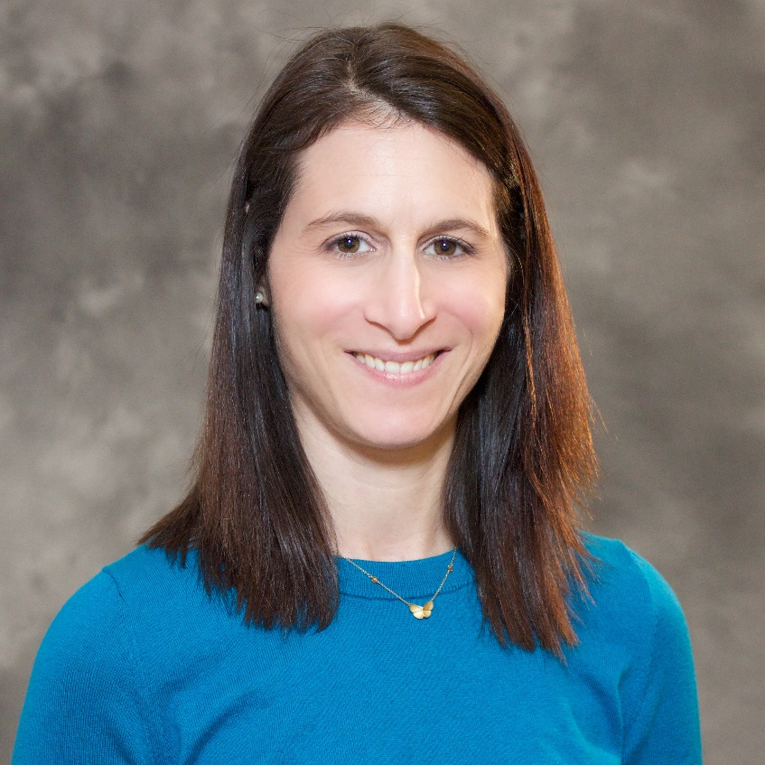

Shayne Robinson, RD, CSO, CDN is part of the oncology team at the Columbia campus as a Dietitian/Nutritionist at the New York Presbyterian Herbert Irving Pavilion Infusion Center. She comes most recently from the New York Presbyterian Weill Cornell campus where her expertise and extensive experience in oncology nutrition has been of benefit to both patients and clinicians.

After receiving her BS from the University of Maryland and internship through the New York Institute of Technology, Shayne spent over 10 years as the Oncology Dietitian at The Beth Israel and Saint Vincent’s Comprehensive Cancer Centers before coming to New York Presbyterian in 2013. She is currently the Oncology Dietetic Practice Group’s representative to the House of Delegates of the Academy of Nutrition and Dietetics. She has served on the board of the Greater New York Dietetic Association, the Oncology Standards of Practice Committee of the Academy of Nutrition and Dietetics, and published articles on oncology nutrition.

Shayne has dedicated her career to providing medical nutrition therapy to patients and education to health professionals and the public on nutrition subjects relating to cancer. In addition to being a yogi and yoga teacher, she enjoys skiing, cooking, running, and gardening in her spare time.

