Plant-Based Cholent

By:
Lori Bumbaco, MS, RDN, CSO, LDN

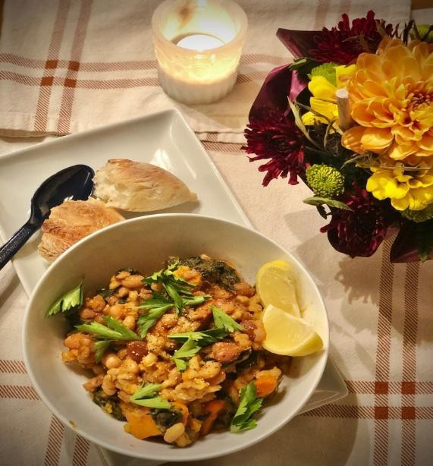

Recipe Ethnicity/Cultural Inspiration:
Jewish Comfort Food

About this recipe:
The word Cholent is derived from the Hebrew word she’lan, meaning, “that rested”, which is a reference to the method of cooking used. The origin of Cholent is from the Middle East in the 9th century, which was created out of necessity to honor kosher dietary laws. Traditional Cholent includes a combination of chicken, beef, eggs, grains such as barley or kasha, potatoes, and vegetables.

Cholent is rooted in the Jewish Sabbath, which prohibits work beginning sundown on Friday through Saturday. If a warm meal was desired, this would be prepared before sundown and would finish cooking overnight to be enjoyed on a Saturday afternoon following synagogue. It is regarded as the ultimate comfort food.

There are many versions of Cholent, in part because of the settling of Jewish people all over the world. They adapted Cholent recipes according to the local ingredients available, which created regional flavors. Much of the differences in Cholent are based on spices that are used. Cholent is a flexible recipe because different ingredients can be used based on preference or need. As a result, all versions of Cholent serve as a delicious and filling meal.

What side effects recipe can help with:

This recipe is ideal for someone struggling with fatigue. The effort required can be minimized with precut vegetables if desired and is hands-off during the slow cooking process. The stew combines nutritious ingredients in a package that conserves energy while eating. The recipe can also be made in meal planning so that leftovers can be enjoyed to minimize time and energy spent cooking.

The high fiber content is helpful for those needing to improve constipation. While the beans can cause gas for some, soaking ahead of time will help to minimize the starchy gas promoters. If desired a piece of kombu could be added to the recipe to make the beans more digestible.

In addition, the warm and soft ingredients make it an easy meal to chew and swallow. The slow cooking process is a method of cooking recommended for anyone needing a meal that “goes down easy”.

The recipe can be adjusted to address taste changes. The plant-based version of this recipe provides quality protein for someone experiencing metallic taste changes and a potential aversion to meat. The squirt of lemon can help to address a bitter, metallic, or even bland taste in the mouth.
The Cholent is served with a plastic spoon to minimize metallic tastes.

Plant-Based Cholent

Servings: 6-8 servings Serving Size: 1 ½ cup

Ingredients:
- 1 cup navy beans (canned can be used)
- 1 cup kidney beans (cranberry beans used in the photo) (canned can be used)
- 2 medium onions, sliced
- 2 garlic cloves, minced
- 1 cup whole barley
- 2 large carrots, sliced
- 2 red or white potatoes, quartered
- 2 sweet potatoes, quartered
- 2 large handfuls spinach

- 1 cup winter squash (acorn, butternut, or delicata), peeled and diced
- 2 Tbsp. smoked paprika
- 1 ½ tsp. salt
- ½ tsp. black pepper
- 2 bay leaves
- Vegetable broth
- Extra virgin olive oil
- Fresh parsley, if desired

Instructions:
  - Presoak dry beans: place beans in a bowl and cover completely with water, leaving about 2” space so that they can expand. Add a splash of lemon juice and cover to soak overnight.
  - Rinse and drain beans.
  - In a skillet, heat oil and sauté onions, garlic, and spinach with salt and pepper over medium high heat.
  - In a slow cooker, place beans, barley, potatoes, winter squash, carrots, and remaining spices. Cover with vegetable broth until level with ingredients.
  - Cover and cook on low setting for about 8 hours.
  - Remove bay leaf. Taste for seasoning and adjust as desired.
  - Top with fresh parsley, a squirt of lemon juice, and serve with fresh baked bread.
