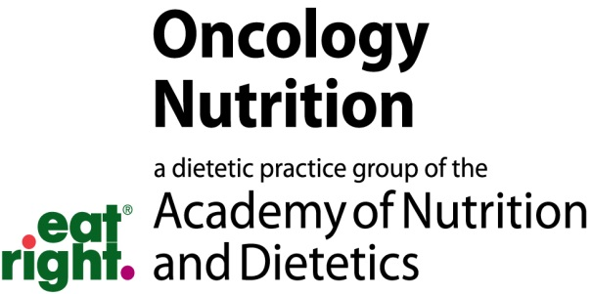

Oncology Nutrition DPG (ON DPG) Small Project Research Grant
There are two ON DPG Small Project Research grants available at this time (for up to $2,500 each). One grant is for the new/novice practicing clinician who may not be as familiar with research. The other grant is for graduate students (i.e. Masters, DCN or PhD). The grants are given on a competitive basis to support research in the area of oncology nutrition. The research or study may involve the following:
- Support Master’s thesis or Doctoral research
- Mixed-methods research
- Outcomes monitoring and/or research
- Nutrition-related interventions
- QI projects
- Animal or human studies
Minimal Qualifications to Apply
Registered Dietitian Nutritionist (RDN) and an Active Member of the Academy of Nutrition and Dietetics; ON DPG membership required. If applicant is a student, a student membership in the ON DPG is required.
Two signed letters of recommendation (at least one from an RDN, one from an advisor or mentor familiar with the project)
- Considerations: testimonial to the person’s interest, ability and the feasibility of the project from someone knowledgeable about the subject to be studied.
- Application must define how funds will be used (include itemized budget and justification).
Study must relate to oncology nutrition and questions/problem statement clearly defined (hypotheses)
Expectations and Use of Funds
- The applications will be treated as confidential information. Copies of the application will not be returned to the applicant.
- Each applicant may apply for up to $2,500. Funds must be used to support the research only (i.e. research supplies, laboratory assessments, required software, statistical consultations, etc.).
- Funds may not be used for salaries, tuition, stipends, etc.
- Research project must be completed within 2 years with project reports at 6, 12, 18, and 24 months.
- Grantees will be encouraged to publish results in the Oncology Nutrition Connection or peer-reviewed scientific journal. Note that mentoring may be available for first-time publishers.
- Grantees will be expected to present progress and results at the ON DPG Symposium and may be invited to speak for 10-15 minutes on project findings.

Application Submission Instructions
- Applications must be submitted to Heidi Ganzer at contact@oncologynutrition.org by midnight 2/15/19. No late or incomplete applications will be considered.
- Complete the attached application face sheet and budget form.
- Complete applications must include the face sheet, budget form, proposal description (single spaced, narrow margins, Arial 11 font). The proposal itself should not exceed 6 pages. The budget, face sheet and any appendix material are not included in the 6-page limit.)
- Proposal should include introduction and background, purpose and aim of the study (hypotheses to be tested), methodology and the feasibility of the study.
- Clinical studies will require IRB approval.
- Applications must be submitted as one scanned PDF document (to include application face sheet, budget form, proposal and supporting documentation such as appendices or references, and signed letters of recommendation).
- Applications must be in the English language.
Questions can be directed to Heidi Ganzer DCN, RD, CSO, LD at contact@oncologynutrition.org . Applications are due by midnight February 15, 2019.

ON DPG Small Project Research Grant Application Face Sheet

Applicant Name
Mailing Address
City, State, Country
Postal Zip Code
Telephone Number
E-mail Address
Title of Proposed Project
Dates of Proposed Period of Support (mm/dd/yy)
Total Anticipated Project Costs

ON DPG Small Project Research Grant Budget Form

Budge should not exceed $2,500. Itemize costs below.

Research Team Names:
Title of Project:
Grant Money Requested (Amount):
Supplies and Other (itemize):
Equipment
Other Costs (Statistical Analysis, Travel Costs)
Total Budget

