Miso Soup

By:
Jennifer Sato, MS RDN

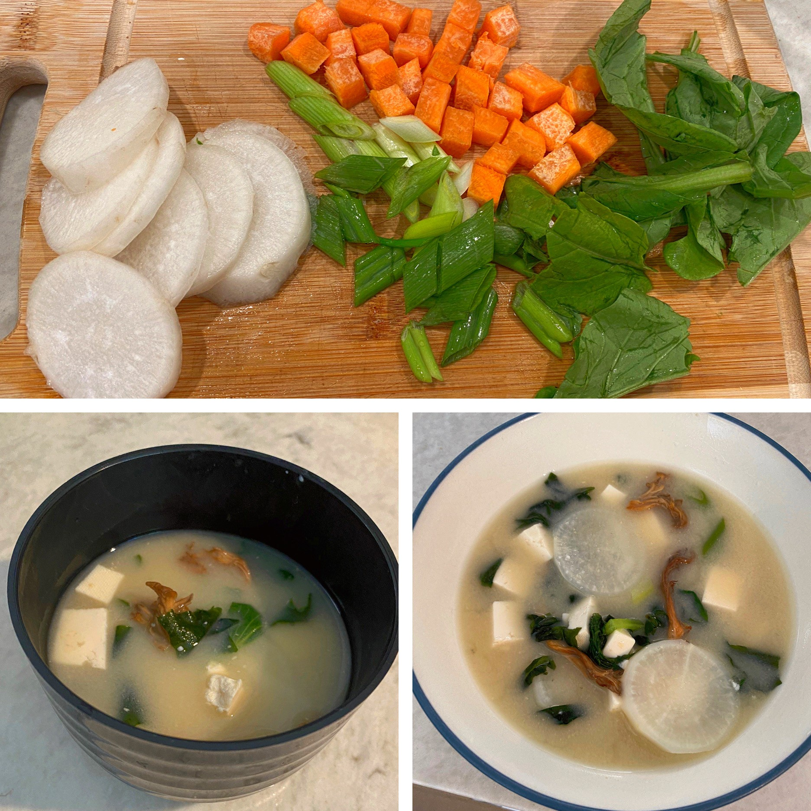

Recipe Ethnicity/Cultural Inspiration: Japanese

About this recipe:
Miso Soup is a traditional Japanese soup made with miso (fermented soybean paste) and dashi (soup stock) plus a variety of other ingredients such as wakame or seaweed, tofu, carrots, komatsuna (Japanese spinach), root vegetables including daikon (white radish), potatoes, and mushrooms. This recipe will use kombu (dried kelp) and bonito flakes (dried skipjack tuna) for its dashi. The soup is served warm, often consumed for breakfast with rice on the side, though it can be enjoyed any time of day. The subtle sweetness of white miso in this recipe combined with traditional Japanese vegetables make this dish a delicious, comforting way to consume lean protein, fiber, vitamins/minerals, and fluids without overpowering the palate.

What side effects recipe can help with:
This nourishing recipe may help those with digestive issues given that miso is a fermented soybean paste high in probiotics and this recipe includes many soft vegetables. This nutrient dense recipe contains spinach, carrots, wakame, maitake mushroom, and tofu which are high in vitamins and minerals including iron, B vitamins, Magnesium, vitamin K, calcium, protein, fiber, and antioxidants. The subtle flavor of this soup may be soothing for those with a change in taste or appetite.

Yam Rice Porridge 地瓜粥 (dìguā zhōu)

Servings: 3

Serving Size: approximately 3/4 cup

Ingredients
- 1 ¼ cup water
- ¼ cup bonito flakes
- 1 (2-inch) piece kombu
- ¼ cup dried maitake mushroom
- 1/8 cup komatsuna
- 1/8 cup carrots, chopped
- 1/8 cup daikon
- 1 stalk green onion
- ~4 oz or 1/3 package of firm tofu, drained
- 2 Tablespoons of Miso ***Used Miso Master Organic Premium Light Miso
- 1 Tbsp wakame

Instructions (please list in numerical order):
Total cooking time: 15-20 minutes
  - Soak the dried maitake mushroom in hot water for at least 15 minutes in its own cup, put to the side.
  - Make the dashi. Boil water with the kombu inside a small 1-quart saucepan. Remove the kombu when the water starts to boil. Add the bonito flakes to the boiling water. Turn the heat down to a simmer for at least 10 minutes. Drain the broth through a strainer, discarding the bonito. (Skip the bonito flakes for a vegetarian option).

Bring the broth back to a rapid simmer.
  - Prep the ingredients. Wash the produce. Peel the daikon radish and thinly slice into circles. Peel and chop the carrots. Trim the stems off the komatsuna spinach. Chop the green onion. Cut the tofu into small ¼ inch cubes.

Add in ingredients that take longer to cook first:
- Add the daikon, carrots and spinach to the broth and cook until tender.
  - Mix the miso. Turn off the heat on the saucepan. Ladle a small amount of broth into a small measuring cup (1/4 cup works well) and carefully stir in the miso, 1 tablespoon at a time. Whisk with a fork until the miso is completely dissolved and no lumps remain. Pour the miso mixture into the saucepan.
  - Add the remaining ingredients. Add the tofu to the broth. The tofu contains a lot of water, the volume of the soup will increase. If the broth gets cooler after adding the tofu, reheat the soup until it is just hot, do not reboil. Add the dried wakame into the soup, it will expand into seaweed. Add the mushroom and green

onion to the broth.
  - Gently stir all ingredients, serve immediately, and enjoy!

