Lauren Talbert, RD, CSO, LDN, CDCES
Rhode Island
ltalbert@wihiri.org

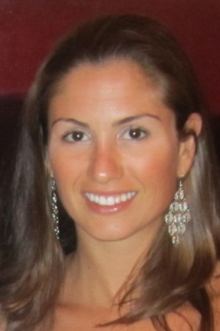
Lauren Talbert RD, CSO, LDN is registered by the Academy of Nutrition and Dietetics and licensed by the State of Rhode Island. Lauren has a Bachelor of Science degree in both dietetics and food and nutritional science from the University of Vermont. She completed her dietetic internship at the Dana Farber Cancer Institute and Brigham and Women’s Hospital in Boston. Lauren is both a certified specialist in oncology and a diabetes educator. She specializes in women’s health. Lauren has been most recognized for her presentations to a wide array of audiences, including medical professionals, patients, and families, as well as the community. Her main approach to nutrition education is to stop confusion and start control. By simplifying information that appears complicated, she aims to motivate patients to feel more in control of their health.

Lauren speaks on topics such as:
- Nutrition recommendations for cancer prevention
- Nutrition goals during chemotherapy and radiotherapy
- Nutrition for cancer survivorship
- Nutrition for cancer prevention in the BRCA positive populations
- Superfoods: out sidekicks to help fight cancer
- Breast cancer survivorship nutrition
- Evidence vs Belief: debunking oncology nutrition myths
- Healthy eating on a budget
- Plant based diet planning
- Going further with food: tips to reduce food waste while eating healthy
- Healthy eating during the holidays
- Eating well with less: Tips to save time, money and stress
- PCOS Nutrition
- Diabetes Nutrition

