Karen Collins, MS, RDN, CDN, FAND
Western New York
karen@karencollinsnutrition.com; https://karencollinsnutrition.com/; On Twitter: @KarenCollinsRD; on Facebook: @KarenCollinsNutrition

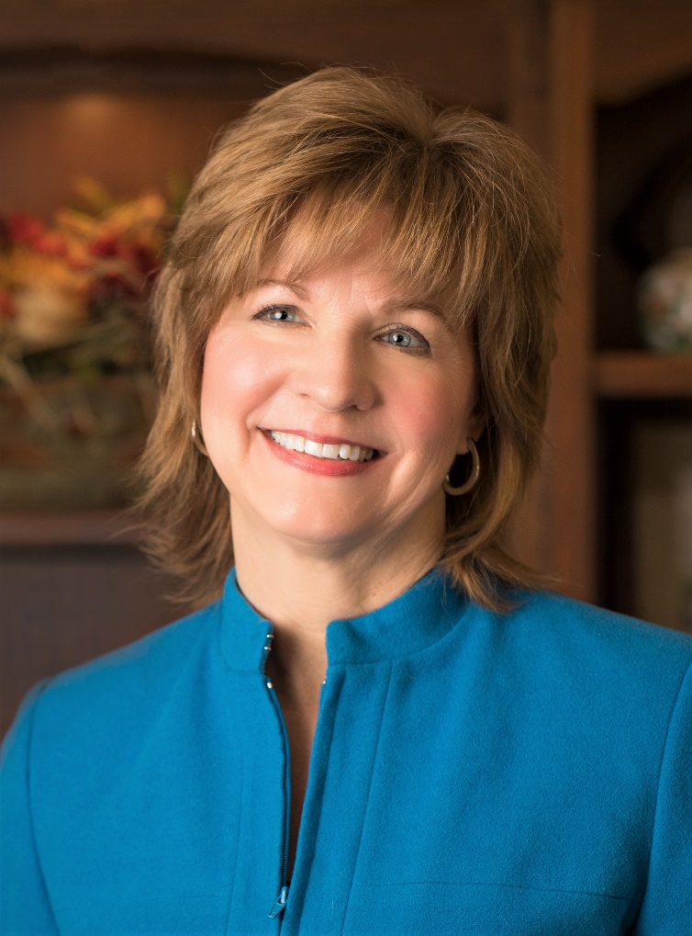

Karen Collins is a registered dietitian who promotes healthy eating as a speaker, consultant and writer. Karen is Nutrition Advisor to the American Institute for Cancer Research (AICR). Her trademarked tagline, “Taking Nutrition from Daunting to Doable”, highlights her focus on translating current research to help people see beyond headlines and put complex information in perspective within the “big picture” of overall research.
She has authored multiple peer-reviewed book chapters and research summaries for health professionals covering cancer prevention and the intersection of cancer, diabetes and heart disease. And she has penned over 2,000 nutrition-related articles for the public. As a speaker or writer, Karen empowers people to feel less overwhelmed and equips them to develop realistic strategies for health.
Karen speaks to health professionals and the general public on topics such as 1) Oncology guidelines, evidence on protective foods/phytochemicals/eating patterns, (cutting through media hype); 2) Cancer Survivors moving into long-term healthy lifestyles; 3) Intersection of Cancer with Cardiometabolic Health.

