Jean LaMantia, RD
Canada
jlamantia@yahoo.com

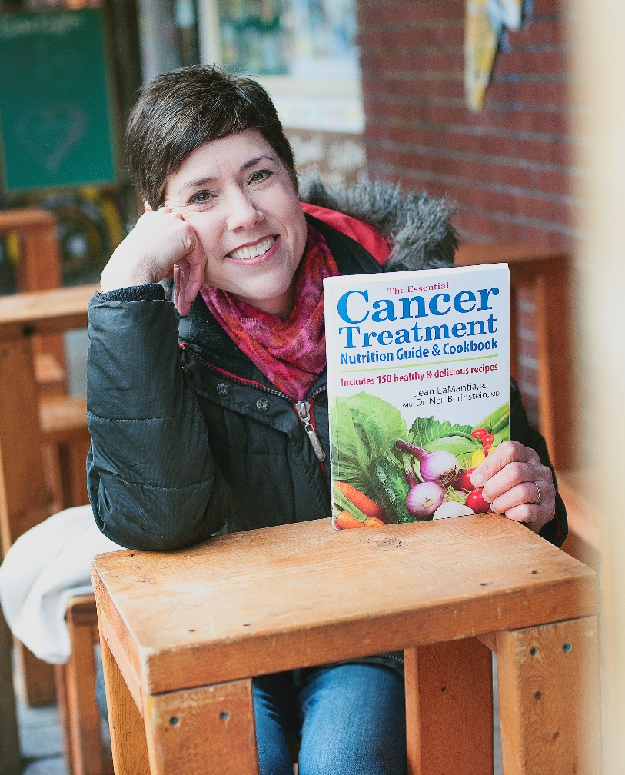

Jean LaMantia, is a registered dietitian, cancer survivor and author of three books: The Essential Cancer treatment Nutrition Guide and Cookbook, The Complete Lymphedema Management and Nutritiion Guide, and Intermittent Fasting: The Complete Guide to Fasting for You Health, Weight and Wellness.

She can speak about the The 3 Keys to Cancer Risk Reduction, Anti-Inflammatory Diet, Intermittent Fasting, Hot Topics In Cancer Nutrition (Sugar, Soy, IV Vitamin C), Lymphedema Diet, Popular Diets in Cancer Nutrition and other topics. She is adept at both live and webinar formats and would be happy to tailor a presentation for your audience.

For a full list of her talks and to find out more about Jean go to https://jeanlamantia.com/

