Greek Avgolemono Soup

By:
Paula Charuhas Macris, MS, RD, CSO, FAND

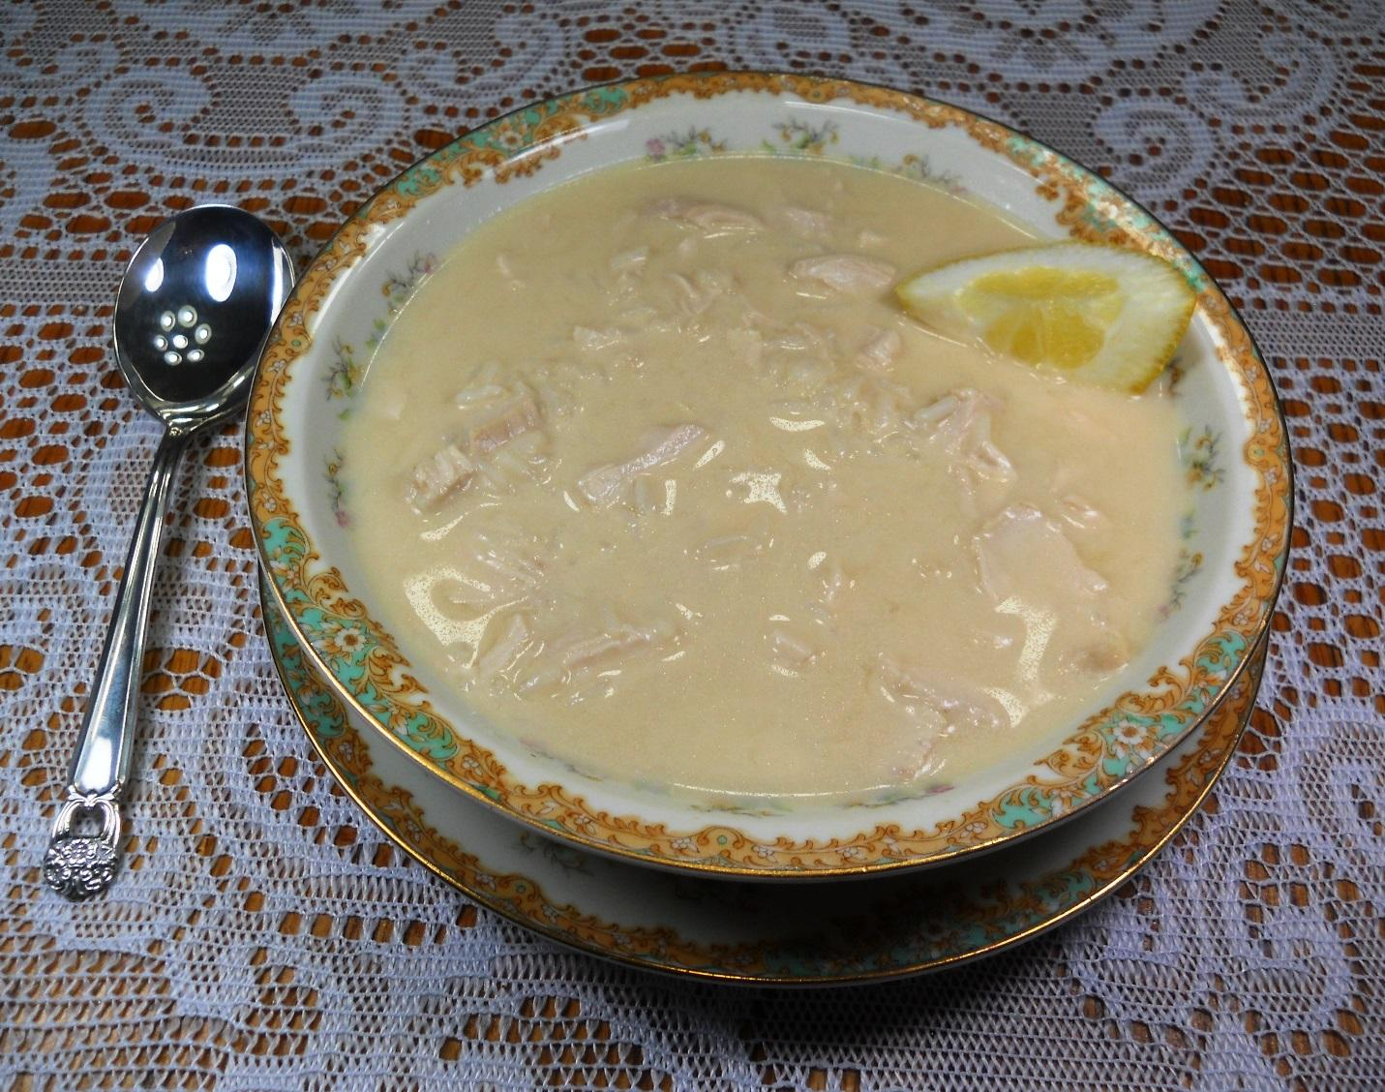

Recipe Ethnicity/Cultural Inspiration: Greek family recipe passed down from my grandmother.

About this recipe:
My grandmother or “Yiayia,” who immigrated from Greece in the 1920s, was a fabulous cook! She frequently made this delicious soup for our family. It was the “go-to” comfort food when we had a cold or sore throat. While Yiayia spent many hours in the kitchen cooking the chicken and preparing the stock, this delectable recipe has been modified to include rotisserie chicken and shelf-stable stock with the same delicious results and a shorter preparation time.
The history of this soup dates back to around 1000 A.D. when Sephardic Jewish people supposedly brought lemons from southern Europe to Greece. The Greeks then created “avgolemono” which means egg-lemon sauce. When combined with chicken, stock, and rice, this easy-to-prepare classic Greek soup is rich and nourishing and the ideal food for patients undergoing cancer therapy. Low sodium chicken stock may be substituted for patients who prefer a less salty taste or need to monitor sodium intake.

What side effects recipe can help with:
This soup is ideal for patients experiencing difficulty swallowing or sore mouth/throat. The tart flavor is well-received by patients with taste alterations. This soup is also a good fluid source for patients who need to boost their hydration intake.

Greek Avgolemono Soup

Servings: 4 servings

Serving Size: 8.5 ounces

Ingredients:
- 1 rotisserie chicken, shredded into bite-sized pieces
- 4 cups natural chicken stock
- 1/2 cup white rice
- 2 egg yolks
- Juice of 1 lemon, freshly squeezed

Instructions:
- Combine stock and rice in a large saucepan; bring to boil and simmer covered for 15 minutes.
- In a medium-sized mixing bowl, using a wire whisk, beat the egg yolks with 2 tablespoons of water; gradually add lemon juice and continue to whisk until frothy.
- Slowly add ½ cup of the stock to the egg-lemon mixture.
- Remove the saucepan with the stock from the stove and whisk in egg mixture.
- Return saucepan to stove and boil for 5 minutes, stirring constantly.
- Add shredded chicken to the stock mixture before serving.
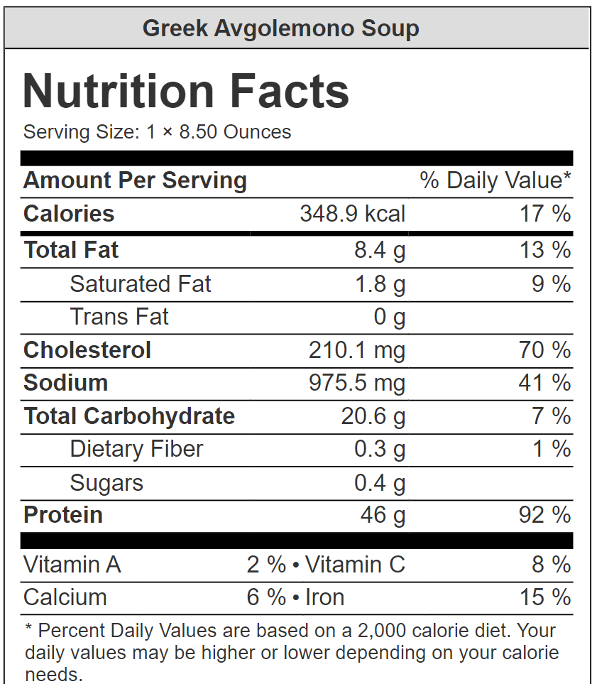

Nutrient Info:

