Golden Milk Smoothie

By:
Kimberly Korff, LDN

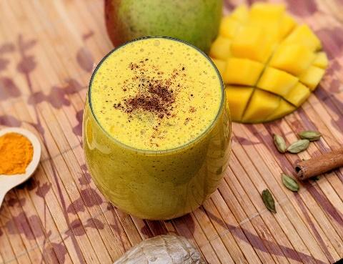

Recipe Ethnicity/Cultural Inspiration: Indian/South Asian

About this recipe:
Golden milk is traditionally a simple Indian beverage – perhaps the origin of today’s turmeric latte. Golden milk typically consists of cow’s milk, turmeric, and other spices and it can be served hot or cold. Turmeric is arguably the most commonly used spice in South Asia and has served in Ayurvedic remedies for centuries. Turmeric brings a warm, rich flavor to dishes. Its active ingredient, curcumin, is a powerful anti-inflammatory compound. This recipe also includes mango, a fruit rich in vitamins C and A, important antioxidants for the body. Don’t skip the black pepper, as this helps to improve the absorption of curcumin in the body.

What side effects recipe can help with:
Combining ingredients in a smoothie can be helpful to cancer patients unable to tolerate solid foods. This recipe may be suitable for those with dry or sore mouth, trouble swallowing, or are requiring relatively simple nutrition. This can also be an excellent breakfast or snack for general cancer prevention and immune support for survivors.

Golden Milk Smoothie

total time: 15 minutes

Servings: 3

Serving Size: 1 cup

Ingredients:
Golden Milk
- 2 cups 1% milk
- 1 tsp ground turmeric
- ½ teaspoon cardamom (ground or 2 green pods)
- ½ teaspoon ginger (ground or 1 slice fresh)
- ¼ tsp cinnamon (ground or 1 stick)
- ¼ teaspoon black pepper
- 1 tsp honey or sweetener (if desired)
Smoothie
- 2 cups brewed golden milk (above)
- 2-3 cups fresh or frozen mango, cubed
- ¼ teaspoon nutmeg (ground)
- ¼ teaspoon cinnamon (ground or 1 stick)

Instructions:
- Place golden milk ingredients in a small pan. Cook, stirring frequently, until warm throughout but not boiling.
- Remove from heat and let cool. Strain milk if whole spices were used.
- Place golden milk and all smoothie ingredients in the blender. Blend until smooth.
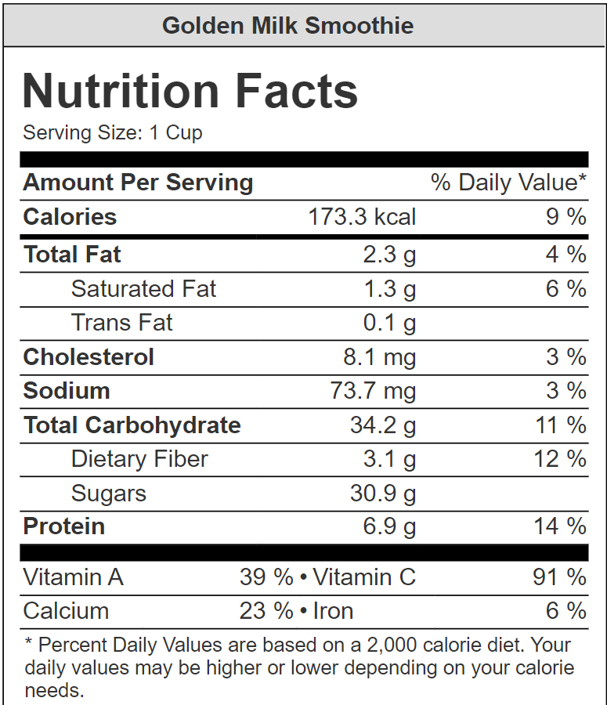

Nutrient Info:

