Chicken Tinola (Tinolang Manok)

By:
Gabbie Sampiano Ricky, MS, RDN, LD

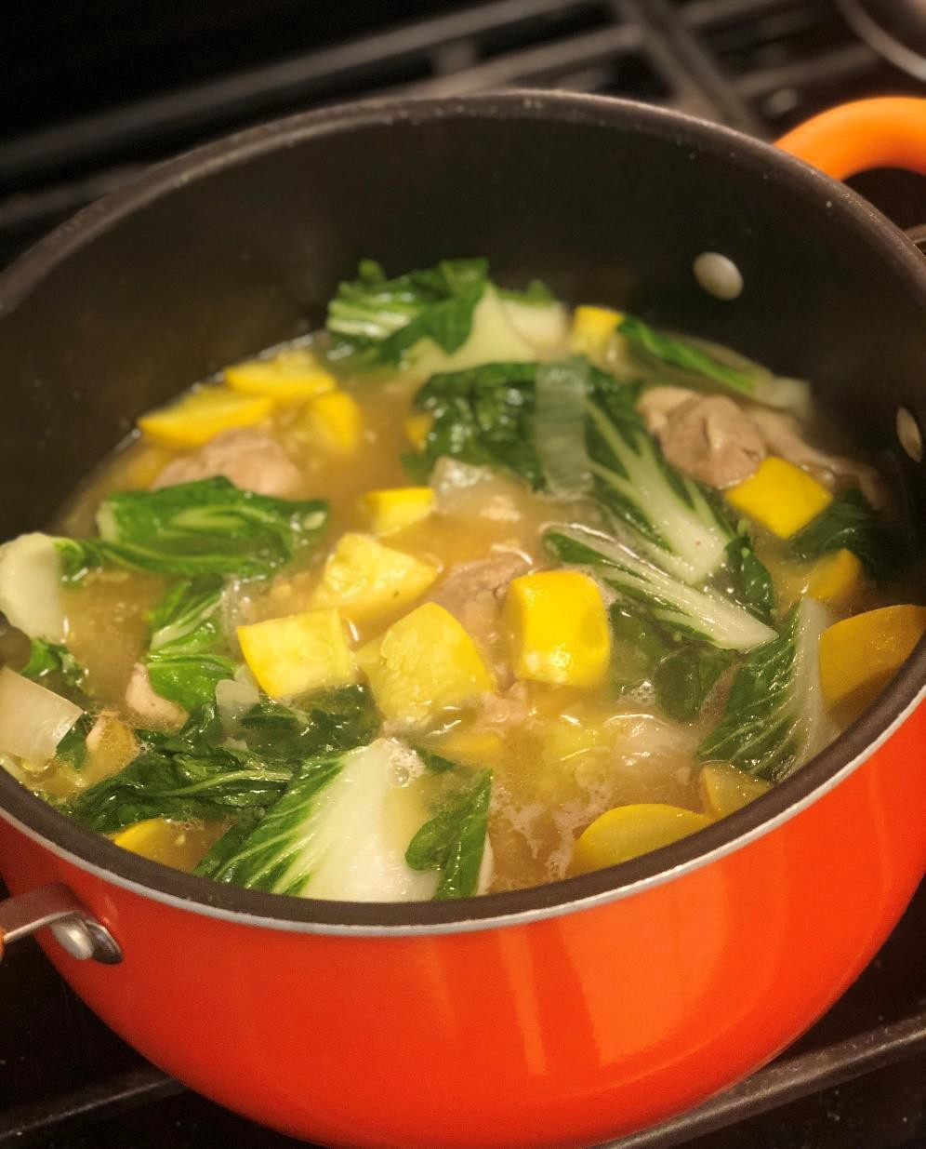

Recipe Ethnicity / Cultural Inspiration: Philippines

About this recipe:
Tinola is a traditional soup dish from the Philippines with recipes that vary slightly by region. It is a supposed favorite of Jose Rizal who was one of the most prominent Filipino nationalists during the Spanish colonial period. The broth is full of flavor from garlic, ginger,
onions, salt and/or fish sauce (patis). You can also enrich the flavor by using bone-in chicken pieces to make your own broth. For this purpose, however, I used skinless boneless chicken thighs.

Chayote and malunggay leaves are the vegetables most commonly used in this Filipino dish, but you can make simple substitutions as needed. Since chayote is a type of summer squash, you can use equal amounts of zucchini or yellow squash. Malunggay leaves are a nutrient-rich leafy green vegetable, but you can use other leafy greens such as bok choy, spinach, Swiss chard, or Napa cabbage as needed or preferred. It is traditionally paired with steamed white rice and often served with a dipping sauce (or sawsawan) made of vinegar, soy sauce, and spices or seasonings per preference.

What side effects recipe can help with:
Cancer treatment can cause symptoms and side effects that make it difficult to eat or drink—this may negatively impact your nutrition status. This Chicken Tinola is a nutrient-dense, mildly flavored soup dish that would be ideal for someone dealing with nausea, sore mouth or throat, taste changes, diarrhea/constipation, and unintended weight loss (common side effects of chemoradiation for head and neck cancers). The chicken is relatively bland and can be well-tolerated if you suffer from taste changes or sore mouth—simply shred the chicken after it is fully cooked. The broth provides additional hydration and electrolytes which are helpful when managing either diarrhea or constipation. Ginger can help combat nausea as well as provide a different flavor for your taste buds if you suffer from taste changes. This recipe is also easily modifiable. If you are dealing with mouth sores, omit the black pepper and fresh sliced ginger for now. You can mix in more squash and leafy greens for
additional fiber to help combat constipation and use more broth for additional hydration. If you prefer
to avoid meat or poultry, you can use grilled or pan-fried fish instead of chicken. For those struggling with poor appetite, early satiety, and unintended weight loss, try mixing in canned coconut cream for additional calories or using a nutrition supplement such as Benecalorie. Also, this dish is a one-pot meal which makes for easy cooking and cleanup for cancer patients and their caregivers

Chicken Tinola (Tinolang Manok)
Servings: 6-7

Serving Size: 1 cup Tinola and ¾ cup white rice

Ingredients:

- A large pot
- 2 tbsp canola oil
- 1 tbsp fish sauce (you can add a pinch or two of salt if you don’t have fish sauce)
- 4 cups of low-sodium chicken broth
- 1 medium yellow onion, sliced
- 2 small or medium yellow squash, chopped into bite-size pieces
- 1 head of bok choy, coarsely chopped
- 1/4 cup of fresh ginger, peeled and julienned, or sliced into coins (per preference)
- 3 cloves of garlic, minced
- 2 pounds of chicken thighs, skinless and boneless
- 3.0 cups white jasmine rice
- Garlic powder
- Onion powder
- Ground ginger
- Ground black pepper

Instructions:

- Cook the rice first, according to the package instructions. I’ve always preferred to use a rice cooker, but you can prepare this on the stovetop if you want.

- Heat 1 tbsp of oil in a large pot over medium heat.

- Add minced garlic and slightly brown. Add onions, fresh ginger, and fish sauce. Cook until the onions are almost translucent. (Note: The fish sauce will smell pretty fishy at first, but it goes away as you continue to cook!)

- Set all of that aside in a bowl and add another tbsp of oil to the pot over medium heat.

- Arrange the chicken thighs evenly in the pot. Season generously with ground ginger, garlic powder, onion powder, and a little bit of ground black pepper. Cook thoroughly, using tongs to flip the chicken until there’s no pink in the center. (Note: The chicken will continue to cook over the next several steps, too!)

- Add the garlic/onion/ginger mix back into the pot with the chicken. Mix everything together and let sit for another 1-2 minutes.

- Pour in 4 cups of chicken broth and bring to a low boil. Add the squash, stir, and cook until softened (4-5 minutes depending on how large or small your squash pieces are).

- Reduce heat from medium to low. Stir in the bok choy and allow the leaves to wilt (another 2-3 minutes).

- The soup is ready to eat at this point! Or, you can leave it on a low simmer for another 10-15 minutes.

Note: When ready to serve, use a medium-sized bowl. Scoop out a serving of white rice and top it off with a helping of Chicken Tinola. Be sure to include enough broth You can add sliced scallions or green onions for garnish, and serve with a side of sawsawan (dipping sauce) if you’d like!

