Caribbean Chicken Stew

By:
Kelly Rashid, RD, CSO
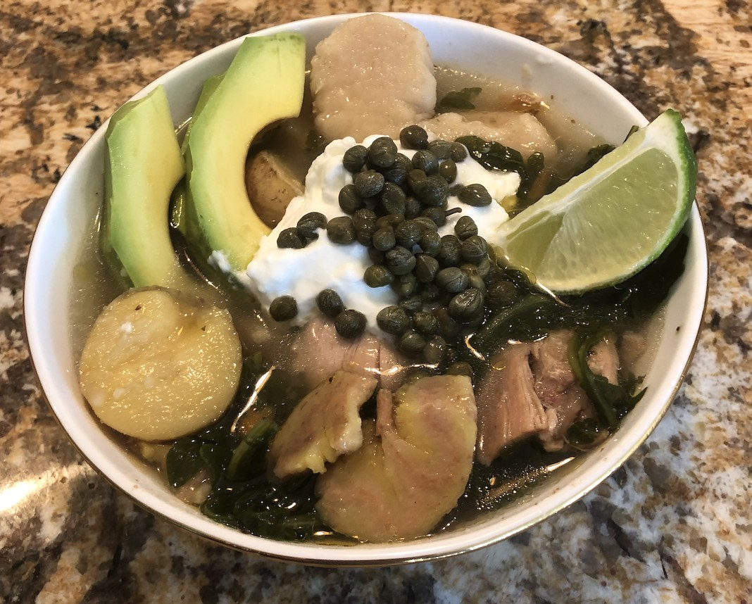

Recipe Ethnicity/Cultural Inspiration: Caribbean fusion with influence from Haitian, Cuban, and Colombian dishes

About this recipe:
It seems that almost every culture has a chicken soup or stew that is a staple for when someone it not feeling well. This stew takes elements from a Haitian Boullion (Bouyon) and Ajiaco soup that is found in Cuban, Colombian, and Peruvian cuisine. Boullion is a hearty stew that is typically made with red meat, vegetables, and starches. Starchy ingredients typically include plantains, malanga, potatoes, and sometimes dumplings. Ajiaco is typically made with chicken, vegetables, corn, and potatoes.
Here we will use chicken as the protein. I chose 3 starches for this stew; plantains, malanga, and potatoes as they are found in both dishes. It is topped with capers, avocado, and sour cream; additions from the Colombian soup. This recipe takes inspiration from each soup and simplifies some steps to make it easier for those who might not have the time or energy to prepare it in the traditional way. While you could use a stove to prepare this, I used an electric pressure cooker to speed up the process. There are several ingredients in this recipe, but the beauty of it is that it is a complete meal in one bowl and only requires one pot to clean!

What side effects recipe can help with:
This stew can be helpful for those with nausea, dry mouth, and chewing difficulties. It can also be helpful for those with taste changes. The caper topping offers a pickled flavor that helps people with a dulled taste sensation appreciate a more recognizable flavor. By toping with avocado and/ or sour cream, you can easily pack in more calories if unintentional weight loss is a problem.

Servings: 12 Serving Size: 2 cups Ingredients:
- 2 limes
- 2 tbsp olive oil
- 1 small onion diced
- 2 cloves of garlic crushed (or more if desired)
- 1 red bell pepper diced
- 3 stalks of celery sliced
- 3 carrots cubed
- 1 green plantain sliced diagonally (about 8 oz)
- 2-3 potatoes peeled and cubed (about 8 oz)
- 1-2 malanga peeled and cubed (about 8 oz)
- 1 tbsp tomato paste
- 3 boxes 12 cups of chicken broth (you could use bone broth for more protein)
- 1 package (about 2 pounds) of boneless, skinless chicken thighs
- 1 bag of spinach
- 1 tsp black pepper
- 1 tsp salt
- 1 tsp oregano

- 1 tsp cumin
- 2 bay leaves
- 1 jalapeño (optional)

Toppings:
- 1 tsp of capers per serving
- 1 tbsp sour cream per serving
- ¼ medium avocado per serving
- ¼ of a lime cut into a wedge

Instructions:

- Marinate chicken thighs in lime juice for one hour. (optional if you don’t have the time)
- Turn on the electric pressure cooker to sauté mode. Once hot, add olive oil, onion, garlic and cook for about 2 minutes.
- Add the spices. Stir.
- Keeping the spinach aside, add the remaining vegetables and starches. Stir.
- Add the chicken and chicken broth.
- Close the lid and turn on the pressure cooker to HIGH PRESSURE for 25 minutes. This will take a while to get to pressure because of the large volume. Be sure you are not over the max fill line of your pressure cooker.
- Once the cooking cycle is complete allow for a natural release of pressure. This will also take time, about 15-20 minutes. After 20 minutes you can use a quick release to relieve any remining pressure. This should take about one hour in total.
- With a long spoon, you can gently break up the chicken thighs. They should easily fall apart into easy to shred pieces.
- Fish out the two bay leaves and discard them.
- Mix in spinach.
- Dish out stew into 2 cup servings.
- Add topping of avocado, capers, sour cream, and lime wedge.
- Enjoy!

