Butternut Squash, Black Bean and Feta Enchiladas

By:
Lee Jackson and Holly Clegg, RDN, LDN
Recipe from the High Fiber chapter of Holly Clegg’s Eating Well Through Cancer cookbook

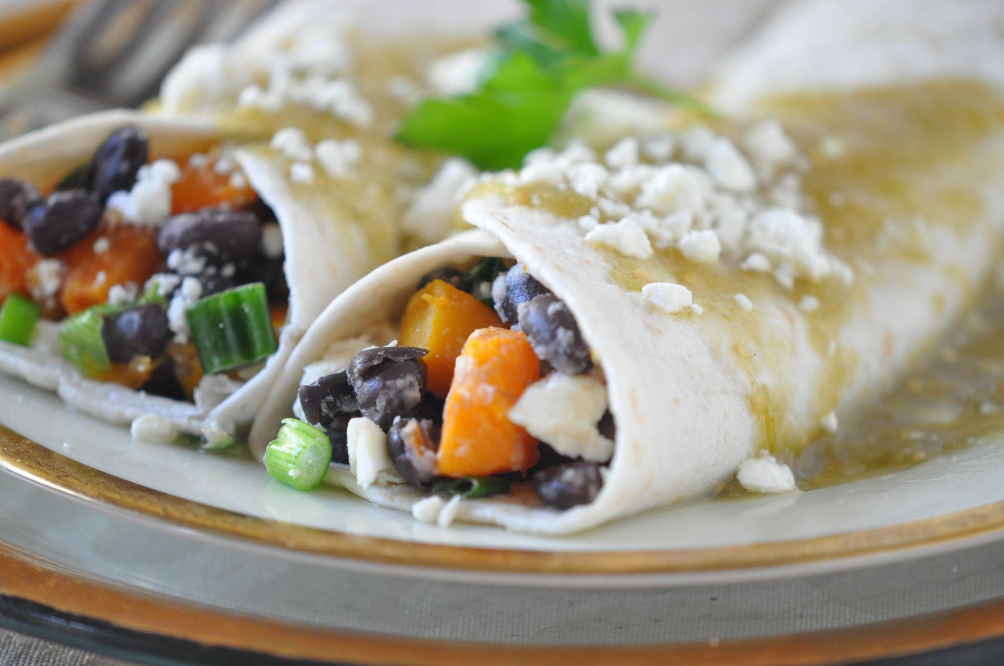

About this recipe:
Butternut Squash, Black Bean, and Feta Enchiladas with Salsa Verde is a mild yet flavorful take on Southwestern food. Salsa Verde gives an easy smooth kick of flavor to these veggie and lentil-filled Vegetarian high fiber enchiladas making them an easy meal to bring to a cancer patient that the whole family and caregivers will enjoy as well.

What side effects can this recipe help with:
Constipation can be a problem at any point throughout cancer treatment and can affect appetite and nourishment. High fiber foods, along with plenty of fluid and regular physical exercise can help aid in bowel movement.

Butternut Squash, Black Bean and Feta Enchiladas with Salsa Verde
Vegetarian, Freezer friendly, Diabetic, Gluten free
Six ingredient vegetarian enchiladas burst with flavor and effortless to make.
Servings: 8

Serving Size: 1 Enchilada

Ingredients:
- 4 cups peeled butternut squash
- 1 (15-ounce) can black beans, rinsed and drained
- 1 bunch green onions, chopped
- 3/4 cup crumbled reduced-fat feta cheese, divided
- 8 large (about 7-inch) corn or flour tortillas
- 2 cups salsa verde

Instructions:
1. Preheat oven 400°F. Coat baking pan with foil and nonstick cooking spray.
2. Place squash on prepared pan and bake 20-25 minutes or until squash is tender but not mushy.
3. Reduce heat to 350°F. In a bowl, combine cooked squash, black beans, green onion, and 1/2 cup feta.
4. Coat a 3-quart oblong baking dish with nonstick cooking spray and spread a little salsa verde on the bottom. Fill tortillas with about 1/2 cup filling, rolling up and place seam side down in dish. Pour remaining sauce over enchiladas. Sprinkle the remaining cheese over the sauce.
5. Cover the pan with foil and bake for 20 minutes are until thoroughly heated.

Terrific Tip: Roasted vegetables are easier to do, easy cleanup, and more flavorful. Look for pre-cut butternut squash in the grocery to save time and energy.

Nutritional Nugget: Use corn tortillas and make this recipe gluten-free.

Recipe from the High Fiber chapter of Holly Clegg’s Eating Well Through Cancer cookbook

Nutrition Information:

