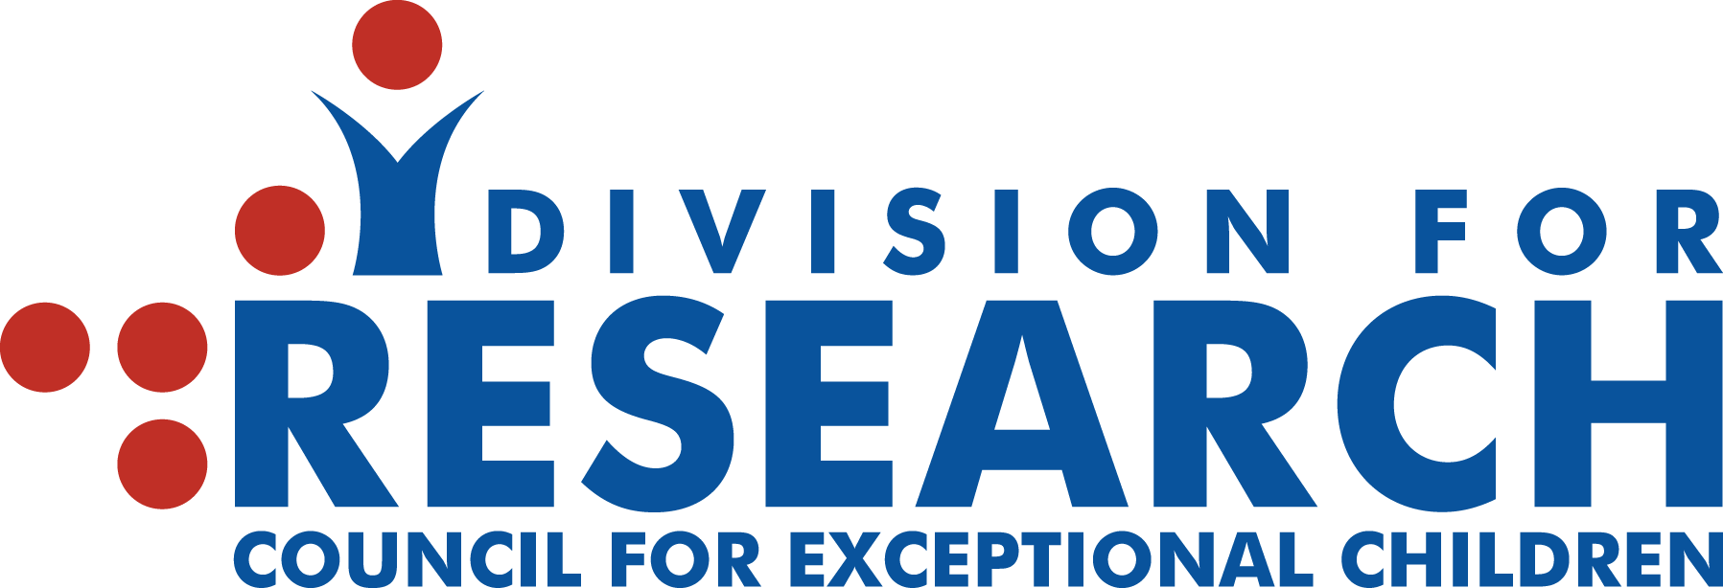

President’s Message, Fall 2018

Urgent, Relentless, and Goal-Directed
David Lee, Pennsylvania State University

Change can be bittersweet. With change comes excitement, but also the realization that things will be different. To that end, each year the members of the Division for Research hold an election for officers. As new officers take their positions, people who have served the Division well over the past few years move on to serve the field (and often DR) in other ways. We have a group of dedicated people who have worked tirelessly to make the research to practice link more evident. I would like to thank Kristen McMaster (President), Betsy Talbot (Past President), and Nancy Mamlin (Treasurer) who have all provided strong leadership, mentoring, and ideas for our group. We also welcome Kathleen Lane (Vice President) and Anne Foegen (Treasurer) to the Board.
The mission statement of the Division for Research indicates that we exist to advance research related to individuals with disabilities and/or who are gifted. Our goals are to promote equal partnerships with practitioners in designing, conducting, and interpreting research in special education. The Division for Research actively engages in activities to promote research in special education. Two recent activities, the CEC-DR Single-Case Workgroup and the response to an IES request for comments, are examples of how our group can make a difference. We are certainly stronger together.
One of our points of focus for this year will be on increasing DR membership—we simply need more members in order to accomplish our goals. There are two steps you can take right now to help DR in this effort. As a first step, please consider speaking with your colleagues and students about becoming an active member of DR. Second, please renew your membership—you are an important part of the team.

