AZCEC & AZCASE in coordination with AASP presents….
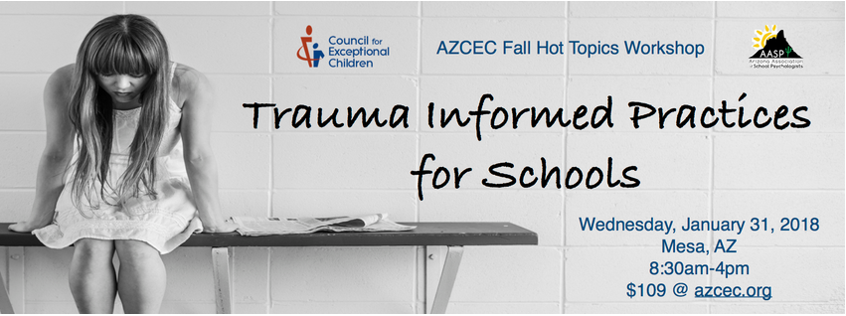
Encore Event!
This workshop is being offered a second time due to popular demand!

Wednesday, January 31, 2018

Mesa Student Services Center
1025 N Country Club Road
Mesa, AZ 85201

7:30-8:30 AM Registration

8:30 AM – 4:00 PM

One out of three children in the United States will experience at least one traumatic event by age 16. These experiences frequently elicit a traumatic stress response, which can impact students’ learning, behavior, formation of relationships, and accomplishment of developmental tasks. The goal of this one-day training is to equip participants with the knowledge of the impact of trauma on the development and behavior of children and youth and the skills to help traumatized students thrive. Activities in this training will help participants to integrate trauma informed practices into the school culture and provide a supportive learning environment for students.

Presented by Debi Neat, M.Ed. Debi has over 35 years of experience in working with adolescents, as a teacher and part of the therapeutic treatment program at the Nevada State correctional facility for youth and as the Prevention Programs Coordinator for the Tolleson Union High School District. Debi is a Learning Systems Facilitator, Coach for KOI Education; Certified Adolescent Health Trainer; Trauma Informed Schools Trainer, and a Lead Trainer for the School Safety and Prevention Unit at the Arizona Department of Education in School Climate and Safety, School Safety Program (SRO grant), Threat Management and Emergency Response Training. Debi Neat has a M.Ed. in Curriculum and Instruction from NAU and retired in 2014 from her 14-year position as the Safe and Drug Free Schools Trainer for the Phoenix Union High School District. In this position, Debi provided staff development workshops to over 2500 employees. Debi has also trained students in Peer Mediation for the campuses, as well as facilitated and provided oversight of prevention/intervention programs and the staff who ran those programs on the campuses.

Learning Outcomes: Over the course of this workshop, participants will:

- Define trauma and describe types of experiences likely to be traumatic for children and adolescents
- Learn how trauma may impact student learning, development and behavior
- Identify the characteristics and components of trauma informed practices in a school setting
- Develop skills to integrate trauma informed practices into school culture and the learning environment

Target Audience: School Psychologists, School Social Workers, Speech/Language Professionals, Principals, Counselors, General Education/Special Education Teachers, Special Education Administrators, Members of MSST Teams, Special Ed Evaluation Teams

$109.00 per person – includes continental breakfast/ lunch and the book:
“Helping Traumatized Children Learn, Vol 1”

Pre-registration is required by January 19, 2018 – Capped at 100 –
First come, first served No refunds after January 19, 2018 - Substitutes OK

Approved for CPD/DHS/ADE Hours
Arizona Association of School Psychologists is approved by the National Association of School Psychologists to offer continuing education for school psychologists (NASP Approved Provider #1013). AASP and AZCEC maintain responsibility for this program. Contact ArizonaCEC1@gmail.com with any concerns or needs regarding this workshop. 7.5 NASP-approved CPDs will be awarded to school psychologists who participate in this workshop in its entirety. Speech/language professionals will receive 7.5 DHS hours. Other participants will receive a certificate indicating 7.5 hours of continuing education that can be used for professional development and/or ADE recertification credit.

AZCEC, AZCASE, & AASP Present:
Trauma Informed Practices for Schools - Wednesday, January 31, 2018

Registration
Pre-registration is required by January 19, 2018 – Capped at 100 –
First come, first served No refunds after January 19, 2018 - Substitutes OK

Name: ___________________________________________ Phone: ____________________________
Email: ___________________________________________ City: ______________________________
School District: ____________________________________ Position: ___________________________

Check enclosed
Here is how to register and pay!

- Send Registration and Check/Purchase Order payable to:
AZCEC, 4850 W Kay T Drive, Tucson, AZ 85745

OR

- Scan and email registration and PO to ArizonaCEC1@gmail.com

A credit card invoice will be emailed to you in 24 hours

Questions? Contact: ArizonaCEC1@gmail.com
Or call 520-870-8274

Purchase Order Enclosed
- Credit card – Request PayPal Invoice

Pl Please specify any special accommodations needed:

Sorry, No refunds Contact us about substitutes.

