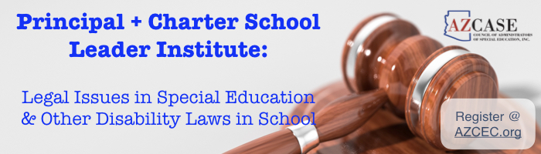
Keeping Your School Safe

Friday, January 18, 2019
Metro Tech High School
1900 W Thomas Rd, Phoenix, AZ 85015
Registration 8:30 AM - Sessions 9:00 AM – 3:00 PM

$109.00/person – includes continental breakfast & lunch
Pre-registration is required by January 9, 2019 Attendance capped at 130- First come, first served

This year’s Institute focuses on Keeping Your School Safe while maintaining the rights and dignity of all students. The goal of this workshop is to provide legal information and practical advice to help principals, building administrators, charter school directors & others in their daily work with students.

Topics to be covered include:
- Student Discipline and Restorative Justice  Suicide and Other Mental Health Issues
- Students on Their Own: Parent and Custody Issues  Student Supports and LRE: 1:1 Nursing & More,
● Attorney Legal “Grab-Bag” – Cautionary Tales, How-to Ideas and Practical Advice

Presenters: Denise Lowell-Britt and others from the Law Firm of Udall Shumway PLC

Each attorney advises and represents public schools and school personnel on a daily basis on a wide range of legal matters, with a significant portion of those matters relating to special education and other disability law situations. The attorneys provide day-to-day legal advice and assistance, defend School Districts and Charter Schools when complaints are filed with ADE and OCR, and represent clients in state and federal courts when litigation cannot be avoided.

Principal & Charter School Leader Institute
January 18, 2019
Registration cost: $109 per person by January 9, 2019

Name: _________________________________________ Position: _______________________________________ Organization: ___________________________________ Email Address: _________________________________

Three ways to register and pay!

- Send Registration and Check/Purchase Order payable to:
AZCEC, 4850 W Kay T Drive, Tucson, AZ 85745

- Scan/ email registration and PO to ArizonaCEC1@gmail.com

- Scan/email registration form with request to pay via credit card. A credit card invoice will be emailed to you in 24 hours

Questions? Please email: ArizonaCEC1@gmail.com or call: 520-870-8274

Phone Contact: _________________________________
Check enclosed
Purchase Order Enclosed
Request PayPal Invoice (credit card)

Sorry, no refunds… but substitutions are OK!

Please specify any special accommodations needed:

