3rd Annual UK Student Paper Contest

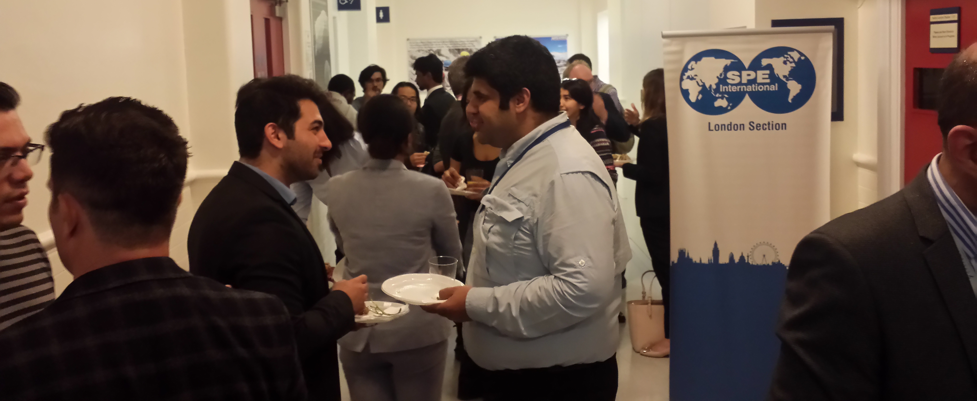

On Thursday 10th September 2015 the SPE YP London section hosted the third edition of its annual student paper contest (SPC) at Imperial College (IC) London.

The event was the final stage of a competition that attracted over 30 abstracts from 9 universities all over the UK, with five finalists from IC, Coventry University and University of Leeds invited to present their research.

After some refreshments Adriana Pinzon, chairman of the SPE YP London opened the evening and introduced the adjudicating panel. The competition began in earnest with a presentation on thin oil reservoir development. This was followed by two more presentations before the break. The research topics presented were wide ranging and captivated the audience, from simulation of surfactant and polymer flooding to multiwell deconvolution.

Despite all the seriousness, the evening also had its fair share of light conversation, especially during the break. In that time the presenters, audience and jury were able to mix and get to know each other better over food and drinks sponsored by E.ON E&P.

The two remaining papers were presented and they proved to be just as interesting as their predecessors. The evening was rounded off by 9.00pm, with the announcement of the winner, Mr. Yit Xiang for his paper on “Multiwell Deconvolution for Shale Gas” and that of the runner up Miss Xutong Li for her research on “Waterflood Management Optimisation Using Streamline Technology”.

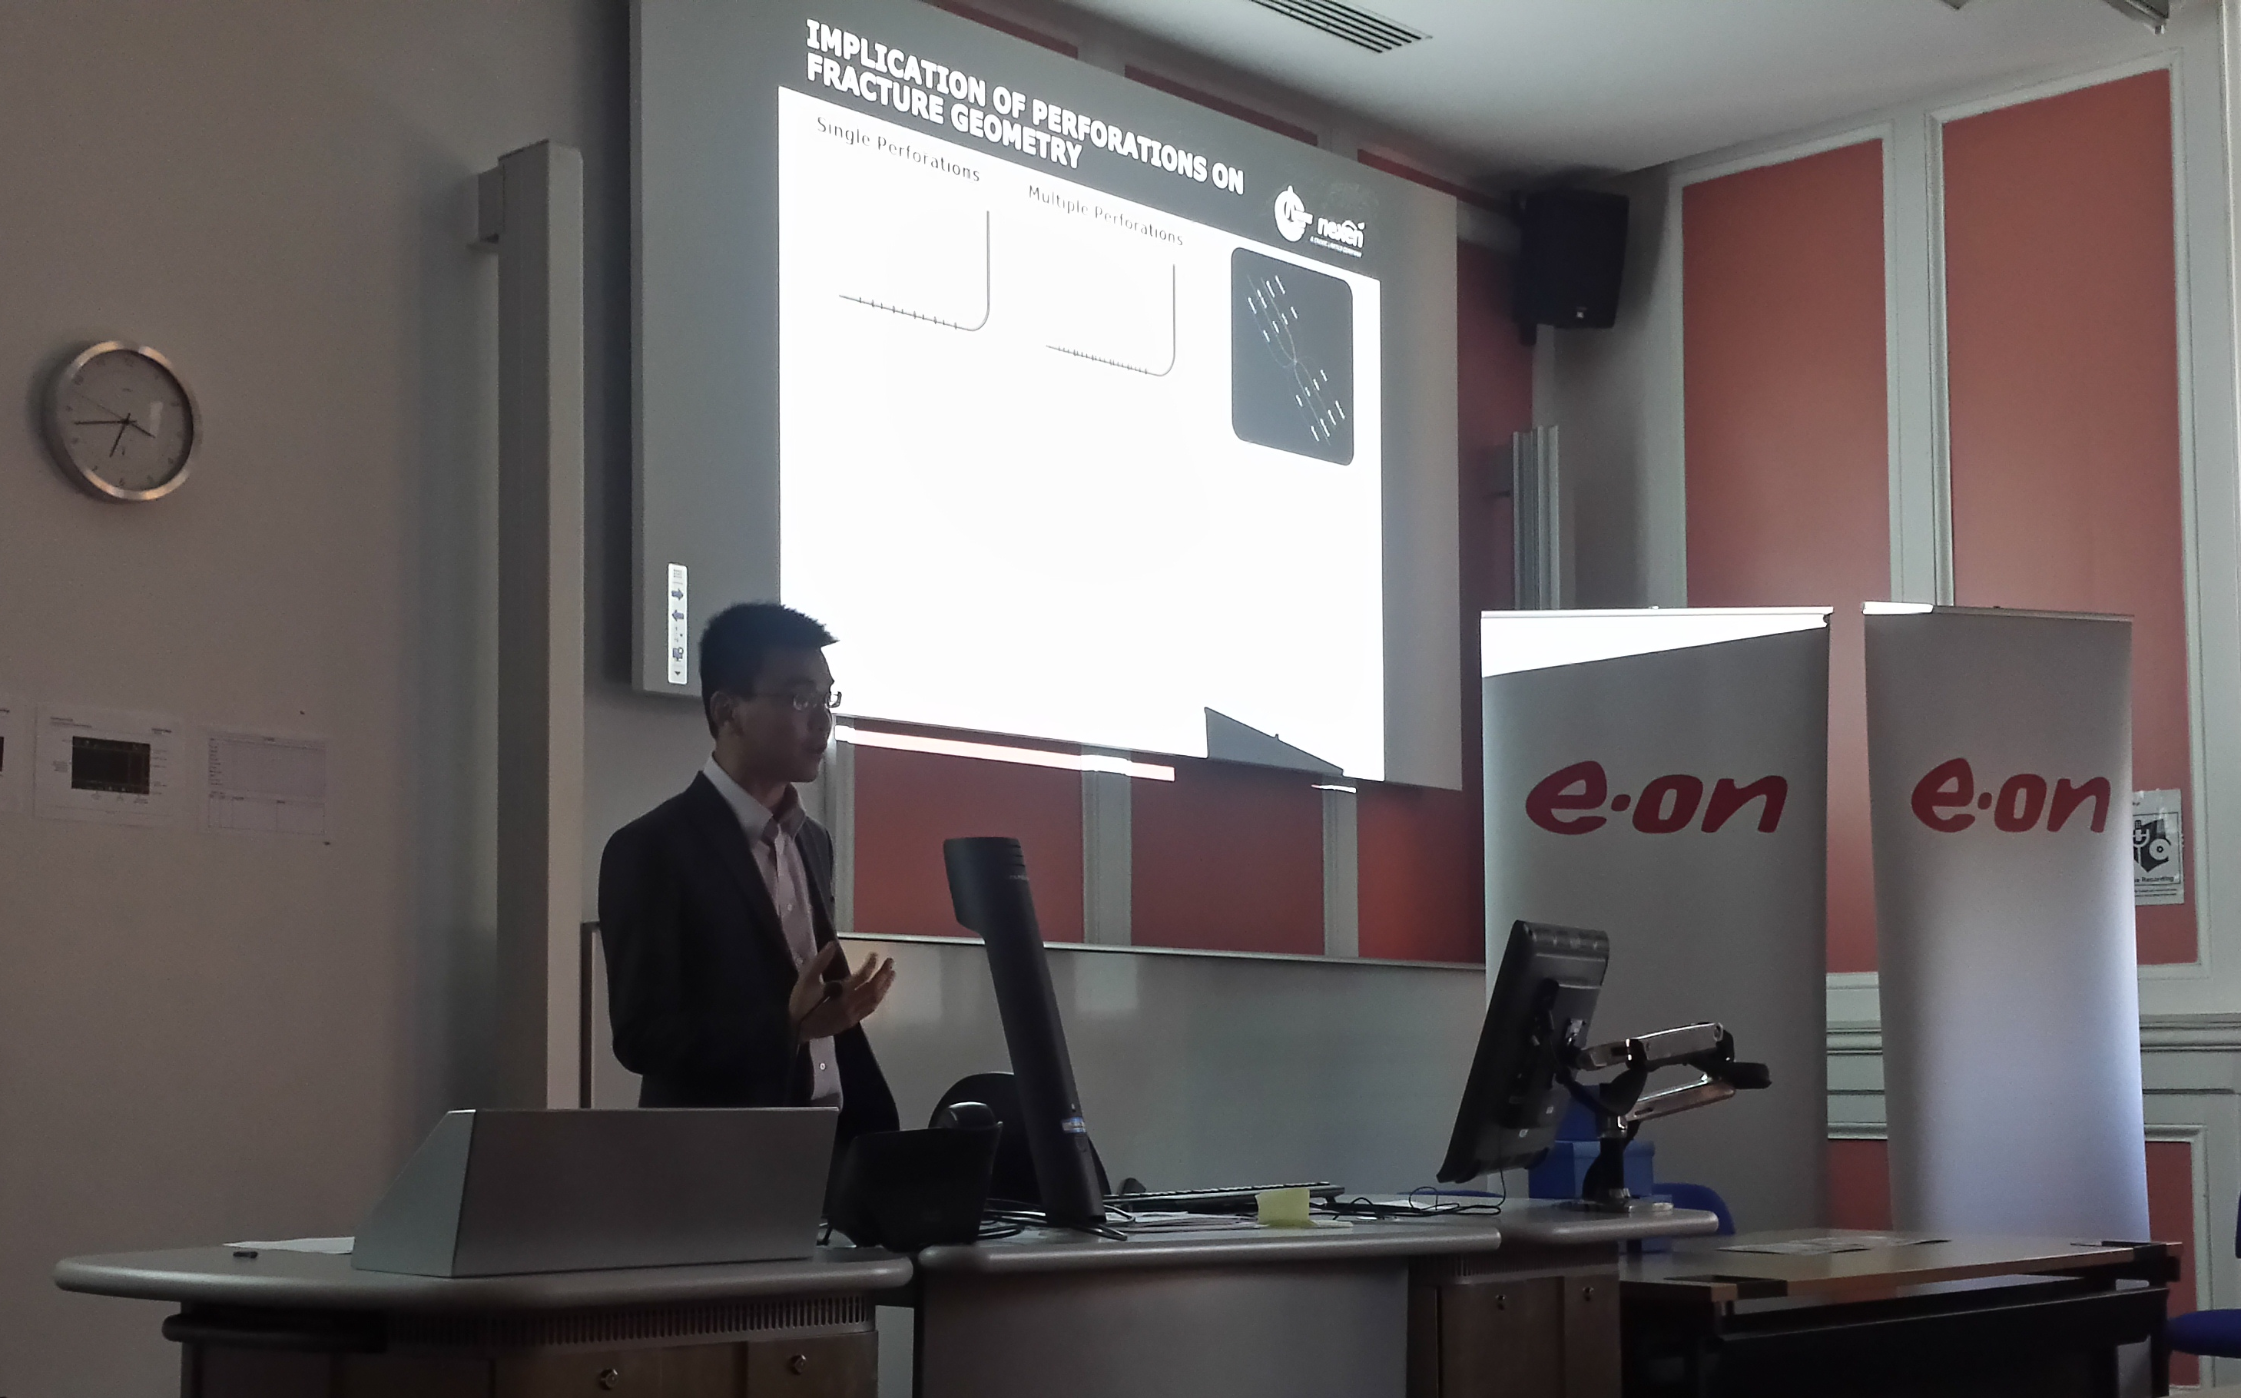
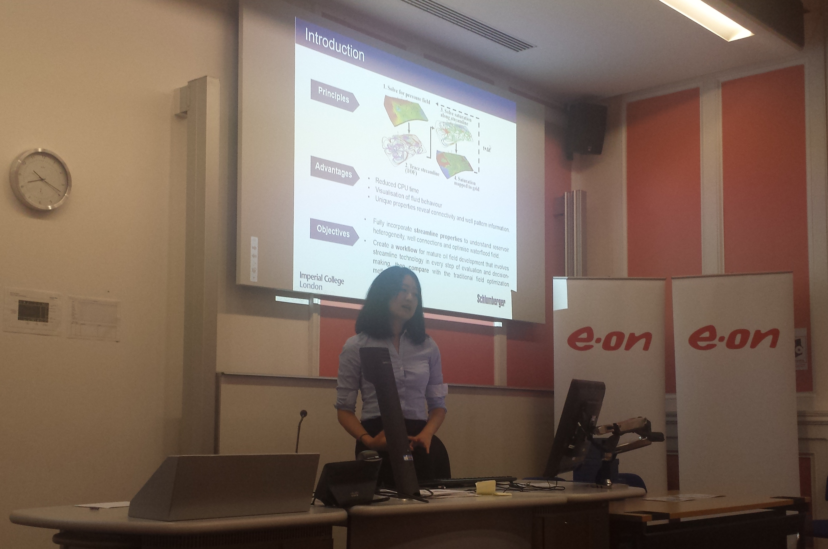
Yit Xiang, winner of 2015 SPC
Xutong Li, runner up of 2015 SPC

The SPE YP London would like to thank E.ON E&P for their kind sponsorship and Imperial College for hosting us. In addition, we would like to thank the jury panel, IC SPE Student Chapter for their involvement and all the students who took part, without whom this event would not have been possible.

