

**Issue 402 Nov-Dec 2022**

SPE SJV News

San Joaquin Valley Section

Society of Petroleum Engineers

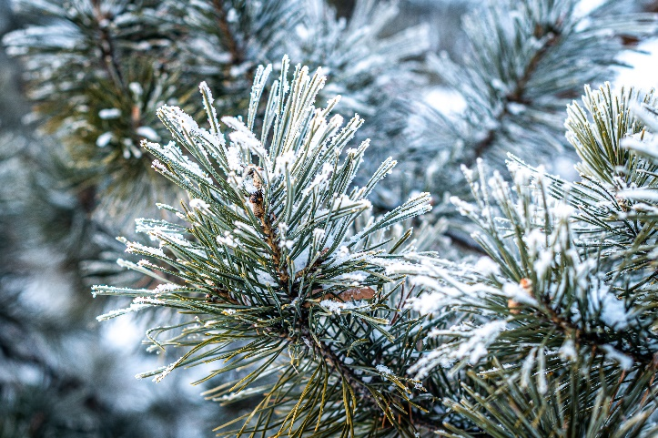



**Inside this issue:**

* From the Chair 2
* Upcoming events 3-8
* 2022/2023 board & openings 9-10
* Scholarship info 11
* Membership information 12
* Sponsorship 13-15

**Visit the SJV SPE website or Follow on LinkedIn:**

<https://connect.spe.org/sjv/home>

[SPE (San Joaquin Valley Chapter) | LinkedIn](https://www.linkedin.com/in/spe-san-joaquin-valley-chapter-a79102198/)

FRoM THE CHair

Geordie Chambers, CHEVRON

Dear SJV Section Members,

I would like to start out by thanking everyone who helped plan and/or attended our October General Section Meeting with SPE Distinguished Lecturer. Darryl Tompkins gave a great overview of production monitoring metering methods and techniques to identify data issues.

Consider signing up to attend our December events, more details are available in the newsletter with details and how to sign up:

* **General Section Meeting** **Thursday, December 8thh** Featuring Ramon Elias at the Chevron 9500 Ming Ave. office
* **Virtual Distinguished Lecture** **Thursday, October 20th** Featuring Arash Dahi Taleghani
* **Golf Outing**, **Monday, December 12** at Seven Oaks Country Club, sign up now

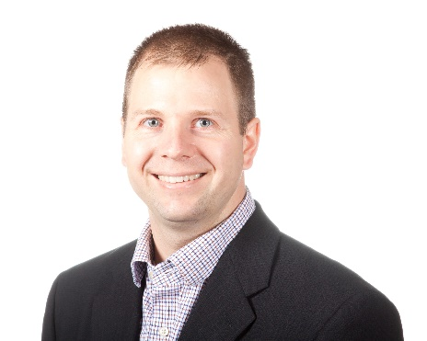

Hope to see everyone soon, please feel free to contact me about anything. Also, there are still lots of opportunities to get involved, including open positions on the board.

**Geordie Chambers (SJV SPE Section Chairman)**

[Geordie.Chambers@Chevron.com](mailto:Geordie.Chambers@Chevron.com?subject=SJV%20SPE)

[SJVsection@Spemail.org](mailto:SJVsection@Spemail.org)

[Geordie Chambers | LinkedIn](https://www.linkedin.com/in/geordie-chambers/)



## General Section Meeting

**Thursday, December 8, 2022**

**The SPE San Joaquin Valley Section Invites you to attend a General Meeting in Bakersfield, California, featuring our guest speaker**

**Ramon Elias**

**Santa Maria Energy & Mason Medizade, CalPoly SLO**

**Matrix Flow Cyclic Steam Injection in the Diatomite zone, Orcutt Field**

Discussion of the continued success seen with steam injection tracking and monitoring using modified Hall plots and their derivatives. Matrix flow in the diatomite modeling using industry accepted analytical calculations for determining a host of parameters including steam zone flow capacity (kh), steam injection rates that avoid formation parting, and the zone of endangering influence (ZEI) needed for UIC approvals.

An cyclic steam case history showing that modified Hall plots provide an alternative method for determining the formation parting flow rate (FPR) in lieu of the formation parting pressure (FPP). As step-rate tests are not reliable (SPE 169513-MS) for determining the FPP. The study shows there to be a wide range of diatomite steam zone injection conditions that do not cause parting or fracturing of the diatomite by steam injection. Real -time Hall plots also provide valuable insights as to how injection zone properties change as the project matures. The project monitoring protocols originally described in our 2013 paper continue to be used with safe and reliable outcomes confirmed by thousands of successful project CSS injection operations.

**Biography**

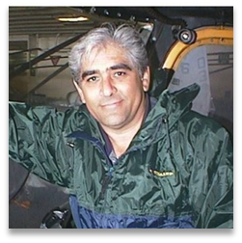 **Ray Elias is a California resident, engineer, scientist, inventor, and area business owner. His career spans over 49 years in energy and business both in the U.S. and abroad. His career started with Getty Oil Company in Bakersfield. His work experience spans field operations, research, process design, reservoir computer simulation, EOR, consulting, and management. He has authored over 25 technical papers domestically and abroad, has been awarded U.S. patents, and is an executive officer and co-founder of Santa Maria Energy and Pacific AgriTec.**

Time:  Doors open at 11:00AM

              Lunch will be served at 11:30 AM

                  Guest Speaker at 11:35 AM

Location:       Chevron Conference Room F - 1056

                    9500 Ming Ave. / Bakersfield, CA 93311

Registration: Special pricing is available for the meeting $10 per person – Register and pay at [SJV.SPE.ORG](http://sjv.spe.org/home) or use this link

If you have questions or difficulty registering, contact the Program Chair at [mark.wolf@wolfprocess.com](mailto:mark.wolf@wolfprocess.com)



## Virtual Distinguished Lecturer

**Wednesday, 14th December 2022**

**Arash Dahi Taleghani**

**Penn State University**

**On Repurposing Oil and Gas Wells to Geothermal Wells**

The number of abandoned oil and gas wells are growing over millions, significant costs are imposed to companies and government for decommissioning these wells. However, it would be very encouraging for the oil and gas industry to take advantage of these wells and use them as a source of geothermal energy. Huge upfront costs have always been a major obstacle for the development of geothermal energy. As a rule of thumb, a quarter of the costs for harvesting geothermal energy is going toward drilling and one third of the costs is spent for completions.

One obvious solution is avoiding these costs by repurposing existing oil and gas wells to generate geothermal power at the end of their economic production life. In some regions of extensive hydrocarbon explorations, the geothermal gradient can be very steep, providing potential well candidates for conversion. Taking into consideration the local energy demand, potential market, existing infrastructure, and technical challenges, a conversion strategy for the existing wells is discussed specially in terms of the wellbore integrity requirement and steps to ensure hydrocarbon containment during the heat extraction process. Potential challenges in inspection and preparation of these wells in terms of well integrity and productivity with possible remedies will be discussed in this presentation.

**Biography**

Dr. Arash Dahi Taleghani is a tenured associate professor of petroleum engineering at Pennsylvania State University. Before joining Penn State, he was an associate professor of Petroleum Engineering at Louisiana State University. He earned his Ph.D. in Petroleum Engineering from the University of Texas at Austin. He has about 12 years combined experience in applied engineering, research and in academia and is a registered professional engineer.

Time:  Talk is scheduled from 11:30 AM – 12:30 PM

Location:       Virtual

Registration: Link to sign up an log in:



## 2022 GSM Schedule

|  |  |  |  |
| --- | --- | --- | --- |
| Month | Speaker | Company | Topic |
| 9/22/2022 | Courtney Lucente | Tre-Altamira | Satellite Based InSAR for ground displacement Measurement |
| 10/20/2022 | Bo Lu | Rockwater | Value-adding to Mature Field with “Green” Microbial Technology |
| 11/9/2022 | Darryl Tompkins | SPE-Distinguished Lecturer | An Examination of the Effects of Surface Data Acquisition Methods on Well Performance Evaluations and Completion Optimization |
| 12/8/2022 | Ray Elias | Santa Maria Energy | Matrix Flow Cyclic Steam Injection in the Diatomite zone, Orcutt Field  Santa Barbara County, California |
| 12/14/2022 | Arash Dahi Taleghani | SPE-DL Virtual | Virtual - On Repurposing Oil and Gas Wells to Geothermal Wells |
| 1/19/2023 | Dr. Amber Krummel | Revelant | Vibration Physics for solving flow assurance problems |
| 2/16/2023 | TBA | Tracerco | TBA |
| 3/14/2023 | Samuel Krevor | SPE-DL Virtual | Virtual -From digital rocks to gigatonne scale CO2 storage:  two revolutions in one |
| 3/23/2023 | David Gregory/ Shawn Poworoznik | Flexsteel | Converting Liabilities into Assets: Rehabilitating Ageing Infrastructure using Steel-Reinforced Thermoplastic Pipe for Carbon Capture Applications |
| 4/20/2023 | Winston Seiler | KCSI Aerial Patrol | Aerial Patrol and imagery for the oil and gas industry |
| 5/18/2023 | TBA | TBA | TBA |
| 7/20/2023 | TBA | TBA | TBA |



## Golf outing

The SPE San Joaquin Valley Chapter is excited to bring back the annual golf tournament. We are dedicating this year to engagement with our members, community, and industry. The 2022 golf outing is our way of uniting everyone in support of our local SPE chapter and our student scholarships, while offering the opportunity for networking and collaboration. We are honored to be invited to host the event at Seven Oaks Country club allowing our membership the exclusive chance to play one of the most spectacular courses in California.

Our Golf outing will be held **Monday December 12th 2022**, what better way is there to start the week? Final timing and sequence of events will be distributed prior to the event. Our shotgun start will occur in the morning (roughly around 8 am). Please plan to arrive early to register your team.

We look forward to this spectacular event. Please sign up early as a limited number of spots will be offered ensuring a reasonable and enjoyable pace of play for all. Proceeds from this event are to support our SPE Chapter and our Scholarship fund. Please remember to encourage your eligible children to apply for the scholarship! <http://sjv.spe.org/aboutus/scholarships>

[**Individual – 180 USD**](https://buy.stripe.com/eVa2bYdVA6a3aAw9AM)

[**Team – 675 USD**](https://buy.stripe.com/4gwaIuaJo8ib4c8dR3)

**Every** participant will get a door prize (golf equipment, sports paraphernalia, wine/spirits, and more!).

For more information on the golf tournament please contact our activities coordinator:

**Alex Lubchansky**

[alexander.lubchansky@gmail.com](mailto:alubchansky@tyrionintegration.com)



## Golf outing Sponsorship

|  |  |  |
| --- | --- | --- |
| **Sponsorship Levels** | Donation | Details |
| Diamond (1 Available) | $4,500.00 | 4 teams, banner, Company branded balls, hole sign (Deadline for logo submission November 1st) |
| Platinum (2 Available) | $2,500.00 | 3 teams and hole sign (Deadline for logo submission November 1st) |
| Gold (4 Available) | $2,000.00 | 2 teams and hole sign (Deadline for logo submission November 1st) |
| Silver (6 Available) | $1,500.00 | 1 team with advertisement and recognition on Website, at the event, and in emails (Deadline for logo submission November 1st) |
| Tee | $250.00 | Tee sign with your company logo at a hole (Deadline for logo submission November 1st) |
| Team | $675.00 |  |
| Individual | $180.00 | Teams take priority, we will do our best to accommodate single players |
| Other options available: Contact Alex for details and options to fit your needs | TBD | (Breakfast Sponsor, Beverage Sponsor, Lunch Sponsor, high end whisky/ wine give away, hottest driver give away, Hottest putter give away, etc) |
|  |  |  |
| **“Games” can be purchased ahead of time or at the event** | Donation | Details |
| Mulligan Card | $25 | 4 max per team- self explanatory |
| Pink Ball | $125 | Must be used by rotating person each hole for all their shots. If the ball remains at the end of the round it is put into a hat and a winner is drawn and rewarded with 50-50 split of proceeds. It also allows you to drive from the Red (Ladies) tees **once per person** using the ball for as long as you have the ball (ball is lost, you forfeit your Red Tee drive). Please keep it honest. |

For more information on the golf tournament please contact our activities coordinator:

**Alex Lubchansky**

[alexander.lubchansky@gmail.com](mailto:alubchansky@tyrionintegration.com)



## SJV SPE board of directors 2022/2023

|  |  |  |
| --- | --- | --- |
| **Position** | **Name** | **Contact E-mail** |
| Chair | Geordie Chambers | [Geordie.Chambers@chevron.com](mailto:Geordie.Chambers@chevron.com) |
| Program Chair | Mark Wolf | [mark.wolf@wolfprocess.com](mailto:mark.wolf@wolfprocess.com) |
| Treasurer | Peter New | [Peter.New@chevron.com](mailto:Peter.New@chevron.com) |
| Secretary | Jared Paddock | [Jared.Paddock@chevron.com](mailto:Peter.New@chevron.com) |
| Membership | Amanda Callahan | [Amanda.Callahan@crc.com](mailto:Amanda.Callahan@crc.com) |
| Awards | Gwyn Mali | [gwynmali@chevron.com](mailto:gwynmali@chevron.com) |
| Subsurface | Ivan Patino | Ivan.Patino@borets.com |
| Community Outreach | Dylan Chennault | [dchennault@outlook.com](mailto:dchennault@outlook.com) |
| YP/CSUB Liaison | Jarred Ghilarducci | [jarred.ghilarducci@ebresources.com](mailto:jarred.ghilarducci@ebresources.com) |
| CSUB Faculty Advisor | Dr Saini | [dsaini@csub.edu](mailto:dsaini@csub.edu) |
| Activities / Golf | Alex Lubchansky | alexander.lubchansky@gmail.com |



## 2022-2023 SJV SPE Open Positions

Currently seeking individuals interested to serve on the SPE board for opportunities including (but not limited to) the following positions: continuing education, regulatory study group, and newsletter editor

Self-nomination is accepted. Upon completing this form, please email it to Geordie.Chambers@chevron.com.

|  |  |
| --- | --- |
| Personal Information |  |
| Name |  |
| Phone |  |
| E-mail |  |
| Company Affiliation |  |
| Job Title |  |

**Brief work history:**

**SPE & Petroleum Industry Contributions:**

**Candidate Synopsis:**



## College Scholarship Program

The San Joaquin Valley (SJV) chapter of the Society of Petroleum Engineers offers a college scholarship every year to support our community and our members. The scholarship program assists with education costs for students interested in the energy industry. The majority of the funds are generated from volunteer efforts of local SPE members, and the support of the oil industry. Please continue this support for the SJV chapter of SPE to help us continue our scholarship program.

Stay tuned for more information on our 2023-2024 scholarships.

Scholarships will be awarded to graduating high school seniors & undergraduate-level college students. Awarded candidates will be selected based on academic achievement and overall strength of the applicant pool

To be eligible an applicant must be a student pursuing a degree in a petroleum-related field (any branch of engineering, environmental or earth sciences) and any of the following:

• A California resident

• Have petroleum industry work experience in California (e.g. internship)

• The child of a current San Joaquin Valley SPE member

For more information, please contact:

**Dylan Chennault**

[dchennault@outlook.com](mailto:dchennault@outlook.com)

Community Outreach Director

SJVSPEscholarships@gmail.com

http://connect.spe.org/sjv/aboutus/scholarships



## A Note from the Membership Chair

The Society of Petroleum Engineers is not just for engineers. Below is a quick list of some of the benefits a membership offers. Membership includes one SPE Local

Section: [San Joaquin Valley (SJV) Section of SPE](https://connect.spe.org/sjv/home)

**Member Benefits**

• Conference and Workshop Discounts – for technical knowledge and interaction

• SPE Bookstore and Magazines – Journal of Petroleum Technology (JPT)

• Technical Papers and Libraries – access to OnePetro, largest online technical library

• Career Advancement – Leadership and volunteer opportunities, Career Center for tools

• Purchases – discounts on insurance, car rental, Lands’ end Business Outfitters

• Use Membership Icon in emails

**Is it time to renew? YES! By keeping your membership, you’ll continue to have be on our distribution list for networking, newsletters, seminars, training, and access to additional information and resources to help you thrive in this industry. Please share the goodness and pass to coworkers who aren’t members yet.**

**Join or Renew online:** [**www.spe.org/join**](http://www.spe.org/join)

**Tip: Set your email preferences with SPE:** [**www.connect.spe.org**](https://chevron-my.sharepoint.com/personal/geordie_chambers_chevron_com/Documents/Geordie/SPE/President/www.connect.spe.org) **&** [**www.spe.org**](https://chevron-my.sharepoint.com/personal/geordie_chambers_chevron_com/Documents/Geordie/SPE/President/www.spe.org)

**Keep your SPE profile up to date:**

* Keeping your profile up to date is a good way to rip the most benefits from your membership. You can set your communication preferences, stay in touch with the local community, hear about training and possible volunteer opportunities
  + Go to spe.org then click ‘My profile’ [MyAccount](https://www.spe.org/member/access/MyAccount)
  + You can review all the various section from the menu on the left
* Maintain your preferences and employment information accurately to get the most out of your membership

For more information, please contact:

**Amanda Callahan**

[Amanda.Callahan@crc.com](mailto:Amanda.Callahan@crc.com)

Membership



## Advertise with us

## and reach out to hundreds of local oil and gas professionals in Kern County

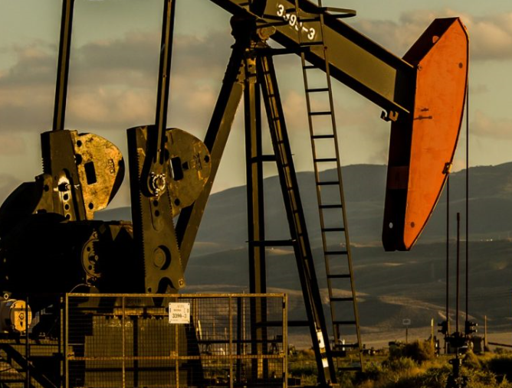

* **Quarterly newsletter and website advertisement:**
* Your advertisement will be placed in the monthly newsletter and our website
* [Online Payment Link](https://society-of-petroleum-engineers-san-joaquin-valley-section.square.site/product/newsletter-advertisement/24?cs=true) (select the desired size option). See rates on the next page
* **Technical meetings sponsorship:**
* Your business name will be included in our email blasts, newsletter and a brief introduction before the technical event.
* [Online Payment Link](https://society-of-petroleum-engineers-san-joaquin-valley-section.square.site/product/newsletter-advertisement/24?cs=true) (select “General Section Meeting). See rates on the next page
* **Networking event sponsorship:**
* Your business name will be included in our email blasts and the newsletter
* You also have the opportunity to advertise your business during the networking event.



## SJV SPE Sponsorship opportunities

San Joaquin Valley Section of Society of Petroleum Engineers

8200 Stockdale Hwy Ste M10-240, Bakersfield, CA 93311

<https://connect.spe.org/sjv/home> • Taxpayer ID# 75-2001539

|  |  |
| --- | --- |
| Company Information | |
| Company |  |
| Address |  |
| City, State, Zip Code |  |
| Phone |  |
| Email Address |  |
| Contact Name |  |
| Date of Request |  |

|  |  |
| --- | --- |
| Item | Rate |
| □ ¼ Page | $100 |
| □ ½ Page | $200 |
| □ Full Page | $400 |
| □ Happy Hour | $250 |
| □ 2022 Golf Tournament | Varies |

*We offer discounts off the above prices, for bulk purchases.

To sign up please contact our treasurer

Peter New ([Peter.New@chevron.com](mailto:Peter.New@chevron.com))



## A big thank you to our WRM sponsors

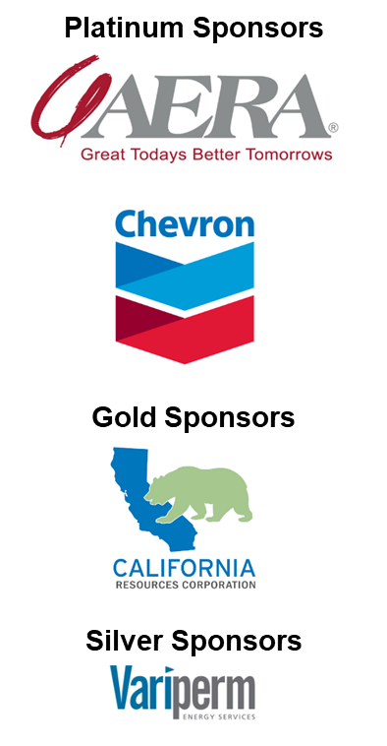

**Visit the SJV SPE website or Follow on LinkedIn:**

<https://connect.spe.org/sjv/home>

[SPE (San Joaquin Valley Chapter) | LinkedIn](https://www.linkedin.com/in/spe-san-joaquin-valley-chapter-a79102198/)