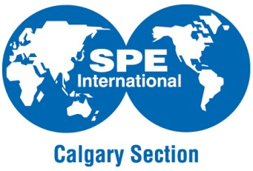
Society of Petroleum Engineers
Calgary Section Young Professionals

Committee Volunteer Application Form
2017-2018

First Name: Click here to enter text. Last Name: Click here to enter text.

Direct Phone: Click here to enter text. Email: Click here to enter text.

Company: Click here to enter text. Position: Click here to enter text.

SPE Member Number (if applicable): Click here to enter text.

Committee Positions

The following are the positions on the SPE YP Committee Term:

Programs Team Lead | Events Team Lead | G&D Team Lead
Technical Development Advisor | Events Team | Growth & Development Team
Workshop Development Advisor  Treasurer | Sponsorship Representative  Corporate Representatives | Marketing Lead  Marketing Director

Please rank your top 3 positions of interest below:
1st Choice | 2nd Choice | 3rd Choice

In 300 words or less, please discuss your interest in volunteering with the Society of Petroleum Engineers Young Professionals, being sure to include: Why you want to join the committee, where do you see value in enhancing your professional development, and how you can contribute to the YP committee in the positions you have selected above.

In 100 words or less, please discuss your thoughts on the importance of the SPE YP and its purpose in our industry.

In 300 words or less, please outline your previous volunteer activities, being sure to include any important skills you think would benefit the SPE YP in achieving its goals (as you have defined in the previous question)

After review, successful applicants will be contacted by a current YP committee member to discuss their interests. An informal interview process may be conducted at the discretion of the committee leads to determine if the selected role is the best fit for you within the organization. Note that there are a limited number of vacancies on the committee. If you are not contacted to join the committee, we still encourage you to get involved with the SPE and SPE YP by attending our activities, and there may be opportunities to engage as a volunteer in other capacities throughout the year.

By applying to the Society of Petroleum Engineers’ Young Professional committee, you agree to serve as a committee member from July 1st 2017 until June 30th, 2018 if selected.

Signature: _______________________________ Date: ___________________________________

Please email completed forms to Laura Weeden (laura.weeden@specalgary.com).

Application Due Date: Monday April 24th, 2017 (5:00 p.m.)

Thank you for your interest in joining the Society of Petroleum Engineers Young Professionals!

