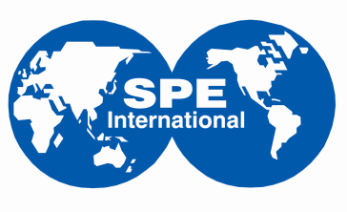

SPE Annual Oloibiri Lecture Series & Energy Forum (OLEF 2021)

Theme: Operational Excellence and Portfolio Optimization, way forward for the Oil and Gas Industry

Sponsorship Opportunities

Your Investment,

Any income from this event will be invested back into SPE to support many other Society programs. When you support or attend an SPE event, you help provide even more opportunities for industry professionals to enhance their technical and professional competence. The Scholarship programs, the Student Chapter programs, the Catch Them Young program, the Distinguished Lecturer program and the SPE’s Energy Education program, Energy4me, are just a few examples that are supported by SPE.

The following broad categories of sponsorship opportunities are available for the 2021 edition of the annual lecture:

Category | Sponsorship Level | Sponsorship Slots | Sponsorship Recognition
Platinum | N4 million | Single | Speech opportunity at event  Venue branding (Centre Stage and Entrance)  Logo insert in all event documentation  Announcement as Sponsor at Event
Gold | N3 million | Multiple | Venue branding (Centre Stage and Entrance)  Logo insert in all event documentation  Announcement as Sponsor at Event
Silver | N2 million | Multiple | Venue branding ( Entrance)  Logo insert in all event documentation  Announcement as Sponsor at Event
Bronze | N1 million | Multiple | Venue branding ( Entrance)  Logo insert in all event documentation  Announcement as Sponsor at Event

To reserve a sponsorship slot, please contact OLEF 2021 Committee Chairman – Mr. Michael Oyere (MOyere@seplatpetroleum.com or call 07035053028) or Basil Okpa (spenc-secretariat@spenigeriacouncill.org) before February 26, 2021.

Event details: http://spenigeria.spe.org/oloibiri

