SPE California
Sustainability Study Group Webinar

Thursday August 20 at 12:00pm (noon) Pacific Time

Ken Haney California Resources Corporation
“The Elk Hill CO2 Carbon Capture & Underground Storage Project”

Mr. Haney will present an overview and the current status of this exciting project—the first CCUS project in California.

The Elk Hills Oil field is a fully developed, multi-reservoir, multi-structure oil production complex ~35 miles southwest of Bakersfield, CA. The Stevens Main Body B and Northwest Stevens A3-A6 sands are the initial targets for CO2 miscible flooding in Elk Hills. The Stevens sand complex, in combination with the overlying Reef Ridge cap rock, has also been recognized as a prime storage complex for CO2 sequestration. The 550MW NGCC Elk Hills Power Plant (EHPP) is the facility from which CO2 will be captured. The EHPP was built in 2003 and is located in the middle of the 75 square mile Elk Hills Oil Field and is fired by natural gas produced by the field.

California Resources Corporation (CRC) resumed efforts to develop a holistic carbon capture and underground storage (CCUS) project with EOR in the Elk Hills field in 2018 and is currently planning to complete the construction phase and begin EOR and storage activities by mid-decade.

Speaker: Ken Haney, California Resources Corporation
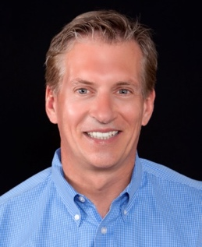
Ken Haney is the Enhanced Oil Recovery (EOR) and Carbon Capture and Storage (CCS) Manager for California Resources Corporation (CRC). He has 34 years of experience in upstream exploration and production with CRC, Chevron, Occidental Petroleum and Texaco. He has worked on projects and reservoirs in California, West Texas and New Mexico, as well as in Alberta, Canada and Columbia. His breadth of technical focus includes miscible and immiscible gas injection, thermal EOR, waterflood and primary operations in shale, clastic and carbonate reservoirs.

Specifically related to EOR with carbon capture and storage, Mr. Haney was the Reservoir Management Team Leader overseeing the Elk Hills CO2 target reservoirs for the 2010-12 Hydrogen Energy California (HECA) Carbon Capture, Utilization and Storage (CCUS)/EOR joint project between Occidental Petroleum and SCS Energy LLC. Ken has worked in his current role, overseeing the Elk Hills EOR/CCS project, for two years.

Mr. Haney holds a B.S. in Geology & an M.S. in Petroleum Engineering and is a member of SPE.

Register Today!

For more information, please contact: info@tonyzamora.com

To learn more about the SPE California Sustainability Study Group, visit our website

