SPE California Sustainability Study Group – Webinar #2

Wednesday July 15 at 12:00pm (noon) Pacific Time

Daniel Palmer of OGCI Climate Investments
Information on the SPE California Sustainability Study Group, visit our website

“Technology and Projects for methane and CO2 emissions in the Petroleum industry in California”

The talk will present an overview of the major sources of greenhouse gas emissions in the oil industry and the technology and projects being developed to address them cost effectively. The talk will start with an overview of the industries emissions and understanding the science behind why methane is increasingly becoming a major focus of the industry.

Technology for detecting methane emissions are advancing rapidly and will be reviewed in some detail. Finally, some technology options will be presented for making practical reductions in emissions and reducing the cost of compliance and lowering the carbon intensity of California oil production.

Speaker: Daniel Palmer, OGCI Climate Investments.

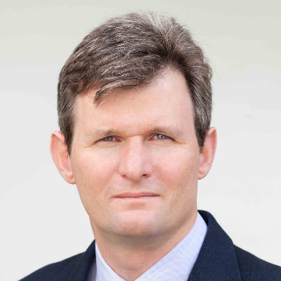

Daniel Palmer leads technology deployment at OGCI Climate Investments. In this role he works to accelerate the deployment of new technologies to reduce GHG emissions in the oil and gas industry.
Daniel has a worked for technology startups in applications of solar energy to oil production, and mining geoscience and previously spent more than 20 years at Schlumberger in various roles across the globe, working across sales, operations, marketing and technical positions. He led the global marketing and technology function for Schlumberger Wireline and holds numerous patents and has widely published in oil and gas, solar enhanced oil recovery and mining technology.
Daniel is a member of the Society of Petroleum Engineers (SPE), holds a master’s degree in engineering from the University of Cambridge and attended Heriot-Watt University for post-graduate studies in petroleum engineering.

Register Today!

