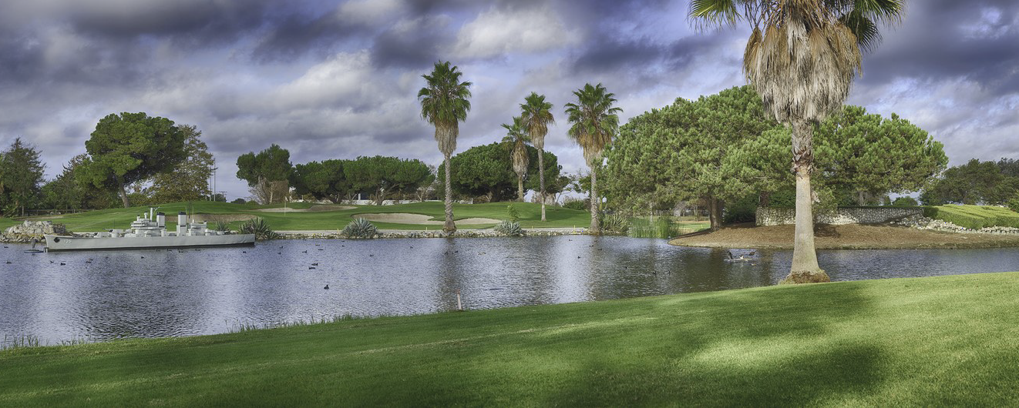
Los Angeles Basin Section

SPE LA BASIN SCHOLARSHIP
GOLF TOURNAMENT

April 21, 2023 – FRIDAY

The Navy “Destroyer” Course
5660 Orangewood Ave., Cypress, CA 90630

08:00 SHOTGUN START
CHECK IN 30 – 45 MINUTES BEFORE THE TOURNAMENT START TIME
(This is a Shotgun Start)

REGISTER AT https://spelabasingolf.com

INCLUDES RANGE BALLS, CART, BUFFET LUNCH, RAFFLE PRIZE TICKETS & MORE

SPONSORSHIPS ARE AVAILABLE

FOR INFORMATION CONTACT
TCFRANKIEWICZ@GMAIL.COM 714-475-8699

THE SPE LA BASIN SECTION IS A 501(c)(3) NON-PROFIT ORGANIZATION
TOURNAMENT PROCEEDS FUND SPE LA BASIN SECTION
SCHOLARSHIPS & OUTREACH PROGRAMS
A PORTION OF YOUR REGISTRATION MAY BE TAX DEDUCTABLE

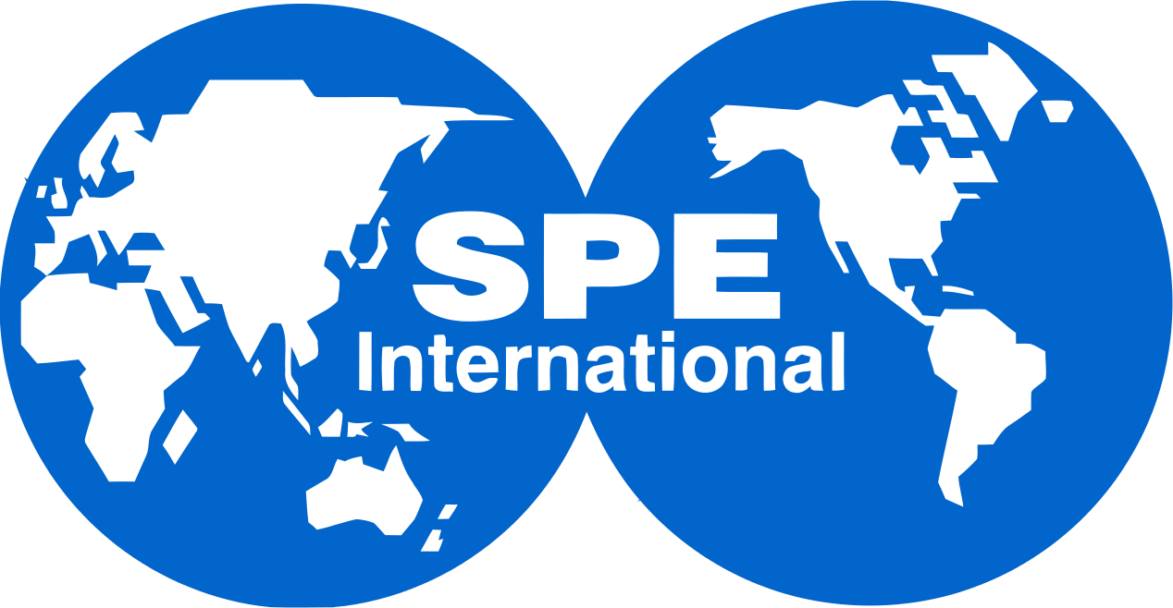
Los Angeles Basin Section

INDIVIDUAL PLAYERS: $ 200
FOURSOME: 4 PLAYERS $ 800
PAR package: 4 PLAYERS + TEE SPONSORSHIP + 5 RAFFLE TICKETS / player $1000 Save $130 BIRDIE package: 8 PLAYERS + TEE SPONSORSHIP + 5 RAFFLE TICKETS / player $1800 Save $210
EAGLE package: 12 PLAYERS + TEE SPONSORSHIP + 10 RAFFLE TICKETS / player $2800 Save $330
RAFFLE TICKETS: $5 each, $20 for 5-tickets
**BUFFET LUNCH & ON-COURSE SOFT DRINKS INCLUDED FOR ALL PLAYERS**

SPONSORSHIPS:
- TEE SPONSORSHIP: $ 250 (18 Available)
- REFRESHMENTS SPONSOR: $ 500 ( 2 Available)
- LUNCH SPONSORSHIP $1000 ( 2 Available)
- SCHOLARSHIP SPONSOR: $ 500 min. $2000 max.

**Raffle Prize donations are greatly appreciated**

Please visit the Tournament Website for registration and sponsorship opportunities https://spelabasingolf.com

for golf tournament questions contact
TCFRANKIEWICZ@GMAIL.COM 714-475-8699

