members.spacecoastmls.com
User Guide

At members.spacecoastmls.com, members can easily connect with each other, ask questions, share expertise, share files and more! This user guide will help you set up your profile and start connecting.

Table of Contents
Logging In
Updating your profile

Communities
Joining a community
Starting a new discussion post
Responding to discussion posts
Creating a library entry
Leaving a community
Sorting discussion threads

Directory
Finding new members
Adding members as contacts

Settings
Community subscription options
Email
Privacy

Participate
Share a File
Create a Blog Post

Logging In:
members.spacecoastmls.com supports the following Internet browsers:
- Internet Explorer (IE) 9
- Firefox
- Google Chrome
- Safari

You can access the members.spacecoastmls.com from SpaceCoastMLS.com or by simply typing in the URL: http://members.spacecoastmls.com.

To access from our website, visit SpaceCoastMLS.com and on the top right-hand side will be a button that says, SIGN IN/REGISTER. Clicking here will bring you to the members.spacecoastmls.com homepage to enter your log in credentials.

Your username is your email. Upon first logging into the site, you will be allowed to create your password. If you’re not sure what your login information is, click on the “I forgot my username or password” link and follow the prompts.

You also can access members.spacecoastmls.com by simply typing in the URL into your web browser: http://members.spacecoastmls.com.

Important: When you log in for the first time, please be sure to read over the E-Group Rules and click on the ‘I Accept’ box at the bottom of the E-Group Rules & Etiquette page. You will need to agree to these rules before continuing to the Discovery Pad.
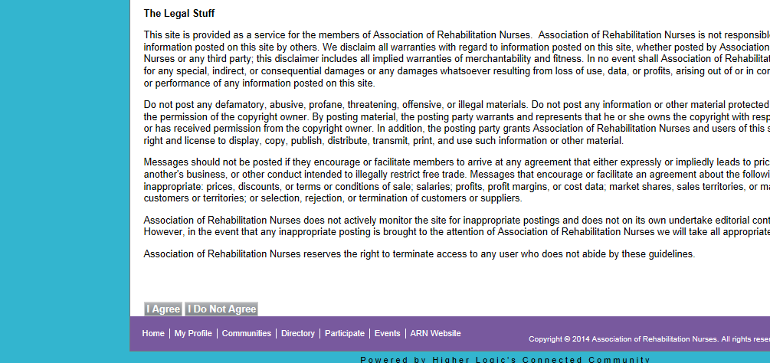

*Note: If you are having trouble logging in to members.spacecoastmls.com, please verify that your email address is accurate in your member profile in the directory section of SpaceCoastMLS.com.

If you continue to have issues logging in, please call us at 321-242-2211 or email us at christine.edwards@space321.com and we will be happy to assist you.

Profile
Updating Your Profile
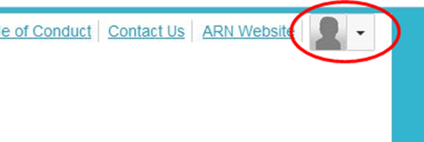
As a member of Space Coast Association of REALTORS®, you already have a profile on members.spacecoastmls.com that is ready for you to customize.
To update your profile, click on your profile picture drop down arrow at the top right of the homepage and then click the Profile button. From here, you can complete your profile by importing information from LinkedIn or simply enter your information manually on the profile page.

*Important: Basic contact and employment information is automatically populated onto your members.spacecoastmls.com profile from the Members Only section of the Space Coast Association of REALTORS® website. Any updates made to your Members Only info on the SpaceCoastMLS.com will automatically be reflected on members.spacecoastmls.com.
To access your account information, click on the:
- Drop down arrow of your profile picture near the top right of the homepage
- Click on the Profile button underneath your name
- Under ‘Contact Details’ in the left column of your profile page, click on the pencil icon to the right of Contact Details. This will take you to your account information on members.spacecoastmls.com.
- Once you are in your members.spacecoastmls.com account, you can update your email address and phone number on the My Account homepage. Click on the ‘Profile & Demographics’ link in the left column to update your name and job title and click on the ‘Addresses’ link in the left column to update your mailing address

Updates will automatically appear on members.spacecoastmls.com.

Communities:
Joining a Community
As a new member of members.spacecoastmls.com, you are automatically subscribed to the all-members REAL Talk and REAL Marketing communities. You can also find and join additional communities under the ‘Communities’ tab on the home screen. Simply browse the communities available and click ‘join’ to add yourself to any additional communities of interest.

Starting a New Discussion Post
From the homepage, click on the “Participate” tab and then “Post a Message”.

You can also post a message by clicking on the “Communities” tab and choosing your desired community. From there, click on the “Discussions” tab and click on the green button at the right that says, “Post New Message”. Enter your subject, choose the community you wish to post the message into, type your message, attach any necessary documents and click send.

You can also post a message directly from your email account without having to log in. In one of the emails you receive from members.spacecoastmls.com, you will see a link at the top that says, “Post New Message Online”. Click on that link, type your discussion post and click send.
Responding to Discussion Posts
If you are replying while logged in to members.spacecoastmls.com, click on the blue “Reply to Discussion” button to send your message to the entire community or click on the drop down arrow and then “Reply to Sender” to reply privately to the original sender.

There are three ways to reply to a discussion post:
•Reply to Discussion- reply to everyone in the group
•Reply to Sender- reply privately to the original sender
•Reply by Email- reply directly from the email notification you receive without having to log in to the community website. To do this, simply click on the blue “Reply All Email” button at the top right of each message.

We recommend replying to the sender for simple comments that add little value to the overall discussion (ex/ thank you); and replying to the entire community when you are sharing knowledge, experience or resources that others could benefit from.
You can also reply directly from your email account. Simply click on the blue “Reply All Email” button at the top right of each message.

Creating a Library Entry
To upload a document to a community, click on the “Participate” tab and then “Share a File”. Enter a title for your library document, select the community you wish to enter the document in, choose the document type and click next.

You can also upload a document to go with the discussion post you are writing. You will see an “Attach” button at the bottom of the page. Click on that button and insert your document. That document will then be linked to your specific discussion post.

Leaving a Community
Go to your profile page, click on the My Account tab and then Subscriptions. Here, you will see a list of available communities and those to which you’ve subscribed. Select “Unsubscribe” for the communities you wish to leave and click the “Save” button at the bottom of the page. You will get a message confirming that your subscription options have been successfully updated.

Sorting Discussion Threads
You have two options to sort discussion posts: sorting by thread or sorting by most recent.

Members.spacecoastmls.com automatically defaults to sorting by thread, so if you prefer to sort all of the posts by date, please see below. Take a look at the screenshot for further assistance.

To sort by date/most recent: Click on the Communities tab > All Communities > Open Forum > Discussions tab. You will see a blue bar with text that says, “Thread Subject, Replies, Last Post, View by Thread”. Click on the small down arrow next to “View by Thread” and click on “View by Date”. This will sort all threads by date. In addition, if you would like to sort the posts within each individual thread by date/most recent, click on the thread you would like to sort, click on the same down arrow next to “Sorted by Thread” and click on “Sort by Most Recent”. This will put the most recent posts within the thread on top.
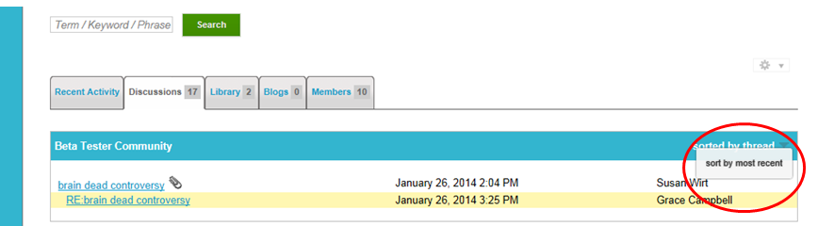

Directory:
Finding Members
You can build your contact list using the directory. When you click on the Directory tab at the top of the members.spacecoastmls.com homepage, you are taken to the Find a Member page. Search by first or last name, company name or email address. You can also do an advanced search if you have specific criteria you are looking for.

Adding Members as Contacts
Once you find the member(s) you are looking for, you can add them as a contact. Adding contacts creates an organized list in your profile where you can easily access who you are looking for. To add a member, click on the button at the right where it says “Add as Contact”. That member is now saved in your contact list.

Benefits of Adding Contacts:
- From your profile, you have quick access to your contacts’ profile information and the ability to send private messages faster.
- Other members can see who your contacts are and which contacts you have in common, which helps you connect with more members.

Settings:
Community Subscription Options
When you join a community, you are automatically subscribed to receive emails containing messages that other users post in that community. To review or edit your email subscriptions, go to your profile page, My Account tab and then Subscriptions. You can choose from the following options:
- Real Time: You will receive an email each time a new message is posted. To reply to a discussion, click on the ‘Reply to Discussion’ link in the column at the right.
- Daily Digest: You will receive one email each day containing all of the previous day’s messages. To reply to a discussion, click on the ‘Reply to Discussion’ link in the column at the right.
- No Email: This means that you won’t receive any emails in your inbox. You will need to log in to the Discovery Pad to view and reply to discussion posts.

You can also edit other email preferences on the My Account tab. Click on My Account drop down button > Email Preferences.

Email
To make sure that you always receive emails from members.spacecoastmls.com, please be sure that the emails are not going into your junk folder. To do this, you need to whitelist “DoNotReply@ConnectedCommunity.org”. Please use the website below to help you add members.spacecoastmls.com to your email safe list.

Instructions for Whitelisting: (source: Simply Hired)
http://blog.simplyhired.com/how-to-whitelist-an-email-address.html

If you continue to have trouble receiving emails, please check the following:
- Verify that your email address is accurate on your member profile in the Members Only section of SpaceCoastMLS.com.
  - If your email address is inaccurate, please update it on the by contacting the Association. Updates will automatically be reflected on members.spacecoastmls.com.
- Verify your email subscription level on the “Subscriptions” page of your profile.

Privacy
In members.spacecoastmls.com, you can control the amount of information other members see on your profile. Once you log in to members.spacecoastmls.com, go to your profile page, My Account tab drop down button > Privacy Settings. From there, you can choose what information others can see or not see. Be sure to click the ‘Save’ button at the top or bottom when finished.
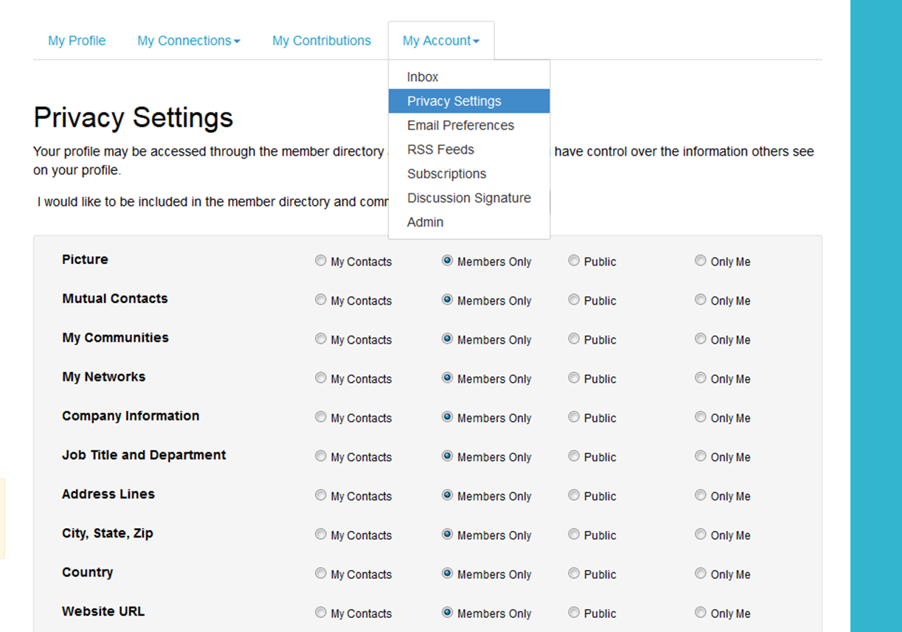

Participate:
Post a Message
From here, you can create and post a message to a community.

Share a File
To upload a file, click on the “Participate tab” in the top menu bar and click on “Share a File”. Please note that uploading a document is done in a few steps, and each step must be completed before you can move on to the next.

Choose a title for your document, include a description, select the library to which you’d like to upload it and choose an Entry Type (most will be Standard Files, but be cognizant of any copyright licensed material). Then click “Next”. Browse and upload your file. Click “Next” if you want to add tags to your file or click “Finish”.
Help/FAQs:
If you have additional questions or need additional support, please contact us at Christine.edwards@space321.com or call 321-242-2211.

