**Space Coast Association of REALTORS®, INC.**

2950 Pineda Plaza Way, Melbourne, FL 32935

Phone: 321-242-2211 Fax: 321-242-2567

[www.Space321.com](http://www.Space321.com) and [www.BrevardMLS.com](http://www.BrevardMLS.com)

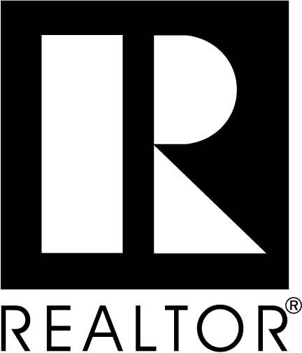

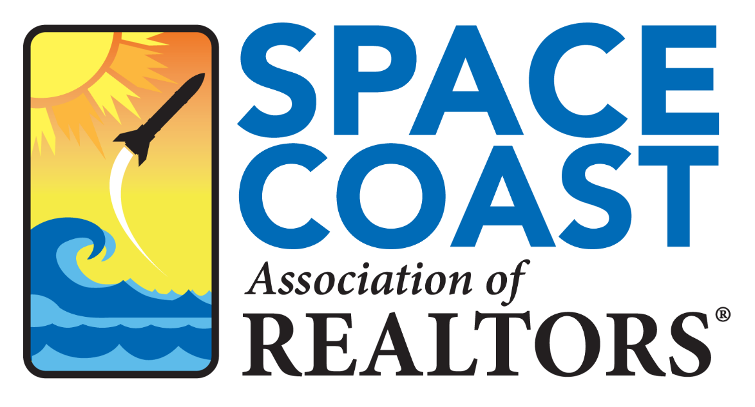

**Space Coast Association of REALTORS®**

**Public Policy**

The **Space Coast Association of REALTORS®** is dedicated to the protection and preservation of the free enterprise system and the individual and collective rights to own real property, as guaranteed by the Constitution of the United States and the State of Florida. We believe that the right to own property is one of the basic tenets of the freedoms granted to us. To that end, we offer the benefits that our knowledge of real estate, our experience, and our technical resources bring to the public in general and to the governments that serve them. We are concerned with a number of issues facing our members, our communities, our state and our country. The following statement of the principles underlying our public policy is to provide the public and our government officials with a better understanding of our specific positions.

**We believe** that property ownership serves as a cornerstone of our democratic system of government and deserves a preferred place in our system of values as it contributes to family security, community responsibility and civic involvement, as well as economic, business and employment stability. As real estate professionals, we know that home ownership is a primary goal of all Americans.

**We believe** that the political stability and economic prosperity of Brevard County and the State of Florida is dependent in large measure upon the right of the individual to own real property and to exercise and enjoy the benefits of ownership. We strongly support the responsible exercise of this right, fully and freely. We oppose actions by governments, groups or individuals that diminish or deny it.

**We believe** in balancing private property rights with economic growth, improving the standard of living and the need to preserve Brevard County and Florida’s unique environment. We strongly oppose any action of government that takes private property for the benefit of others under the banner of economic development.

**We believe** in and support policies that promote the healthy growth of Brevard County and the State of Florida’s economy through investment in commercial and residential structures, and in the skills of people, necessary to increase the standard of living, jobs and household income. We also believe in the importance of a solid infrastructure and responsible planning to support the growing population of Brevard County.

**We believe** that every individual should have the opportunity to live in safe and decent housing. These objectives are best served by a healthy residential and commercial real estate market in an economic environment that fosters an ample supply and accessible financing provided by both domestic and international sources.

**We believe** in equal/fair opportunity in housing. No person should have his or her right to rent or purchase shelter of choice compromised because of race, color, religion, sex, age, handicap, familial status or national origin.

**We believe** in the free enterprise system and oppose undue intervention by the government in the affairs of Brevard County businesses. We oppose taxation and governmental guidelines, regulations, rules and procedures that unnecessarily increase consumer costs and unfairly burden the business community.

**We believe** in the democratic process and actively support political candidates, regardless of party affiliation, who strongly identify with issues important to the real estate industry and the promotion and preservation of private property rights.