2950 Pineda Plaza Way, Palm Shores, FL 32940

Phone: 321-242-2211 Fax: 321-255-7669

www.spacecoastmls.com

NOTICE TO MEMBERS

***Act Immediately***

***Director Election Instructions***



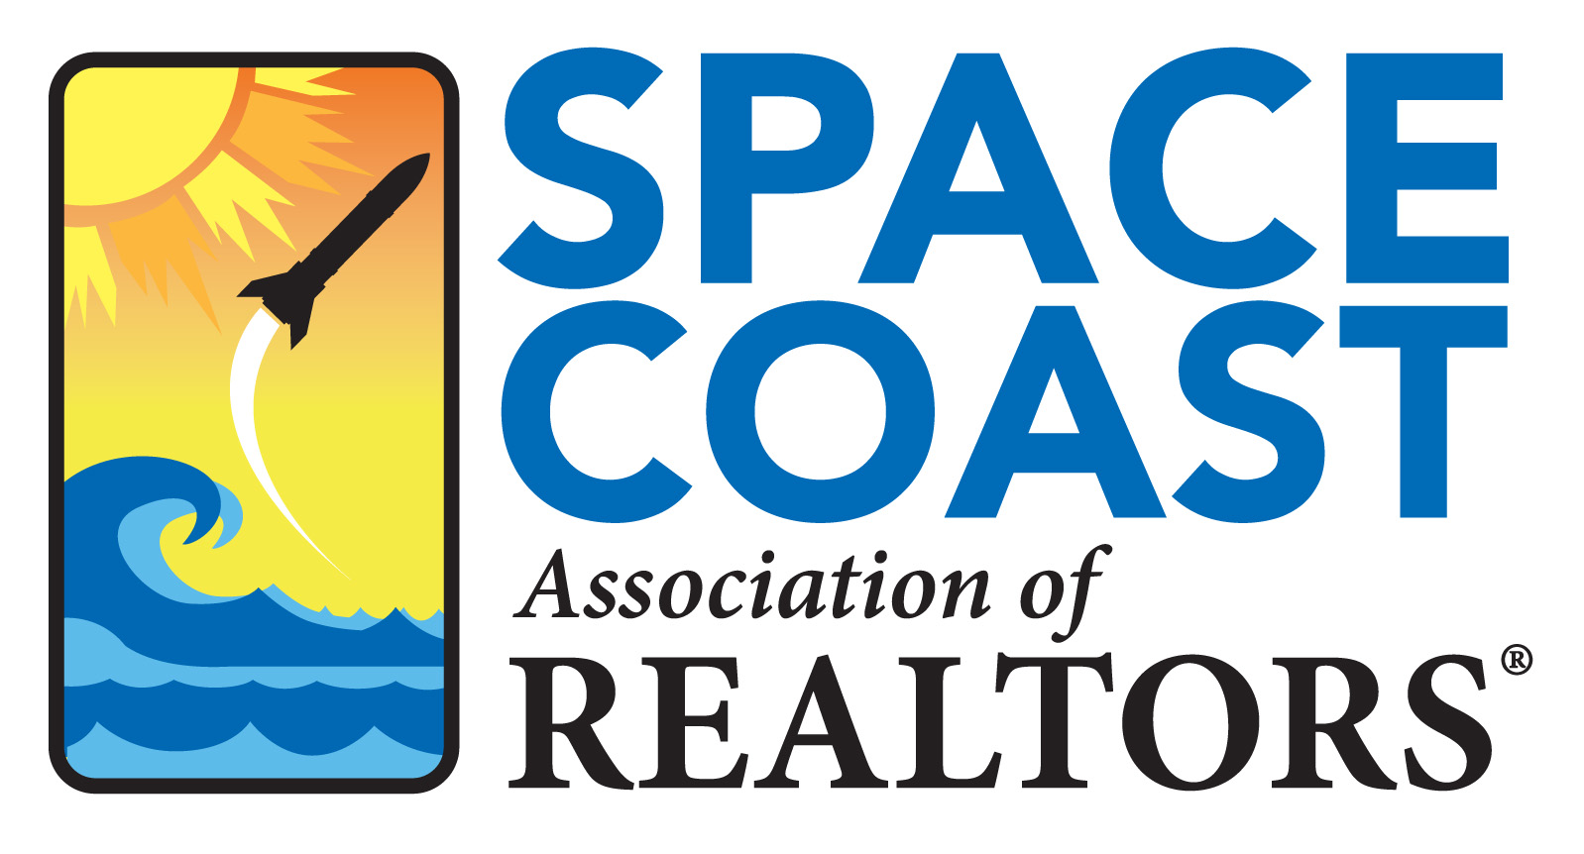

Our **Annual Meeting of the Space Coast Association of REALTORS® will be held on September 8, 2021 at 10:00 a.m.** in our Association office 2950 Pineda Plaza Way, Palm Shores. During this Annual Meeting, all candidates for the Board of Directors will be introduced and given an opportunity to share their visions for the future of our Association.

If you would like to be considered for a position on the Board of Directors please complete and return the Director Profile form, which is included in this announcement no later than 9:00 a.m. on August 4, 2021. Please submit a personal photo with your membership profile. The election ballots and Member Profiles will be available to the general membership beginning on September 8, 2021 at which time you can cast your vote for the candidates of your choice. The deadline to complete your voting is September 22, 2021 at 9:00 a.m. Election results will be released to the membership within 24 hours of the election polls closing.

The criterion to serve as a member of the Board of Directors:

* Must have been a REALTOR® for the immediate three (3) preceding years.
* Must have actively served on at least two (2) Committees, Task Force or Focus Groups in this Association.
* Must commit to the use of email as the primary communication tool of the Board of Directors.
* Must exhibit leadership dynamics and vision for the future of the Association.
* No former employee of the Association, or its predecessors, who was terminated for cause will be eligible for election.

The elected Directors, as are required to fill vacancies, shall be elected for three (3) years unless they are filling a vacancy created by a resignation. Elected Directors may serve no more than six (6) consecutive years, unless elected to fill unexpired terms of vacancies created by resignations. The Bylaws require that seven (7) of the 13 members of the Board of Directors must be Broker/Owners and that no more than two (2) individuals may serve, at the same time, from any one firm, regardless of locations. Additionally, no more than three (3) members from any one franchise may serve and at least two (2) members of the Board must be from non-franchised companies. The Officers of the Association shall be a President, President-Elect, Secretary and a Treasurer. The Officers are appointed from the existing directors for the ensuing year by the current Board of Directors at their first meeting immediately following the election. The Officer appointments shall be for a term of one (1) year except the President-Elect who shall automatically become President the year following their term as President-Elect and then will serve an additional year on the Board as Immediate Past President.

**The Board of Directors consist of a total of 13 members and all must be REALTOR® Members.**

**Based upon the current make-up of the Board of Directors for this election we will be electing a total of five (5) Directors, two of which must be Broker/Owners and the remaining three can be of any licensure status. For additional criterion to serve, please read this full document or the Association Bylaws.**

*For your information, the following previously elected Directors will continue to serve during the year 2022*

Immediate Past President: **Patricia Weeks,** Happy House Real Estate

**Donna Tidwell,** Ideal Real Estate

**Robin Turner,** Happy House Real Estate

President: **Jim Britton**, Britton Group

**Tamara Crisafulli**, Denovo Realty

**Mitch Ribak**, EXP Realty, LLC

**Omar Capellan,** Semper Realty Property Mgt

**Rusty Melle,** ITG Realty

***DIRECTOR "PROFILE" FORM***



**Mail to**: Qualifying Committee, Space Coast Association of REALTORS®, Inc.

2950 Pineda Plaza Way, Palm Shores, FL 32940 **August 4, 2021 deadline 9:00 a.m.**

Fax: 321-255-7669 or email**:** leah.selig@space321.com



**Please Note**: This form must be typed. Candidates are requested to confine remarks to spaces allotted on the form and no attachments will be accepted. Remarks are to be in outline format. We may reproduce the completed form as received, with no corrections. A Microsoft Word version of this form can be obtained from the Association website: [www.spacecoastmls.com](http://www.spacecoastmls.com) on the main page of the member’s only side.

**With each application please submit a personal photo.**

|  |  |
| --- | --- |
| Name: | Firm Name: |

|  |  |
| --- | --- |
| Firm Street Address: | City: |

|  |
| --- |
| Position within the firm: [ ] Broker/Owner [ ] Broker [ ] Broker-Associate [ ] Salesperson [ ] Other (please explain: |

|  |  |
| --- | --- |
| Number of years licensed: [ ] | Member of any other REALTOR® Associations [ ] Yes [ ] No  If yes, which associations: |

|  |
| --- |
| Number of years as a member of any REALTOR® Association in Brevard County [ ] |

|  |
| --- |
| Current profile of real estate activities: |

|  |
| --- |
| Occupation(s) prior to obtaining a real estate license in Florida: |

|  |
| --- |
| Have you ever been suspended or penalized by the Florida Real Estate Commission? [ ] Yes [ ] No  Are there any pending actions against you or your company by the Florida Real Estate Commission? [ ] Yes [ ] No |

|  |
| --- |
| Have you ever been suspended by an Association/Board of REALTORS®? [ ] Yes [ ] No |

|  |
| --- |
| Will you make a commitment to attend all Directors’ and Association Membership Meetings? [ ] Yes [ ] No |

|  |
| --- |
| Will you make attempts to attend the two (2) regular meetings Florida REALTORS holds in Orlando during your elected term, as well as other special meetings? [ ] Yes [ ] No |

|  |
| --- |
| Itemize your Space Coast Association of REALTORS® association involvement over the past **four (4) years** and list principal services and/or positions held by year. |

# Director Application Form, Page 2

|  |
| --- |
| Itemize your Florida REALTORS® involvement over the past **four (4) years**, list principal services and/or positions held by year. |

|  |
| --- |
| Itemize your NATIONAL ASSOCIATION OF REALTORS® involvement over the past **four (4) years**, list principal services and/or positions held by year. |

|  |
| --- |
| What Trade Organizations in Allied Fields and/or Civic Organizations are you a member of? |

|  |
| --- |
| Recent Business Accomplishments (Awards, Leadership and Management Positions) have you earned during the past **four (4) years:** |

|  |
| --- |
| You are welcome to document any lifetime accomplishments, awards, volunteer activities, participation in Association activities, leadership positions you’ve held for more than **five (5) years** in this block. |

|  |
| --- |
| Why would you like to be a member of the Board of Directors? |

Signature:

Print Name: Date: