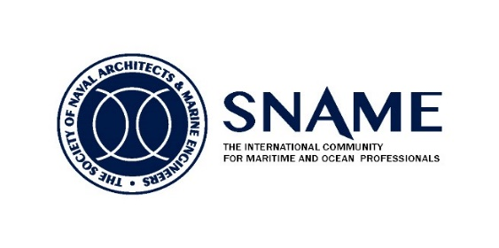

**Supported by**

**Western Europe Section** [](http://www.eagle.org/)****

**SYMPOSIUM**

The Symposium welcomes attendees to the 10th Annual event held on board HQS Wellington on the Victoria Embankment on the River Thames. The program includes technical presentations and discussions from industry experts, along with a buffet lunch. The Symposium is offered at no cost to the attendees due to the generosity of ABS and the HCMM. The symposium will provide opportunities for SNAME members and guests to meet and discuss technical initiatives and innovation, provide professional networking, present Society strategic direction and find out what's new at SNAME WES.

**Presentations and Authors:**

**Drones**

by Dr. Raouf Kattan and Dr. Ralitsa Mihaylova, Safinah Group

**Providing end to end Assurance Solutions for Offshore Fish Farms**

by Mark Tipping and Vincent Doumeizel, LR

**Some Considerations on the Impact of the Agenda 2030 on New Technologies Applied**

**to Naval Architecture and Engineering.**

by Blanca Parga Landa, Technical University of Madrid

**Mega Cruise Ship: Design for Safety**

by Fotios Stefanidis, UCL and Konstantinos Tsitsilonis, Datum Electronics

**Marine Situational Awareness Solution: Smart Sensor Fusion**

by Ines Simic, Rotterdam University (Paper Contest 1st Prize)

**3:30 Analysis of Safety Implications for the Power Plant Auxiliary Systems of Cruise Ships** by Kritonas Dionysiou, University of Strathclyde (Paper Contest 2nd Prize)

**Date & Time**  
Friday, October 11th, 2019 9:30am – 5:00pm   
**Place**           
HQS Wellington, Temple Stairs, Victoria Embankment, London, WC2R 2PN  
**Registration**   
[Register Online Today](http://www.sname.org/InternationalActivitiesCommittee/UKcollegium/Registration/)!  [www.sname.org/upcoming events/ events](http://www.sname.org/upcoming%20events/%20events)/

**Contacts**          
Lourdes (Nina) Lilley, SNAME Viviana Carta, Longitude

Jr. Regional Vice-President , International Secretary, WES

Email: [snamewes16@gmail.com](mailto:snamewes16@gmail.com) Email: [cartaviviana@gmail.com](mailto:cartaviviana@gmail.com)

Phone: +44 7479 639770 Phone: +44 7986 812506