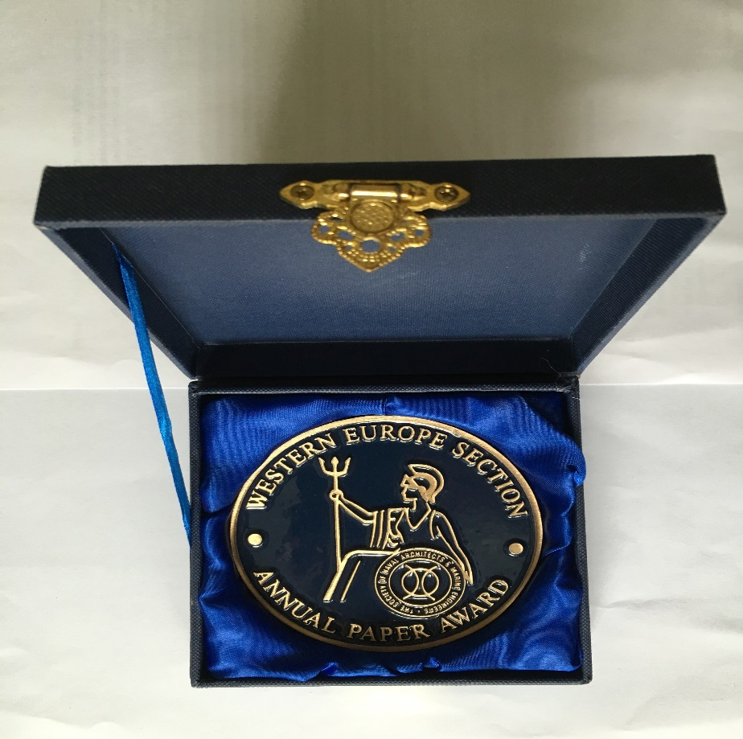
FIRST PRIZE - GOLD
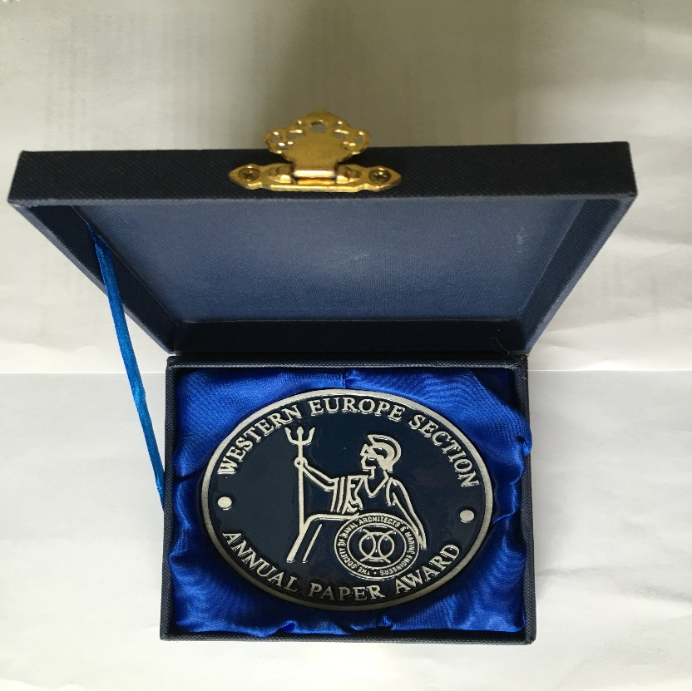
2ND PRIZE – SILVER
3RD PRIZE – TO BE ANNOUNCED

