Author Agreement

(Conference Name & Date)

(Paper Title)

Copyright Transfer
SNAME requires a copyright assignment for papers that are published under SNAME’s purview. Therefore, based on mutual and adequate consideration, the undersigned author(s), hereby assigns and transfers to SNAME all right, title, and interest, including copyright and all rights subsumed thereunder, in and to the paper or other work identified below. This copyright assignment includes all rights in the work, in all formats and media of expression now known or later developed, including electronic, internet, CD, or others, as well as for individual sale or distribution, as well as all translations. Such rights and permissions include, but are not limited to, the use of my (our) name(s), recorded voice(s), photograph(s), and video presentation (PowerPoint, video, or equivalent).

Presentation Authorization & Release
By authorizing SNAME to record my (our) presentation, as well as to use any written materials submitted by me (us) in connection with the presentation, I (we) agree that the encoding, storage, transmission, retransmission, copying, distribution, performance, display, or other uses of the presentation, including all written materials submitted in connection with the presentation to include workbooks, slides, sound files, etc., will not violate or infringe the rights of any third parties, including but not limited to copyrights, rights of privacy, trade secrets, and non-disclosure agreements. I (we) also waive any claim for compensation. I understand that this information will be publicly accessible and may be considered prior publication by some journal publishers.

The author(s) retains the following rights:

- all proprietary rights other than copyright, including patent rights;

- the right to make oral presentations of this material; and

- the right to reproduce figures and extracts from the paper with proper acknowledgement.

US Government Employees
For papers written by employees this form must also be signed by the employer’s representative. For papers written as the result of a US Government contract, or if the author(s) is (are) a US Government employee(s), copyright is neither possible nor required; nevertheless, the author(s)’ signature(s) is (are) required to affirm that the paper is cleared for public release. Author(s) acknowledge and agree that author(s) will receive no royalty or other compensation for this assignment or SNAME’s use of the paper, that the paper is original, that the paper does not violate the rights of others, and that the author(s) has (have) the right to make this assignment and has obtained permission to use any previously copyrighted material, which are necessary conditions for all publications. Author(s) also authorize SNAME to use the author(s) name(s), photograph(s), and biographical data in connection with publication of the paper.

Statement of Originality
Paper submissions must be original work that has not previously been presented or published elsewhere.

If this paper has been presented or published in this or a similar form before, please state the title, date, and circumstances (venue of the presentation or name of the publication(s)), and include a copy of the paper(s) with your response. Also provide proof of permission from the previous publication organization granting SNAME permission to reprint.
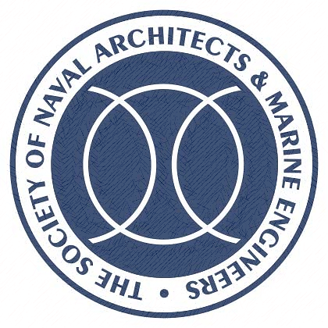

Language in which it was published:

The author must agree to not submit the paper for review or publication elsewhere while under review by SNAME.

No paper can be considered for publication by SNAME without a properly executed copy of this form; however, if the paper is not accepted for publication, this agreement is nullified.

With this signature, I confirm that the above statements are true. (Lead author only.)

Please indicate acceptance of this agreement by completing the appropriate section A or B:
*All author signatures are required, though they need not be on the same form*

A. Copyright Transfer:

Author Signature Date

Company Representative Signature Date

B. Government Employee Certification
This will certify that all authors of the paper are US Government employees and prepared the paper within the scope of their official duties. As such, the paper is not subject to US copyright protection.

Author/Authorized Signature Date

