Quintin McGrath, Chair of SIM’s ReThink Everything!, accomplished a significant milestone by successfully defending his doctoral dissertation at the University of South Florida

“Yesterday was another one of those days that I will remember for a long time - I crossed the near final major milestone on my Doctoral marathon with the successful defense of my doctoral dissertation: ‘An Enterprise Risk Management Framework to Design Pro-Ethical AI Solutions.” Last week, SIM’s ReThink Everything! Chair Quintin McGrath successfully defended his doctoral dissertation on designing pro-ethical AI solutions at the University of South Florida.

In his dissertation, McGrath stated, “the broader individual and social impact of AI-enabled solutions are of concern.” He upheld this claim by exploring the ethical ramifications of AI and by questioning its societal impact. He also looked into whether those displaced by AI can be retrained for other roles and where responsibility lies for the cost and provision of retraining.

McGrath dedicated his study to: “all those who, like me, love technology and hold tightly to the opportunities of progress it proffers; and equally tightly hold onto human flourishing and a desire to see a world filled with what my Jewish friends understand as Shalom– peace, harmony, wholeness, completeness, prosperity, welfare, and tranquility– for all! May this work contribute to our dream.”

Afterwards, McGrath shared on LinkedIn his gratitude for those at USF’s Muma College of Business who helped him achieve this accomplishment, including SIM Tampa Bay member Gert-Jan de Vreede. Gert-Jan de Vreede commented: “You did an amazing job, Quintin! We’re very proud of you! Congratulations again.”

McGrath recently spoke with approximately 50 Arizona SIM members about AI, machine learning, and associated data privacy concerns during a hybrid SIM chapter meeting. The group’s primary focus was building an understanding of the topics above by exposing them to:
- The extent of AI use in organizations
- The speed of the advancements in AI
- Leveraging AI for good

For McGrath, AI is not virtuous, but proper training and use have ethical constituents attached to them. Still, despite the immediate benefits of AI, there are great risks and unintended consequences, such as the misuse of facial recognition, incorporation of deepfakes, and blender bots. McGrath advocated for transparency between businesses and clients to protect users from risks. This includes data governance, privacy protection, disclosure, and knowing what is collected and why.

After the lively debate, McGrath wrote: “Thanks to Simon Taylor, I had a wonderful opportunity to spend time with the SIM Arizona chapter discussing AI, Machine Learning, ethics, and data privacy. It was a great opportunity to share ideas and recognize our joint responsibility as IT leaders to drive pro-ethical AI into our various businesses!”

In 2021, McGrath co-created ReThink Everything!– a SIG that aims to assist members in navigating major disruptive technologies and global megatrends and their potential impacts on their businesses. It nationally launched on March 23, 2022, with over 70 registered attendees, and it continues to grow today. “RTE is looking for those who may be a few steps ahead in their journey. We want to partner with them and help other SIM members move forward with their organizations,” McGrath said shortly after the launch.

The SIG highlights the importance of living in the “Exponential Era” through the Convergence Cocktail funnel, beginning with the all-inclusive topic of Megatrends. This portion focuses on the cyber environment, digital disruption, societal change, hyper-connectivity, augmented/virtual worlds, and abundance.

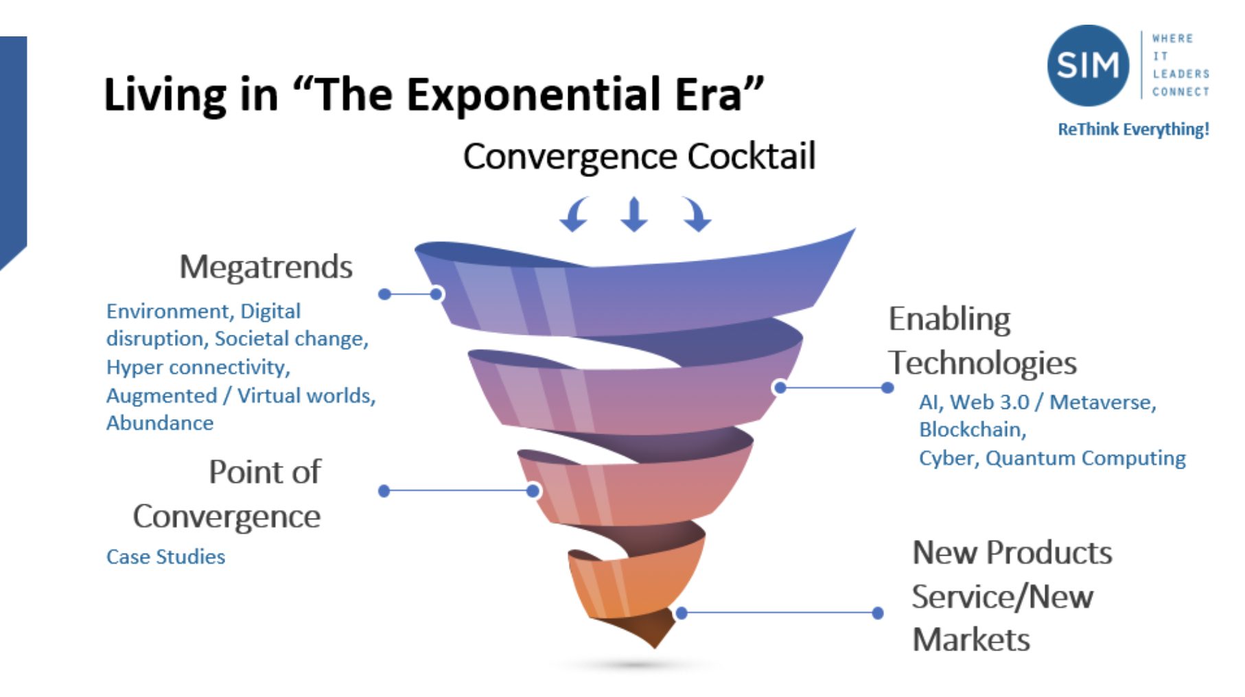
The funnel then narrows to Enabling Technologies like AI, Web 3.0/Metaverse, Blockchain, Cyber, and Quantum Computing before channeling into a tighter discussion of the Point of Convergence and case studies. Finally, RTE pinpoints Products, Services, and New Markets that aid in living in the Exponential Era. “Our vision is to form a community of leaders who are deep thinkers on these topics. Experts who will help us guide and inspire the SIM community as it grapples with the rapidly changing and volatile environment we operate in today,” McGrath said in March. “CIO and IT leaders need to understand the megatrends and be able to respond to them in their new business models. We hope to provide insight through the RTE SIG.”

SIM members interested in joining RTE can do so through SIM’s RTE Program Page, the LinkedIn Group Profile, and by reaching out to McGrath at quintin.mcgrath@gmail.com. If interested in becoming a member of SIM, please reach out to sim@simnet.org.

