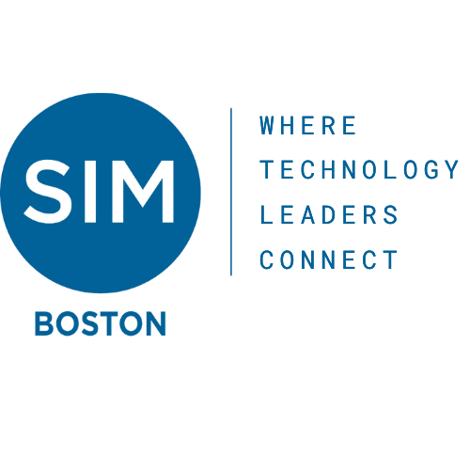
SIM Boston Outreach Partner Funding Proposal
Outreach Mission: “Give back to our community by supporting programs that contribute to the vitality of the Information Technology profession”

Partner Organization:
Partner Contact Name:
Outreach Liaison Name:
Program Name:
Submission Date:

Program Description: Briefly describe the nature of the program that will receive the funding. This must include how the program supports the Outreach Mission, i.e. how it contributes to the vitality of the IT profession.

[Enter Text Here]

Amount of Money Requested: $[Enter Text Here]

Number of Individuals to Benefit: How many people will directly benefit from/participate in the program?

[Enter Text Here]

Opportunity for SIM Member Participation: Briefly describe the opportunity for SIM members to participate in the program

[Enter Text Here]

PR mechanism for SIM and Funded Organization: Briefly describe how SIM Boston will be promoted by the funded organization and how SIM Boston will promote the program.

[Enter Text Here]

