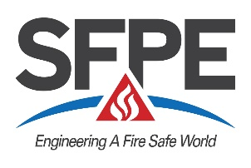
Sponsor’s Nomination Form
For Fellow of SFPE - 2025
Deadline: April 4, 2025

Before completing, please review Instructions for Initiators and Sponsors for Nomination of a Fellow

This form is to be completed in addition to the cover letter and other information required in the nomination package and sent to Ben Fogel at SFPE Headquarters, 9711 Washingtonian Blvd., Suite 380, Gaithersburg, MD 20878 ATTN: Ben Fogel or email to bfogel@sfpe.org

1. NOMINEE_______________________________________________________________________

2. SPONSOR
Name_______________________________________________________________________________
Employer____________________________________________________________________________________________
Address _____________________________________________________________________________________________
Sponsor Grade of Membership ◻Professional Member ◻Fellow

3. SIGNIFICANT SERVICE TO SFPE
Involvement in SFPE activities such as service on SFPE committees or task groups, board of directors, local chapter leadership, etc.

- SIGNIFICANT ACCOMPLISHMENTS IN FIRE PROTECTION ENGINEERING
Significant accomplishments shall be based on process or product developments, project leadership, managerial achievement in bringing engineering efforts to fruition, the education of engineers and technical publications, patents, or theoretical development.

- STATURE IN FIRE PROTECTION ENGINEERING
Stature shall include an evaluation of awards, honors, appointments, leadership positions, length of career, service and achievement in other professional societies and contributions to the community.

- ADDITIONAL INFORMATION
Additional information in the form of resumes or job descriptions can be helpful or provide selected excerpts to emphasize specific accomplishments.

Sponsor’s Signature: ____________________________________ Date: ____________________

Rev: 01/30/2025

