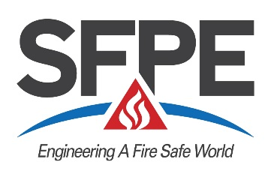

Sponsor’s Nomination

Form for Fellow of SFPE - 2021
Deadline: April 5, 2021

Article IV, Section 4 of the Constitution states that a Fellow shall have been a Professional Member for at least 10 years and that election to the grade of Fellow shall be in recognition of significant accomplishment and stature in fire protection engineering and service to SFPE. It also states that election to the grade shall be upon nomination by five Fellows or Professional Members, reviewed and recommended by the Qualifications Subcommittee and a favorable majority vote of the SFPE Board of Directors. This form is to be completed and sent to Julie Gordon at SFPE Headquarters, 9711 Washingtonian Blvd., Suite 380, Gaithersburg, MD 20878 or emailed to jgordon@sfpe.org.

1. NOMINEE

2. SPONSOR
Name ______
Employer ____________________________________________________________________________________
Address
Sponsor Grade of Membership ◻ Professional Member ◻ Fellow

3 SERVICE TO SFPE (If Known)
Involvement in SFPE activities on the local, national or international level, such as service on SFPE committees or task groups, board of directors, local chapter leadership, etc.

- SIGNIFICANT ACCOMPLISHMENTS IN FIRE PROTECTION ENGINEERING
Significant accomplishments shall be based on process or product developments, project leadership, managerial achievement in bringing engineering efforts to fruition, the education of engineers and technical publications, patents or theoretical development.

- STATURE IN FIRE PROTECTION ENGINEERING
Stature shall be based on awards, honors, appointments, leadership positions; valuable service to SFPE; and service and achievement in other professional societies.

- ADDITIONAL INFORMATION
Additional information in the form of resumes or job descriptions can be helpful or provide selected excerpts to emphasize specific accomplishments.

Sponsor Signature: ____________________________________ Date: __________________

