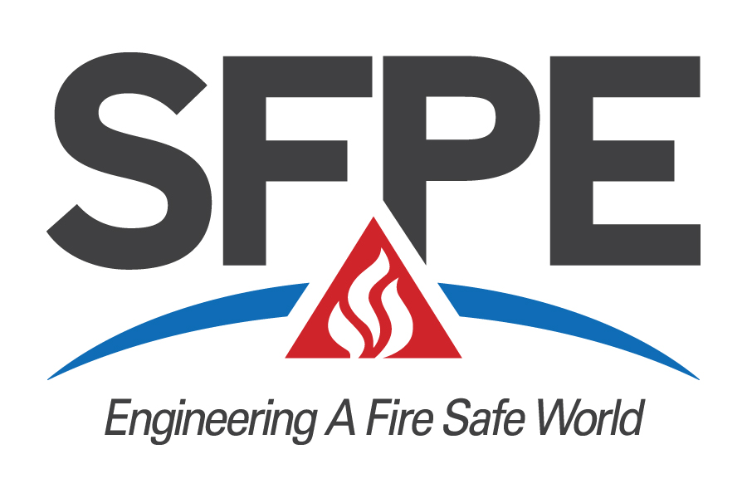
Initiator’s Nomination Form
For Fellow of SFPE - 2023
Deadline: April 14, 2023

Before completing please review Instructions for Initiators and Sponsors for Nomination of a Fellow

This form is to be completed in addition to the cover letter and other information required in the nomination package and sent to Ben Fogel at SFPE Headquarters, 9711 Washingtonian Blvd., Suite 380, Gaithersburg, MD 20878 ATTN: Ben Fogel or email to bfogel@sfpe.org

1. NOMINEE
Residence Address

Employer Nominee’s Position Title
Employer’s Address

2. YEAR NOMINEE ELECTED TO PROFESSIONAL MEMBER GRADE

3. INITIATOR

i). Name
Employer _____________________________________________________________________________________
Address

Initiator Grade of Membership ◻  Professional Member ◻ Fellow

- SPONSORS

ii). Name
Employer _____________________________________________________________________________________
Address
Sponsor Grade of Membership ◻ Professional Member ◻ Fellow

iii). Name
Employer _____________________________________________________________________________________
Address
Sponsor Grade of Membership ◻ Professional Member ◻ Fellow

iv). Name
Employer _____________________________________________________________________________________
Address
Sponsor Grade of Membership ◻ Professional Member ◻ Fellow

v). Name
Employer _____________________________________________________________________________________
Address
Sponsor Grade of Membership ◻ Professional Member ◻ Fellow

- PROFESSIONAL RECORD (use additional sheets if necessary)

Dates
To  Year | To  Year | Employer/title, brief job description

- EDUCATION/PROFESSIONAL REGISTRATION

Please fill in appropriate blanks:  State/Prov.  - P.E ____________  or ____________  P.Eng. ____________  ____________ | Date  College/University Degree Major degree earned

- SERVICE TO SFPE
Involvement in SFPE activities such as service on SFPE committees or task groups, board of directors, local chapter leadership, etc.

- SIGNIFICANT ACCOMPLISHMENTS IN FIRE PROTECTION ENGINEERING
Significant accomplishments shall be based on process or product developments, project leadership, managerial achievement in bringing engineering efforts to fruition, the education of engineers and technical publications, patents or theoretical development.

- STATURE IN FIRE PROTECTION ENGINEERING
Stature shall be based on awards, honors, appointments, leadership positions; valuable service to SFPE; and service and achievement in other professional societies.

- ADDITIONAL INFORMATION
Additional information in the form of resumes or job descriptions that may be helpful to evaluators or provide selected excerpts to emphasize specific accomplishments can be attached to this form.

- SUMMARY STATEMENT
The summary statement of qualifications for the grade of fellow will be used to introduce the candidate at all levels of the evaluation and will be used in the program booklet at the annual awards and honors banquet for all successful candidates. [Suggested length 100 words]

Initiators Signature: ______________________________________________ Date: _______________________

Rev: 02/05/23

