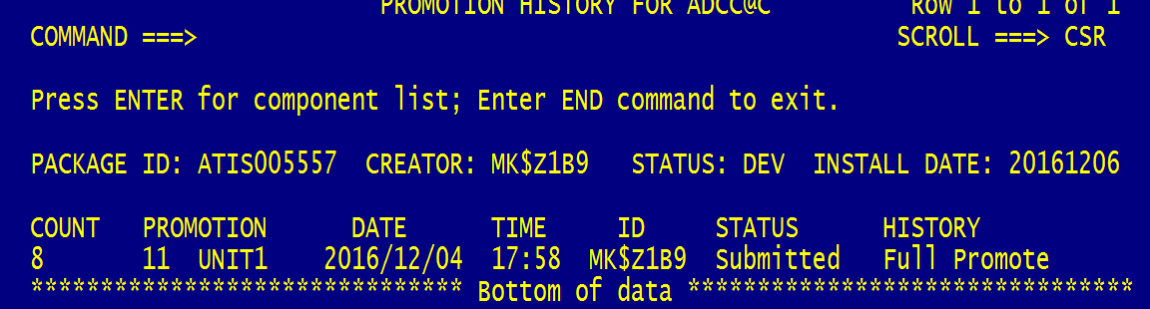
Look at this date. Do you think this means anything??
