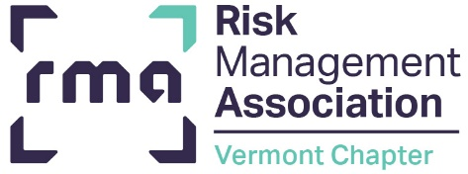

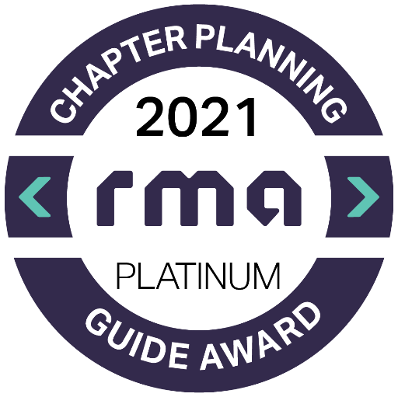
SPRING 2022

In This Issue
Chapter Events P.1
RMA Membership Information P.2
RMA Reminders P.3
RMA Events & Virtual Training Options P.4

SAVE THE DATES

May 3,4,10,11,17 & 18, 2022 – Commercial Lending School with Phil Hatch, Mascoma Bank, White River Junction

May 10, 2022 - Annual Meeting, virtually
Topic: Climate change as it relates to credit risk
Speaker: Michael Marino – M & M Consulting LLC

May 19, 2022 –– Senior Lender Roundtable at DFR, Montpelier, VT

June 23, 2022,– Credit Analyst Roundtable at DFR, Montpelier, VT

More information will be shared as it becomes available. Also remember to check our Chapter website for more information regarding these events.

Vermont Chapter
Events
THE CREDIT COURIER
The longer days, crocus buds, and running sap are welcome signs of a Vermont spring. Spring is fortunately bringing with it this year reduced COVID numbers, which should provide us more flexibility on how we deliver programming in the coming months.
We hosted our first Ski and Ride event at Bolton this February. Cairn Cross of Fresh Tracks and John Antonucci of The Dudley Fund joined us to discuss Venture Capital for growth businesses. We were blessed with sunshine, fresh snow, and a welcome opportunity to network with our peers. We anticipate this being an annual event and encourage you to join next year.
Our annual meeting this year will focus on climate change and how it relates to credit risk. This is an emerging topic that is important to consider with credit risk and for potential focus by regulators. We hope you can join us virtually in May to learn more.
We are excited to host our two roundtable discussions and upcoming credit school in person:
- The Senior Lender Roundtable will be hosted by Sarah Cowan (NBM), Chris Caldwell (CNB) and Bill Kidder (Ledyard) in Montpelier on May 19, 2022.
- Our Young Professional group will also be coordinating a Credit Analyst Roundtable later this spring.
- Phil Hatch will be teaching Commercial Lending School in White River Junction in May. This comprehensive lending school has been designed to serve the fundamental commercial credit analysis training needs of community bankers.
- Finally, as a reminder membership is simplified and more inclusive. Historically, there were three layers of dues, institution, associate, and Vermont. Now any employee with an institution membership (i.e., if your bank is a member) can become an associate member free of charge. This is a great opportunity to broaden RMA reach outside of commercial credit. The Vermont Chapter continues to charge a $25 per person fee to cover our operations which will be billed annually in August by June Hibbs from VBA.
Thanks for your support!
Meaghan McLaughlin
RMA Vermont Chapter President
National Bank of Middlebury

A Message From Your Chapter President
RMA Associate Membership Information



Chair, Meagan Carter
Co-Chair, Cameron Blais
A big thanks to everyone for a successful Environmental Event and Economist Event! And of course, a big thank you to our presenters Duane Beck, Jeff Polubinski, and Jeff Carr.
We also had a great time at the Bolton Ski Day and look forward to possibly adding a YP component to this event next year.
We postponed the Credit Analyst Roundtable in hopes of having the event in person; we are currently in the planning stages and exploring dates in June as we think this is the perfect follow-up to Commercial Lending School in May.
We are currently looking for new members, if you or someone you know would be interested in being part of our group, please reach out!
Happy Spring!
The RMA YP Group
RMA Member Benefits Reminder

RMA Members have access to:
- The Member Forum – An online community for real-time discussions with your peers

- The RMA Journal – A monthly publication of risk management news and practical ideas written by risk professionals, for risk professionals

- Member Pricing – Preferred pricing on all events, training, and products

- Risk Readiness Webinars – Complimentary access to RMA’s regularly scheduled webinars on the industry’s top risks

- Roundtables – Exclusive ability to participate in RMA’s invite-only member roundtables on a variety of important topics

- Unlimited Employee Access – As an institutional member of RMA, all employees can participate in RMA membership at no additional cost

To access these benefits, visit: https://www.rmahq.org/membership

NOTE: RMA Vermont Chapter Support Notifications are sent out in August. Be sure to renew your membership to continue to receive these benefits and support our local chapter.
If you have any questions regarding the Vermont Chapter, contact June Hibbs by email at vtbanker@sover.net .

Associate Member Opt-in Process

In order for individuals from a Member Institution to opt-in for membership they must complete an opt-in process via the RMAHQ.org website. All member banks were given materials to promote the new membership structure and provide information to their employees to opt-in. Here is an opt-in guide if you need it: Online Opt-In to RMA Membership
An Update from
Young Professionals


The RMA Journal
RMA FORUMS
RMA’s forums combine lecture and peer sharing and provide you with the best opportunities to discuss issues related to structuring, organizing, and effectively managing the various credit, operational, and enterprise risk functions with your peers and industry experts. Each forum enables you to share information to understand what works and what does not work, ask questions, exchange ideas to broaden your knowledge and understanding of the issues discussed, and learn best practices you can take back to your institution. RMA’s forums help you stay abreast of timely topics while building a network of peers that you can draw on in the future.

your peers and to identify best practices that you can take back to your institution to enhance the value of your loan operations function. The forum will feature a lead facilitator, round table group discussions, and small breakout groups that will delve deeper into issues of specific interest. You will benefit from the problem solving techniques discussed by your peers, regardless of the size of the particular institution. Participants share information, ask questions, and exchange ideas to broaden their knowledge and understanding of the issues discussed in a round table environment. Best of all, attendees will have a network of peers to reach out to in the future.
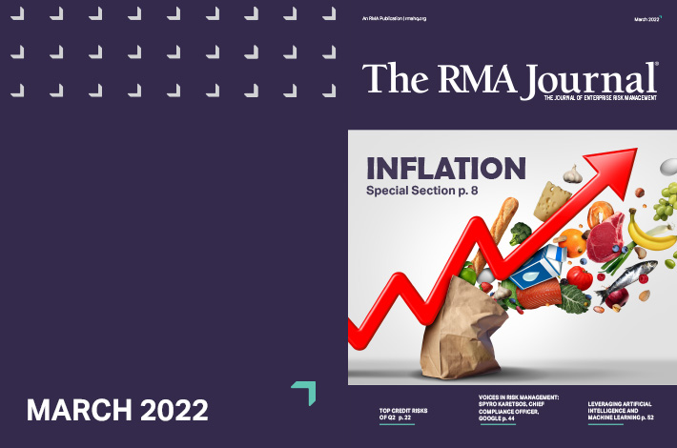
Loan Operations Management Forum – APRIL 27-28, 2022
RMA's Loan Operations Management Forum, a peer learning event, provides loan operations professionals the opportunity to discuss issues related to structuring, organizing, and effectively managing the loan operations function. The interactive sessions focus on managerial and operational topics and help create efficiency when organizing operational responsibilities. Concepts of functional structure, service quality, performance metrics and use of technology are included in the discussions. Because the role of the loan operations department varies widely among banks, the different responsibilities housed within the function and staffing models will be discussed. The forum presents a valuable opportunity for you to meet and discuss common challenges with

Advance Your World

The RMA Journal provides risk management news, practical ideas, and insights that give you a competitive edge and are designed to fit your needs wherever you are in your career.
Be sure to subscribe to access current and past Journals. Find podcasts here or subscribe though iTunes, Spotify, or Google Play.

Happy reading … and listening!.
Scholarship Opportunity
We are pleased to announce the winner of this year’s VT RMA Chapter scholarship is Megan Gracey-Barlow, Credit Analyst at Mascoma Bank.


Be on the look out for next year’s application to share.

RMA Student Memberships
Students and faculty at colleges or universities that are not RMA University Members can still join RMA individually. These individual memberships benefit from access to The RMA Journal, Risk Readiness webinars, the member forum, and member pricing on all courses and events. Click here to learn more and to join.

Upcoming RMA Forum


RMA’s Governance, Compliance, and Operational Resiliency (GCOR) XVI Virtual Conference | June 6 – 9, 2022
In today’s rapidly changing world, managing operational risk is a necessity not an option. As your professional association, RMA takes great pride in developing practical thoughtful, and timely programs designed to enhance your skills and increase your value to your institution. GCOR is the only government compliance & operational risk conference developed by the industry, for industry.
Register Now

Upcoming Virtual Courses
- May 2 – 4, 2022: Analyzing Business Tax Returns
- May 2 – 6, 2022: 360 Negotiation Skills for Bankers
- May 2 – 11, 2022: Financial Statement Analysis
- May 4 – 6, 2022: Cash Flow Refresher for Experienced Bankers
- May 4 – 6, 2022: Lending to Medical and Dental Practices
- May 9 – 12, 2022: Global Cash Glow I: Foundation in GCF Concepts
- May 9 – 12, 2022 Commercial Real Estate Lending II: Underwriting
- May 9 – 16, 2022 Cash Flow Analysis II Applied Concepts
- May 11, 2022: Leveraged Loan Transactions: Understanding and Managing the Risks
- May 17 – 19, 2022: Relationship Management Skills for Commercial Lenders
- May 24 – 26, 2022: Commercial Real Estate Lending III: Global Cash Flow
For more courses and detailed information click here.

Professional
Development
With RMA

MISSION
RMA is a member-driven professional association whose sole purpose is to advance sound risk principles in the financial services industry.

Stay connected with RMA:
Member Forum RMA Journal
RMA Blog Podcast

Vermont RMA Chapter, Inc.

% Vermont Bankers Association, Inc.
P.O. Box 587, Montpelier, VT 05601-0587
802-229-0341 ph
802-223-5078 fax
vtbanker@sover.net

