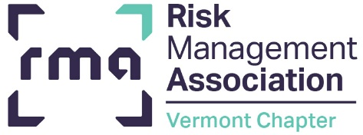

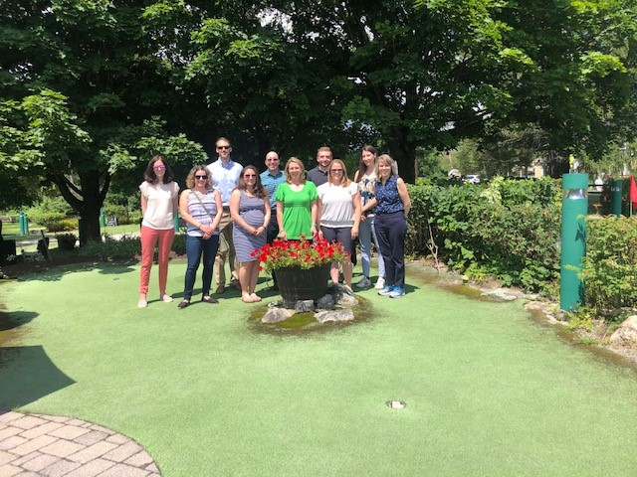
Stowe, Summer 2021 Chapter board gathering for team building and planning the 2021/2022 year.
In This Issue
Chapter Events P.1
RMA Membership Information P.2
RMA Reminders P.3
RMA Events & Virtual Training Options P.4

SAVE THE DATES

December 9, 2021 Environmental Assessments & Construction Monitoring, via Zoom

January 2022, - date TBD Credit Analyst Roundtable

February 2022, date TBD – Senior Lender Roundtable (may be in person or virtual)

March 2, 2022 – Women in Leadership in partnership with Vermont Bankers Association
March 2022
Commercial Lending II – date TBD

May 3,4,10,11,17 & 18, 2022 – Commercial Lending School with Phil Hatch, Mascoma Bank, White River Junction

More information will be shared as it becomes available.

Vermont Chapter
Events
THE CREDIT COURIER
FALL 2021

Happy Autumn!
The Vermont Chapter is excited to offer a broad array of programming in the coming year. In an effort to keep everyone safe, we are offering virtual events in the near term. Our first event was Credit Enhancement Day in October and was well recieved.
RMA continues to be offering all courses virtually, with in-person tentatively set to resume in spring 2022. Our chapter will once again offer Commercial Lending School with Phil Hatch next spring when in-person events are permitted. If you, or your co-workers are looking for courses, please take advantage of their online course opportunities. A full list of Vermont programming is included in this newsletter and we very much hope you can join us.
There are several exciting changes to share from RMA national. Membership is simplified and more inclusive. Historically, there were three layers of dues, institution, associate, and Vermont. It was both expensive and a lot to keep track of! Now any employee with an institution membership (i.e., if your bank is a member) you can become an associate member free of charge. This is a great opportunity to broaden your reach, at my own bank we have folks from technology, compliance, loan managers, and head tellers all join as new members. It is a great educational opportunity for all. The Vermont Chapter continues to charge a $25 per person fee to cover our chapter operations which will be billed annually by June. Details on how to sign up as an associate and Vermont member on page 2. The other change we wanted to share is a launch of fresh branding. RMA has spruced up their logo as seen throughout this newsletter and on their website.
Finally, time to toot our own horn. The Vermont Chapter earned the RMA Platinum award this past year. This highest level of award for local chapters is based on offering robust programming, stable membership, and an engaged board. We could not have achieved this honor without the help of our members! Thank you for once again helping this brave little state shine.
Meaghan McLaughlin
RMA Vermont Chapter President
National Bank of Middlebury

A Message From Your Chapter President
RMA Associate Membership Information

Chair, Meagan Carter
Co-Chair, Cameron Blais
The YP Group is busy planning upcoming events including an Environmental Event scheduled for December 2021 and a Credit Analyst Roundtable in January 2022. Keep an eye out for advertising coming soon for the Environmental Event once speakers and content have been finalized. Additionally, the RMA YP Group is planning to hold an Economist Update Event in February 2022. While all events are likely to be virtual for the time being, we are always considering the viability of returning to in-person meetings while planning.
Happy Fall!
The RMA YP Group
Welcome New YP Member
Sadie Fosco, National Bank of Middlebury

RMA Member Benefits Reminder

RMA Members have access to:
- The Member Forum – An online community for real-time discussions with your peers

- The RMA Journal – A monthly publication of risk management news and practical ideas written by risk professionals, for risk professionals

- Member Pricing – Preferred pricing on all events, training, and products

- Risk Readiness Webinars – Complimentary access to RMA’s regularly scheduled webinars on the industry’s top risks

- Roundtables – Exclusive ability to participate in RMA’s invite-only member roundtables on a variety of important topics

- Unlimited Employee Access – As an institutional member of RMA, all employees can participate in RMA membership for no additional cost

To access these benefits, visit: https://www.rmahq.org/membership

NOTE: RMA Vermont Chapter Support Notifications went out in August. Be sure to renew your membership to continue to receive these benefits and support our local chapter.
Not sure if your Chapter membership was renewed or would like to join the chapter, contact June Hibbs by email at vtbanker@sover.net .

Associate Member Opt-in Process

In order for individuals from a Member Institution to opt-in for membership they must complete an opt-in process via the RMAHQ.org website. All member banks were given materials to promote the new membership structure and provide information to their employees to opt-in. Here is an opt-in guide if you need it: Online Opt-In to RMA Membership
An Update from
Young Professionals


The RMA Journal
Agricultural Lending and Credit Forum – NEW FORUM - FEBRUARY 10-11, 2022
Agricultural Lending and Credit Forum is a peer-learning event for experienced lenders and underwriters who handle the lending and credit oversight for agriculture related business from production farming to agribusiness. The forum will focus on current issues in agriculture lending. Participants will hear presentations from guest speakers on a variety of timely topics and share information, ask questions, and exchange ideas to broaden their knowledge and understanding of the issues discussed.​​
Environmental Risk Managers Forum – NEW FORUM - JANUARY 11-12, 2022
RMA's Environmental Risk Managers Forum is a NEW peer learning event that provides environmental risk professionals the opportunity to discuss issues related to structuring, organizing, and effectively managing the environmental risk function within your institution. The interactive sessions focus on topics to help create efficiency when organizing environmental risk responsibilities. Concepts of process, workflow, roles & responsibilities, staffing and reporting structures are included, but not limited to these discussions. The forum is a valuable opportunity for you to exchange ideas and discuss common challenges with your peers and identify best practices that you can take back to your institution to enhance the value of your environmental risk function.

RMA’s forums combine lecture and peer sharing and provide you with the best opportunities to discuss issues related to structuring, organizing, and effectively managing the various credit, operational, and enterprise risk functions with your peers and industry experts. Each forum enables you to share information to understand what works and what does not work, ask questions, exchange ideas to broaden your knowledge and understanding of the issues discussed, and learn best practices you can take back to your institution. RMA’s forums help you stay abreast of timely topics while building a network of peers that you can draw on in the future.

Advance Your World

The October Journal also highlights the benefits of promoting gender diversity in the financial industry—which RMA is championing with its first Women in Risk Summit October 29—and debuts the “Voices in Risk” interview series that celebrates the diversity of experience, background, and skill driving today’s best risk management practices.
Get the latest in RMA thought leadership through RMA podcasts, including this recent interview with Regions Bank CRO of Consumer and Wealth Management George Buchanan on transformation risk. Find more podcasts here or subscribe though iTunes, Spotify, or Google Play.

Happy reading … and listening!.
Scholarship Opportunity
The RMA Vermont Chapter Inc. has a $500 scholarship to award to for the 2021/2022 year. Desired candidates will exhibit a commitment to professional development within the Vermont banking industry as well as a desire to take an active leadership role in the future of this industry. Deadline to submit an application is April 5, 2022 and the scholarship will be awarded at the RMA Vermont Chapter, Inc.’s annual meeting in May 2022. See Scholarship Program Guidelines for more information.


Be sure to share the application and guidelines with anyone you feel should apply for the scholarship!

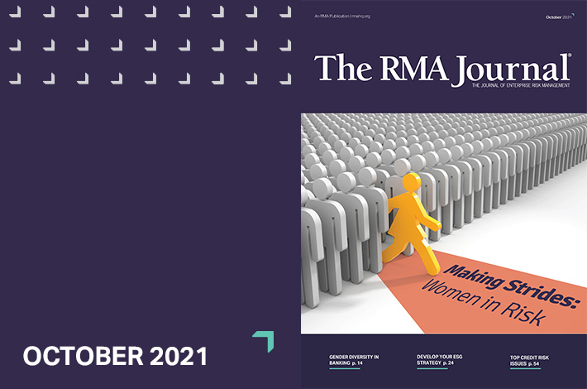
Upcoming RMA Forums


Best Practices In Asset/Liability Management: A Focus on Liquidity and Market Risk | 11/2-11/16
It is no secret that well-managed assets and liabilities can increase a bank’s profitability, but today’s volatile economic landscape presents new challenges to the teams responsible for developing and executing the asset/liability management (ALM) strategy. Using practical, relevant examples, this course is designed to help you broaden your skills and gain a deeper understanding of balance sheet management, market risk, liquidity risk, and how to apply these concepts in the current environment.
Register Now

Upcoming Virtual Courses
- 11/01 - Financial Statement Analysis
- 11/03 - Lending to the Long-Term Care Industry
- 11/03 - Lending to Medical and Dental Practices
- 11/03 - Analyzing Business Tax Returns
- 11/04 - Advanced Operational Risk Management Virtual Course
- 11/08 - Commercial Real Estate Lending III: Global Cash Flow
- 11/08 - Small Business Lending Fundamentals
- 11/08 - 360 Negotiation Skills for Bankers
For more information click here.

Professional Development
With RMA

MISSION
RMA is a member-driven professional association whose sole purpose is to advance sound risk principles in the financial services industry.

Stay connected with RMA:
Member Forum RMA Journal
RMA Blog Podcast

THE CREDIT COURIER 09/2020

Vermont RMA Chapter, Inc.

% Vermont Bankers Association, Inc.
P.O. Box 587, Montpelier, VT 05601-0587
802-229-0341 ph
802-223-5078 fax
vtbanker@sover.net

