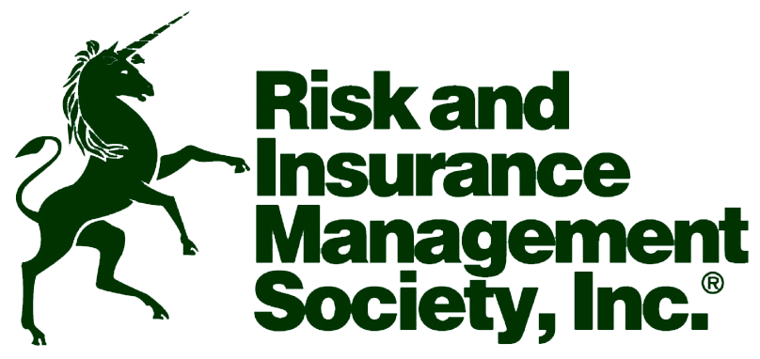

JANUARY MEETING

Tuesday, March 13, 2012 – 11:30 to 1:00 PM

Brio on the Plaza
502 Nichols Drive
Kansas City, MO 64112
(816) 561-5888

The Greater Kansas City Chapter of RIMS invites you to join us for a lunch and an informative presentation on Tuesday, March 13 at Brio on the Plaza from 11:30 to 1:00.

Luke Harrison, Midwest Director for Aon Group Risk Consulting practice, will discuss data-driven strategies to reduce Total Cost of Risk through analytics, KPI’s, and proven diagnostic processes. This session will explore best practices techniques for establishing a risk profile, improving that profile, and optimizing that profile. As every risk management professional is responsible for optimizing their organization’s Total Cost of Risk with the support of our underwriting, claims and loss control administration and broker partners, this session will be of interest to all of our members.

The cost for this event is $25 per person. If paying by check, please make your check payable to KC-RIMS.

Please e-mail your reservation to Danny Rose at danny_rose@collectivebrands.com no later than 5 pm on Friday, March 9. If it becomes necessary to cancel your reservation, you may do so until 5 pm on Monday, March 12.

Please note your Entrée Selection with your RSVP.
Chicken Under the Brick-Boneless, skinless chicken breast, grilled and pressed under a brick. Served with Marsala mushroom sauce.
Pasta BRIO-Rigatoni pasta tossed with grilled chicken, garlic, Cremini mushrooms, Parmesan cheese and a sweet roasted red pepper cream sauce.
Shrimp Diavolo-Penne pasta tossed with sautéed shrimp in a spicy tomato cream sauce made from marinara and Alfredo sauces, lobster butter, and garnished with green onions.

President
DANNY ROSE
COLLECTIVE BRANDS, INC.
danny_rose@collectivebrands.com
Tel: 785.295.2456
Fax: 785.295.2080

Vice-President Membership
DENNIS HARBER
GREAT PLAINS ENERGY
dennis.harber@kcpl.com
Tel: 816.654.1910
Fax: 816.556.2992

Treasurer
STEVE DIGIACINTO
HALLMARK CARDS, INC.
sdigia1@hallmark.com
Tel: 816.274.3654
Fax: 816.545.6550

Secretary
JOHN EVANS
AMC Entertainment
jevans@amctheatres.com
Tel: 816.480.2541
Fax: 816.480.2582

Chapter Delegate
LAURA VUNOVICH
HNTB COMPANIES
lvunovich@hntb.com
Tel: 816.527.2515
Fax: 816.472.6305

http://greaterkansascity.rims.org

MISSION STATEMENT
Greater Kansas City Chapter of RIMS will further the risk management profession and promote ethical conduct by providing educational programs, networking opportunities, and influence legislation and regulatory processes relating to risk management for chapter members and the risk management community.

