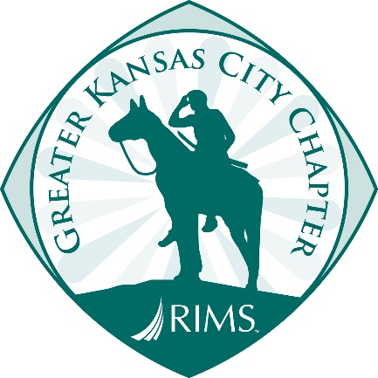

2020 Kansas City RIMS Student Summer Internship Program

The Kansas City Chapter of the Risk and Insurance Management Society (RIMS) will again be sponsoring an eight-week paid internship for qualified students hosted by some of Kansas City’s premier companies.

We match exceptional students with exceptional employers, offering students a rich learning experience through practical application.

Since the program began in 1997, Kansas City RIMS is proud to have sponsored several interns from the Kansas City area at top local companies, such as:

AMC Theatres American Century American Safety
Ameristar Casino Asurion Broadspire
Cerner Corporation DST Systems Evergy
H&R Block MRI Global Virtus Insurance
Renzenberger Seaboard Dairy Farmers of America

Participating schools have included, but are not limited to:

Central Missouri Oklahoma State UMKC Notre Dame
Missouri State University of Missouri Park University Harvard
Kansas State University of Kansas William Jewell Miami of Ohio
Avila University Rockhurst University Texas Christian Vanderbilt

FOR MORE INFORMATION, PLEASE SEE PAGES 2 & 3 ATTACHED

For additional questions, please contact:

David Fromm, Chairman
RIMS Summer Internship Program
913-961-0628
dfromm@american-safety.com

Please also visit our website at: http://greaterkansascity.rims.org/events/new-item3

General Program Guidelines:

- Proceeds from the KC RIMS Spencer Golf Tournament will be used to fund all internship grants and determine the number of internships offered each year.
- Each grant will be $5,000 for an 8-week internship period.
- At the discretion of the RIMS Board, a $1,000 bonus may be offered as a tuition credit upon the student’s successful completion of the internship and a recommendation by the host employer.
- The $5,000 grants will be made by KC RIMS directly to the host employer that will then assume the employment relationship and pay the intern through its payroll system.
- The internship committee will review employer and student applications. The committee will first select host employers and then collaborate to match employers with students whose career goals and objectives match the employer's needs.

Employer Responsibilities/Requirements:

- Any KC RIMS Chapter Member or Associate ember are eligible to apply to host a student intern.
- Prospective host employers must apply by November 29.
- Host employers will be selected in late November.
- Employers must pay out the entire $5,000 grant to the intern in the form of gross wages over an 8-week period. In event of premature termination of the internship (less than 8 weeks) employer must return pro-rata the unused portion of the grant.
- The employer is free to supplement intern compensation beyond the amount of the RIMS $5,000 grant and to extend the term of employment beyond the minimum 8-week requirement.
- The host employer is responsible for all employee payroll withholdings, employer matching contributions, tax filings, and other legal requirements.
- The sponsoring employer is responsible for other benefits such as workers compensation and unemployment insurance.
- Employers must reimburse students for out of pocket costs for business travel, if applicable.
- The employer will provide a mentor who will supervise the intern, conduct periodic written or verbal feedback sessions with the intern and complete a RIMS Intern Review form at the conclusion of the internship.

Employer Responsibilities/Requirements Continued:
- The mentor and intern will make every effort to attend (1) our KC RIMS summer meeting when we introduce our summer interns to the membership and recognize host employers and (2) a wrap-up lunch meeting at the end of the summer with KC RIMS officers.
- We also encourage host employers to (1) sponsor an event for all interns at some point during the summer to give interns additional opportunities to interact and share experiences and (2) support of the September RIMS Golf Tournament, which raises funds for the internship program.
- The employer is not required to provide housing for the intern.

Student Responsibilities/Requirements:

- Students must complete an application and submit it with a general resume by December 9 although we will continue to accept applications until all internships are filled.
- Must be a bona-fide undergraduate student during the time of the internship.
- Must have completed 45 credit hours prior to commencing internship.
- Students pursing this opportunity ideally have a concentration in Risk Management and Insurance, Safety Science, Fire Protection, and/or Actuarial Science. Business Administration, Accounting, and/or Finance majors, with an interest in risk management, may also apply. (Evidence of interest might include taking any available insurance and risk-related courses.)
- All applicants must have completed six semester hours toward a major before the beginning of the internship.
- All students must have achieved a minimum GPA of 2.75 on a 4-point scale.
- Interns are responsible for arranging their own housing during the internship.

